Waste and Plastic Waste Analysis for Guinea

Methodology, Implementation and Accuracy

Executive Summary
This module maps waste accumulation in Guinea from satellite imagery, on water and on land, and reports the outcome of a test of whether the plastic content of individual sites can be estimated from orbit. It has four components, developed and validated separately and reported together here because they share a study area, a reference dataset, and a common constraint on what optical remote sensing can establish about material. The first three work from imagery; the fourth quantifies the leakage indicator: how much plastic is generated and how much escapes.
Components A and B deliver a nationally deployable detection capability on water and on land, and component D quantifies leakage nationally without imagery. The third line of work (component C, the characterization test) tested whether the plastic fraction within a detected site can be retrieved from orbit. It returned a negative result on three of its four pre-declared gates, and is reported in Appendix C.
Three results from that work change how the module should be read. First, the floating-debris layer is a two-stage detector, and only the second stage makes it specific. The Floating Debris Index, run through a classifier trained on MARIDA achieves a precision of 0.90 on the benchmark's test pixels and 0.92 on geographically unseen tiles, and the published layer is the rule followed by that classifier (§7.1.13, §7.1.14). On Guinean imagery the photo-interpreted precision is lower, 36.8% of decided patches at Conakry, and that is the figure that describes Guinea (§7.1.3).
Second, upstream detection is measurably less sensitive than coastal. Per-tile thresholds in river corridors run about 1.2 times the Conakry threshold, and up to three times on individual tiles, because a corridor's water population is mixed with turbid and bank-adjacent pixels. Only 55% of screened corridor length carries a usable threshold at all, and no patch was published on it in January 2024. A low upstream patch count therefore measures reduced sensitivity, not a clean river (§7.1.12).
Third, plastic reaching the Guinean environment is estimated at 18,166–84,017 t yr⁻¹. The range is a factor of 4.6 and is driven by a disagreement about evidence, not by noise: the scenario gap exceeds the statistical interval within either scenario, so no further computation narrows it. Guinea has no recent national waste composition survey (§7.6).
Seven findings should govern how these outputs are used.
- The Floating Debris Index responds to any material that raises near-infrared reflectance above the water baseline, so seaweed, algal mats, timber and sea foam are flagged identically to macroplastic. The terrestrial layer detects the visual signature of accumulated waste, which carries no material information at all. The platform therefore maps waste accumulation hotspots (dumpsites on land and floating material on water), and establishing their material composition requires ground survey.
- Spatial footprint, not spatial resolution, governs detection performance on land. The two were conflated for a substantial part of the work. Degrading imagery from 0.29 to 1.18 m per pixel changed nothing measurable (delta ROC-AUC -0.011, P = 0.70), while changing the analysis window from a 250 m cell to an 80 m crop changed the model's behavior categorically. At 250 m the classifier scored residential negatives above real dumpsites (0.626 against 0.618): it was a settlement detector that appeared to work only because dumpsites sit in settlements. Correcting the footprint required no additional imagery spent.
- Licensed imagery is measurably better, but only once the footprint is correct. On identical samples, Google imagery at zoom 19 reached ROC-AUC 0.911 and average precision 0.696 against 0.832 and 0.543 for free Esri imagery at zoom 17 (delta AP +0.144, 95% CI [+0.036, +0.250], P = 0.004, paired block bootstrap). Before the footprint correction the same comparison showed no meaningful difference. The deployed cascade confirms on free Esri imagery with a classifier fitted on Esri crops, and its blind-grid performance is measured separately (§7.2.11).
- Performance measured on point-centered crops does not transfer to a blind grid, and the gap is large. The ROC-AUC 0.911 figure answers the question “is this crop a dumpsite?”, on a crop already centered on a coordinate a human selected. The platform implementation asks, “where are the dumpsites in this area?”, scoring every window of a blind grid. On 422 exhaustively hand-labelled windows over Conakry the same model achieves ROC-AUC 0.682 and average precision 0.477 (0.738 and 0.640 on a second blind grid at Boké, §7.2.8). With free Esri imagery at stage 2, as deployed, ROC-AUC is 0.594 at Conakry and 0.687 at Boké, and at the medium tier precision is 0.347 and 0.586 — about 1.3 times the base rate in both towns — with end-to-end recall of 46% and 23% (§7.2.11). That is a usable screening signal for analysts and is best used as a prioritization aid: the sites it returns are a subset of those present rather than a complete register.
- Local precision of the floating-debris layer is modest, and its confidence levels do not rank it. All 26 patches published for Conakry in January 2024 were photo-interpreted: 7 positive, 12 negative and 7 ambiguous, a precision of 36.8% on decided patches and 26.9% if every ambiguous patch is counted as false. Every negative was near-shore water in which the patch could not be distinguished from its surroundings, and the high-confidence band scored below the medium band (§7.1.3).
- Plastic concentration cannot be estimated from currently available satellite data, for physical reasons. Plastic identification rests on C-H bond absorption near 1215 nm and 1730 nm; neither wavelength falls inside a Sentinel-2 band. The openly available sensors that do resolve them have 30 to 60 m pixels, and Guinea's dumpsites measure a median 14.0 m area-equivalent side, which fills 0.22 of an EnMAP pixel and 0.05 of an EMIT pixel by area. No pixel anywhere in Guinea contains only dumpsite. Four independent lines of evidence converge on this conclusion (§C.6).
- Two deliverables answer the underlying programme need. The first is the first measured dumpsite size distribution for Guinea; the second is a waste mobilization model identifying which sites most likely discharge waste to watercourses in the rainy season. The latter is validated against observed flooding (AUC 0.771, p = 0.001), which is what a river-trap siting or clean-up prioritization decision requires.
On internal consistency, the marine pipeline agrees with an independent offline implementation of the same indices to 5.96e-08 over 5,169,355 pixels, and the monthly-archive path reproduces the main composite path exactly. Threshold perturbation of plus or minus 10% moves the patch count by +23.1% and -46.2%, monotonically but by a large margin, so the January 2024 count is provisional for that scene (§7.1.6).
What remains open is validation coverage rather than method. Of the four marine regions only Conakry has been photo-interpreted under the current detector; Fatala's four patches have not been reviewed, and Konkouré and the southern offshore region returned none. The terrestrial blind-grid figures come from two towns: Conakry, in an area selected because it contained known dumps, and Boké, which was not selected that way. The ground truth throughout is photointerpretation by a single annotator: no detection in this module has been confirmed in the field, and no inter-rater agreement estimate exists. These limits are set out in §8.

1. Introduction and Objectives

1.1 Background
Marine and coastal plastic pollution in Guinea concentrates around the Conakry peninsula and the estuarine systems of the Konkouré and Fatala rivers, where riverine transport, dense coastal settlement and limited formal waste collection combine. Guinea has no comprehensive national record of informal waste disposal sites. Municipal collection covers a minority of generated waste, and uncollected material accumulates in informal dumps on vacant land, in drainage channels and along peri-urban margins. These sites are a public health burden, a source of groundwater and surface-water contamination, and, where they lie in drainage paths, a mechanism by which plastic enters river systems and ultimately the Atlantic.
A growing waste-to-value sector already operates in the country. Enterprises such as BGS Recyplast in Conakry convert plastic into paving material, and comparable initiatives upcycle sachets and produce agricultural fencing. These operations are constrained by a fragmented supply chain: they cannot efficiently locate high-volume plastic sources. A spatial record of where waste accumulates is a precondition for connecting that supply to demand.
The Guinea Environment Digital Hub specifies a National Hotspot Map (GEDH-FR-0503) combining two independent and independently toggleable layers: mesoscale optical detection of floating debris on water, and macro-scale detection of illegal dumpsites from high-resolution imagery on land. The concept note specifies a further analytical step applied to the detected sites, namely estimating plastic concentration in order to distinguish plastic-heavy hotspots from organic dumps. That step is required by the plastic brick initiative, which must screen out polyvinyl chloride, and by FR-0503's requirement that hotspot polygons be color-coded by concentration level.

1.2 A four-component design
A fourth component, plastic leakage estimation, was added after the first three and is described in §5.4. Components A and B answer where material is; component D answers how much is generated and how much escapes, which is the quantity the concept note's leakage indicator requires and which no detection layer can supply. Keeping it separate preserves the provenance distinction the module depends on — satellite detection measures where material is, gravimetric sorting measures what share is plastic, and terrain models say where it goes. The three imagery-based components address physically different detection problems.
Table 1. The three operational components and what each delivers. Component C, the characterization test, is reported in Appendix C. Components A and B detect waste but neither measures plastic; component D estimates quantity without imagery.
Component | Target | Sensor | Status
A. Floating debris | Debris accumulations on coastal and estuarine water | Sentinel-2, 10-20 m | Operational; benchmarked on MARIDA, photo-reviewed at Conakry
B. Dumpsite detection | Waste accumulation sites on land | Esri and Google RGB basemaps, 0.3-1.2 m | Operational as a screening aid
D. Leakage estimation | Plastic generated and reaching the environment, nationally, by region and by site | No imagery: population, waste statistics, literature parameters | Operational as a modelled estimate; range spans 4.6× (§7.6)
Component A exploits a spectral contrast that exists only over water. Water absorbs strongly in the near-infrared and short-wave infrared, forming a dark, low-variance background against which floating solids appear as a positive anomaly. Component B has no such contrast available: terrestrial dumpsites sit on soil and laterite, which are themselves bright in the same bands, so detection becomes a textural and contextual image-classification problem over high-resolution optical imagery rather than an index-thresholding problem over multispectral data. A third question, about material composition, depends on absorption features that neither sensor samples; it was tested and is reported in Appendix C.
Two consequences follow. The marine method does not transfer to land: the Floating Debris Index depends on the debris-against-dark-water contrast, which does not exist over soil, and §C.4 quantifies what it does instead. And Sentinel-2 index-based approaches were evaluated for dumpsite detection and falsified before the high-resolution route was adopted (§C.3). Additionally, the SDG AI Lab's Guatemala illegal dumpsite detection model was not adapted, for reasons given in §5.2.1.

1.3 Objectives
For component A, floating-debris detection:
- Produce a reproducible, literature-grounded detection of candidate floating-debris accumulations in Guinea's coastal and estuarine waters from Sentinel-2 imagery.
- Establish every parameter of the detection rule by reference to published work.
- Quantify what accuracy evidence is available without field verification.
- Deliver the result in a form the Hub platform can publish monthly (GEDH-FR-0507) at national coastal scope.
For component B, dumpsite detection:
- Define a national search footprint from a published standard.
- Collect an unbiased labelled sample across that footprint.
- Establish whether free basemap imagery is sufficient, or whether licensed imagery is required, by controlled test.
- Produce a detector deployable nationally within a stated budget.
- Measure performance in the configuration in which it will be deployed. This objective was added during the work, after the discrepancy described in §7.2.6 was discovered.
For component C, the characterization test:
- Establish whether the plastic fraction within a detected site can be retrieved from any openly available orbiting instrument.
- Fix the pass condition of each falsification gate before the data are examined, so that neither a positive nor a negative outcome can be constructed after the fact.
- Measure whatever is needed to explain the outcome, whichever way it falls, rather than reporting a result without a mechanism.
For component D, plastic leakage estimation:
- Quantify how much plastic is generated nationally and how much reaches the environment and watercourses, which is the quantity the concept note's leakage indicator requires and the one no detection layer can supply.
- Distinguish uncollected waste from leaked waste, since the two are routinely conflated and open burning is the dominant fate of uncollected plastic.
- Propagate uncertainty in a way that respects the governing parameters being national, and therefore shared across every region rather than independent between them.
- Report the disagreement about waste composition as a scenario range rather than averaging across it.
- Check the chain wherever independent Guinean evidence exists, against figures the model does not take as inputs.

1.4 Scope and Limitations
The scope is deliberately narrow in six respects, each stated here.
Material. No output of this module directly measures plastic. Component A produces floating-debris candidates — the single public term used throughout this document and in the interface, meaning a patch anomalous in the index over water rather than material verified as debris; component B produces waste accumulation sites identified from appearance; the characterization test establishes that plastic fraction is not measurable from orbit (Appendix C). This wording should be preserved in all user interface copy.
Geography. For component A, “national” means national coastal and estuarine coverage. The index is defined only on water and the permanent-water constraint (§5.1.3) removes land, so the marine layer does not cover Guinea's interior. For component B, the search footprint is the settled 2.29% of the national land area (§3.2). The method itself applies anywhere in the country; the footprint is a cost and plausibility restriction, since waste accumulation is a settlement-associated phenomenon and scanning unsettled terrain would multiply imagery cost without a corresponding gain in detections.
Detection limits. Component B detects the visual signature of accumulated waste in overhead imagery. It does not identify material composition, estimate volume, depth or mass, confirm that a site is illegal or currently active, or detect sites invisible from directly overhead, including waste under tree canopy, in narrow alleys, or inside walled compounds. Basemap imagery is typically 17 to 19 months old over the towns examined, so a detection date is the date the model ran, not the date the waste was observed.
Accuracy. All evidence is photo-interpretive, from a single interpreter, and in the marine case reviewing the detector's own output. It is provisional evidence of performance, not a validated accuracy figure, and it carries no inter-rater agreement estimate.
Extent measurement. Dumpsite sizes rest on 46 sites annotated by a single interpreter; 9 further sites were excluded as unclear. A blind re-measurement of 12 randomly selected sites by the same interpreter (§7.3) gives a median relative difference of 42% and a concordance correlation of 0.49. The absolute size figure is therefore not quotable to better than roughly 40%, although the conclusion it supports is not sensitive to that imprecision. The second read was an independent reproducibility check, not a second human interpreter.
Validation of the negative result. There is no plastic-fraction ground truth for Guinea. No result in this document is validated against field measurement. This constrains the negative result exactly as it would have constrained a positive one: the module demonstrates that no usable signal is detectable in these data, not that no plastic is present.

2. Literature Review
This review is organized around one question: what can satellite imagery establish about waste, and at what spatial scale. §2.1 covers optical detection of debris on water, §2.2 detection of waste sites on land, §2.3 the spectral basis on which material identification would have to rest, §2.4 transport and emission modelling, and §2.5 to §2.6 the validation practice and the operational precedents that constrain how any of it may be published. §2.7 states what this module adds.

2.1 Optical detection of floating marine debris
Detection of floating material from multispectral satellite imagery rests on the spectral contrast between water, which absorbs strongly in the near-infrared (NIR) and short-wave infrared (SWIR), and most floating solids, which do not. Water therefore forms a dark, low-variance background against which floating material appears as a positive NIR anomaly. Topouzelis et al. (2019, 2020) established the feasibility of the approach with controlled plastic targets deployed in Aegean coastal waters, showing that aggregations on the order of a Sentinel-2 pixel are detectable and that sub-pixel targets are not. Themistocleous et al. (2020) reached comparable conclusions with independently deployed targets off Cyprus. The consequence for an operational layer is that what is detected is an accumulation dense enough to alter the reflectance of an entire 10 m pixel. This sets a floor on detectable size that no processing choice can lower.

2.1.1 The Floating Debris Index
Biermann, Clewley, Martinez-Vicente and Topouzelis (2020) introduced the Floating Debris Index, which isolates the NIR anomaly by subtracting a baseline interpolated between the red-edge and SWIR bands. The index is computed from Sentinel-2 bands B8 (832.8 nm), B6 (740.5 nm) and B11 (1613.7 nm), with the wavelength of the red band B4 (664.6 nm) in the interpolation ratio, exactly as published (their equations 1 and 2); versions of this module before October 2026 used B8A in place of B6, which is a different index. Subtracting an interpolated baseline rather than using raw NIR suppresses the confounding effect of suspended sediment and sun glint, which raises reflectance across the whole spectrum.
Critically, Biermann et al. (2020) do not threshold the index. They train a naïve Bayes classifier in the two-dimensional NDVI-FDI feature space against a spectral library of seawater, seaweed, timber, sea foam, pumice and macroplastics, reporting approximately 86% overall accuracy. The classifier is what delivers material discrimination: plastic, seaweed and timber all sit high on both axes relative to seawater, but occupy separable regions of the joint distribution.
That approach requires labelled spectra, and none exist for Guinea; the class boundaries also depend on local water optical properties. The MARIDA benchmark (Kikaki et al., 2022) supplies labelled Sentinel-2 pixels of debris and of its confusers from other coasts, and the module uses a classifier trained on it as the second stage of detection (§5.1.4); whether it transfers to Guinean water is tested in §7.1.14. The distinction between thresholding the index and classifying in its feature space is therefore the central methodological choice any implementation must make, and the two are not equivalent in what they can claim about material identity.

2.1.2 Operational thresholding workflows
Digital Earth Africa published an operational floating-marine-debris workflow that does threshold the index, and it is the basis of the detection rule used here. Their sequence masks to water using a coastline buffer and the Water Observations from Space product (WOfS) water frequency, then requires a pixel to exceed the mean plus three standard deviations of the water population on both FDI and NDVI. Their published run reports thresholds of 0.0409 (FDI) and 0.2721 (NDVI) derived this way. The anomaly framing suits FDI well. The debris signal is an elevation above a water baseline, not a second mode in a bimodal histogram, and the water population is both large and homogeneous enough for its mean and standard deviation to be stable.
Kikaki et al. (2023) do pair FDI with Otsu's (1979) unsupervised threshold, but only inside a buffered, hand-annotated region of suspected debris, as a label-refinement step ahead of training a deep model. Otsu's two-class assumption holds in a small pre-localised region; it does not hold across a whole coastal scene.

2.2 Remote detection of solid waste on land
Solid waste on land lacks the distinctive spectral signature that makes floating debris detectable at sea. Where the marine approach exploits a near-infrared anomaly over a dark background, terrestrial dumpsites present as a textural and contextual anomaly: irregular mixed-albedo material, disturbed ground, vehicle tracks, and proximity to settlement. Detection is therefore posed as an image-classification problem over high-resolution optical imagery.
The strongest published satellite study of land-based plastic waste is Kruse et al. (2023), which uses Sentinel-2 to find waste sites, reports a mean site area of 0.47 ha and a minimum detectable size near 30 m, and states explicitly that it cannot determine plastic fraction or concentration within a site: it identifies site presence only. That boundary — site detection yes, composition no — is the state of the art. Component B works at 0.3 to 1.2 m rather than 10 m, which matters for Guinea specifically: measured Guinean dumpsites have a median area-equivalent side of 14.0 m (§7.3) and therefore fall below Kruse et al.'s detection floor entirely.
Where labelled data is scarce, features from a network pre-trained on a large generic corpus, used without fine-tuning and followed by a simple linear classifier, are a strong and difficult-to-beat baseline (Razavian et al., 2014). This “linear probe” approach has the property that matters most here: it has few free parameters, so it can be fitted and honestly validated on a few hundred labelled examples.

2.3 Terrestrial plastic indices
Detecting agricultural plastic film and greenhouses from satellite is an established field, and it is the natural place to look for a plastic index that might transfer to dumpsites. The Plastic-Mulched Landcover Index of Lu, Di and Ye (2014) is a normalized difference of shortwave infrared and red reflectance. Yang et al. (2017) developed the Plastic Greenhouse Index and its retrogressive variant from visible and near-infrared bands, reporting detection where the plastic fraction exceeds roughly 12% of a mixed pixel. Hasituya et al. (2019) proposed three Sentinel-2 variants dividing a near-infrared minus shortwave-infrared difference by different band sums. Zhao et al. (2004) proposed the Greenhouse Vegetable Land Extraction Index. Band mappings follow Güngör et al. (2026), which tabulates the family for Sentinel-2.
Two properties of that literature bound its transferability. These indices target large, uniform, high-albedo plastic sheeting on a soil background; a mixed municipal dumpsite is neither uniform nor predominantly plastic. And Yang et al.'s (2017) own 12% threshold is a statement about the minimum plastic fraction of a pixel at which their index responds. The transfer to municipal waste is therefore an assumption requiring test, which is what gate 2 (Appendix C) provides.

2.3.1 The physical basis of plastic identification
Plastic identification from reflected sunlight rests on C-H bond absorption features near 1215 nm and 1730 nm. These are the only physically grounded discriminators; everything else is an appearance proxy that confuses plastic with other bright, non-vegetated materials. The distinction is central to this document, because an index that separates dumps from their surroundings without sampling those features is separating on something else, and the most parsimonious candidate is bare ground.
Sentinel-2 carries shortwave infrared bands, which makes it natural to assume it can observe these features. It cannot: both fall in gaps between its bands. The plastic-mulch index family therefore measures the shape of the shortwave infrared continuum rather than C–H absorption. EnMAP, EMIT and PRISMA, sampling at roughly 6.5 to 12 nm, resolve both features directly, at 30 to 60 m ground sampling.

2.3.2 Hyperspectral detection of plastics on land
The closest published analogue to a hyperspectral test over municipal waste is the use of PRISMA hyperspectral imagery over the Ghazipur and Okhla landfills in Delhi (Dutta et al., 2022), which identified specific plastic materials against spectral libraries. Recent reviews survey the field as a whole (Danilov and Serdiukova, 2024; Potiracha and Baars, 2026), and machine-learning detection of coastal plastic from Sentinel-2 is reported by Nivedita et al. (2024). Related work includes plastic litter detection from hyperspectral aerial remote sensing (Balsi et al., 2025) and a critical review of hyperspectral plastic detection (Polák and Kupková, 2026).
The Delhi landfills are hundreds of meters across. Target size relative to the pixel is therefore the governing variable in this literature: a pixel over a large landfill is filled with landfill, whereas a pixel over a small dumpsite is dominated by its surroundings.

2.4 Waste mobilization and riverine plastic emission modelling
Separate literature models where waste goes rather than what it is made of, and it becomes relevant precisely because composition proved unmeasurable. Meijer, van Emmerik, van der Ent, Schmidt and Lebreton (2021) give a probabilistic model combining mismanaged waste, land use, wind, precipitation and river networks, whose two dominant geometric terms are distance to the river network and distance to the basin outlet. The Plastic Pathfinder (Mellink, van Emmerik et al., 2022) holds that waste is mobilized when driving forces (surface runoff and wind) overcome terrain friction, itself a function of slope and land-use type. A comparable GIS and remote-sensing leakage mapping approach for a tropical developing basin is given for the Lower Mekong by Tran-Thanh et al. (2022).
Two features of this literature make it usable here where characterization was not. Every input term is directly observable from open data, and the plastic-specific quantity enters only through a mass term that Meijer et al. derives from national waste-composition statistics.

2.5 Validation under spatial dependence and class imbalance
Geospatial samples violate the independence assumption behind random cross-validation: nearby observations share terrain, imagery capture and settlement pattern, so a random split leaks information between training and test folds and inflates measured performance. Blocked cross-validation, in which folds are separated spatially, is the standard remedy (Roberts et al., 2017). All cross-validated figures in this document use spatial blocking.
Blocking is necessary but not sufficient. It prevents a training tile from leaking into an adjacent test fold, but it does nothing about a correlation between terrain type and label present across the whole dataset, because every fold then shares the same biased distribution. That is covariate shift between the sampled and deployed negative distributions, and only a blind-grid test exposes it (§7.2.6).
Under strong class imbalance, ROC curves are dominated by the majority class and present an optimistic picture; precision-recall summaries are more informative because precision responds directly to false positives (Saito and Rehmsmeier, 2015). Average precision is therefore reported alongside ROC-AUC throughout, with its no-skill baseline stated as the positive prevalence rather than 0.5, and it is the metric treated as authoritative where the two disagree.
Where two models are compared, their intervals are not compared by inspection for overlaps, which is a well-documented error that understates significance (Schenker and Gentleman, 2001). Differences are assessed by paired bootstraps on identical samples.

2.6 Regional evidence and operational platforms
Published remote-sensing detection of floating debris for the West African coast is sparse, and no peer-reviewed FDI application to Guinean waters is known to the authors. The closest operational precedent is the Digital Earth Africa workflow above, which is continental in design intent. This absence is itself a reason to report conservatively: there is no regional benchmark against which to sanity-check a Guinean detection rate, and no local literature on the prevalence of confounding floating vegetation in mangrove-fringe waters.
No operational public platform currently publishes floating-debris detections for Guinea, so external benchmarking of the kind applied in the Land Use and Deforestation modules, where Global Nature Watch and Hansen products provide independent comparators, is not available here.
For terrestrial waste-site detection, two operational platforms provide the relevant precedent on how detections are published. Global Plastic Watch maps waste accumulation from Sentinel-2 and does not publish a single detection cut-off: it operates several sensitivity regimes and attaches a confidence score to each polygon. Global Forest Watch publishes GLAD and RADD disturbance alerts with explicit confidence levels, where a lower-confidence alert is escalated once corroborated by subsequent observations, and users may filter to high-confidence alerts only. Both informed the decision in §5.2.5 to publish confidence tiers.

2.7 Synthesis: contribution of this module
Literature establishes three boundaries that this module operates within. Floating material is detectable from Sentinel-2 as an accumulation, but discriminating its material requires a trained classifier and labelled spectra. Waste sites on land are detectable, but published work states that composition within a site is not. And plastic sheeting is spectrally identifiable when it is large, uniform and fills a substantial fraction of a pixel.
Within those boundaries the module makes four contributions. First, a reproducible floating-debris detection for Guinean coastal waters that follows the published index and threshold rule and filters the rule's detections with a classifier trained on a public benchmark, with an explicit and quantified account of what it cannot do. Second, a nationally scoped dumpsite screening workflow built on open or low-cost imagery. Third, and most transferable, a documented and quantified demonstration that spatially blocked cross-validation on point-centered crops substantially overstates performance on the blind-grid task that deployment actually performs; the size of this gap has not, to the authors' knowledge, previously been reported for dumpsite detection, and it bears directly on how published accuracy figures should be compared. Fourth, a quantified negative for sub-pixel municipal waste characterization in a West African setting, together with the first measured dumpsite size distribution for Guinea, which is the measurement that explains why the negative was inevitable.
A methodological note on register applies throughout. Several results below overturned an earlier assumption held within this project, and in each case the superseded position is stated alongside the correction. An unsourced threshold, a circular metric or a stale cache that was silently corrected leaves a reader unable to judge which figures were affected.

3. Study Area
The two operational components cover different parts of Guinea, for reasons intrinsic to their methods, and neither covers the whole country.

3.1 Coastal and estuarine zone (component A)
Component A covers Guinea's coastal zone. Four regional areas of interest are defined and each is executed independently (§5.1.6). The Conakry area serves as the reference scene for method development and validation because it combines the highest population density on the coast with the most complex port infrastructure, making it the most demanding case for false-positive control.
Table 2. Regional areas of interest for the marine component. Pixel counts are approximate, computed at the 20 m analysis scale. The full coastal zone is listed for scope reference and is deliberately not executed as a single pass (§5.1.6).
Region | Bounding box (WGS84) | Extent | Pixels @ 20 m | Role
Conakry | −13.90, 9.30, −13.40, 9.70 | 55 × 44 km | 6.1 M | Reference / validation scene
Konkouré | −14.80, 9.70, −14.20, 10.30 | 66 × 66 km | 10.9 M | Estuarine, national run
Fatala (Boffa) | −14.20, 10.00, −13.85, 10.35 | 39 × 39 km | 3.8 M | Estuarine, national run
Southern offshore | −14.50, 9.00, −13.50, 9.50 | 110 × 55 km | 15.1 M | Open water, national run
Full coastal zone | −15.50, 8.80, −13.00, 10.80 | 274 × 221 km | 151.6 M | Scope reference (not run as one pass)

For context, the bounding box of Guinea's entire land territory would contain approximately 1,241 M pixels at 20 m. Extending the analysis inland would add roughly eight times the pixel count and almost no detectable area, because the permanent-water constraint removes non-water surfaces. Coastal restriction is a property of the method, not a limitation of the implementation.

3.2 National settled footprint (component B)
Guinea covers 244,006 km² as measured on the analysis grid. Scanning it exhaustively at the working window size is neither affordable nor sensible: informal dumping is a settlement-associated phenomenon, and most of the national territory contains no candidate sites.
The search footprint is defined from the GHSL Settlement Model (SMOD), the Degree of Urbanization classification endorsed by the UN Statistical Commission for international comparison. The adopted footprint is SMOD class 21 or above, that is, urban center, dense urban cluster, semi-dense urban cluster and suburban or peri-urban grid cells, expanded by a 1 km buffer to capture the peri-urban fringe where informal dumping concentrates.
Table 3. Candidate national search footprints. The adopted footprint is 2.29% of the national land area, which is what makes a costed national scan possible at all.
Footprint | Area | 250 m cells | Share of Guinea
Whole country | 244,006 km² | 3,904,090 | 100%
SMOD ≥ 21 | 2,584 km² | 41,351 | 1.06%
SMOD ≥ 21 + 1 km fringe (adopted) | 5,583 km² | 89,336 | 2.29%
SMOD ≥ 21 + 2 km fringe | 9,152 km² | 146,433 | 3.75%

Adopting a published standard rather than a bespoke mask means the footprint is defensible, reproducible, and updates independently of this project. Labelling and validation cover all eight administrative regions: Conakry, Boké, Kindia, Mamou, Labé, Faranah, Kankan and Nzérékoré.

3.3 Labelled reference data
The reference set is a single national random sample, drawn once and reused by both terrestrial components, which is what allows their results to be compared directly. It consists of 651 labelled points across all eight regions — 111 explicit dump-point coordinates and 540 negatives — falling in 595 distinct 250 m cells. Three analyses draw on it at different granularities, and the counts differ accordingly: the stage-1 cell screen uses the 595 cells, of which 55 are positive; the 80 m point-centred analyses use all 651 points; and the Sentinel-2 index evaluation in C.3 uses 646 of them. labelled points from: from the positive cells, and 535 negative cells
Positives use the annotator's point coordinates, because a 250 m cell is several pixels across at every resolution considered and a dump may sit at its edge. Positive cells were expanded to one sample per dump pin, because cells frequently contain several distinct dumps: 55 positive cells yielded 111 pins.
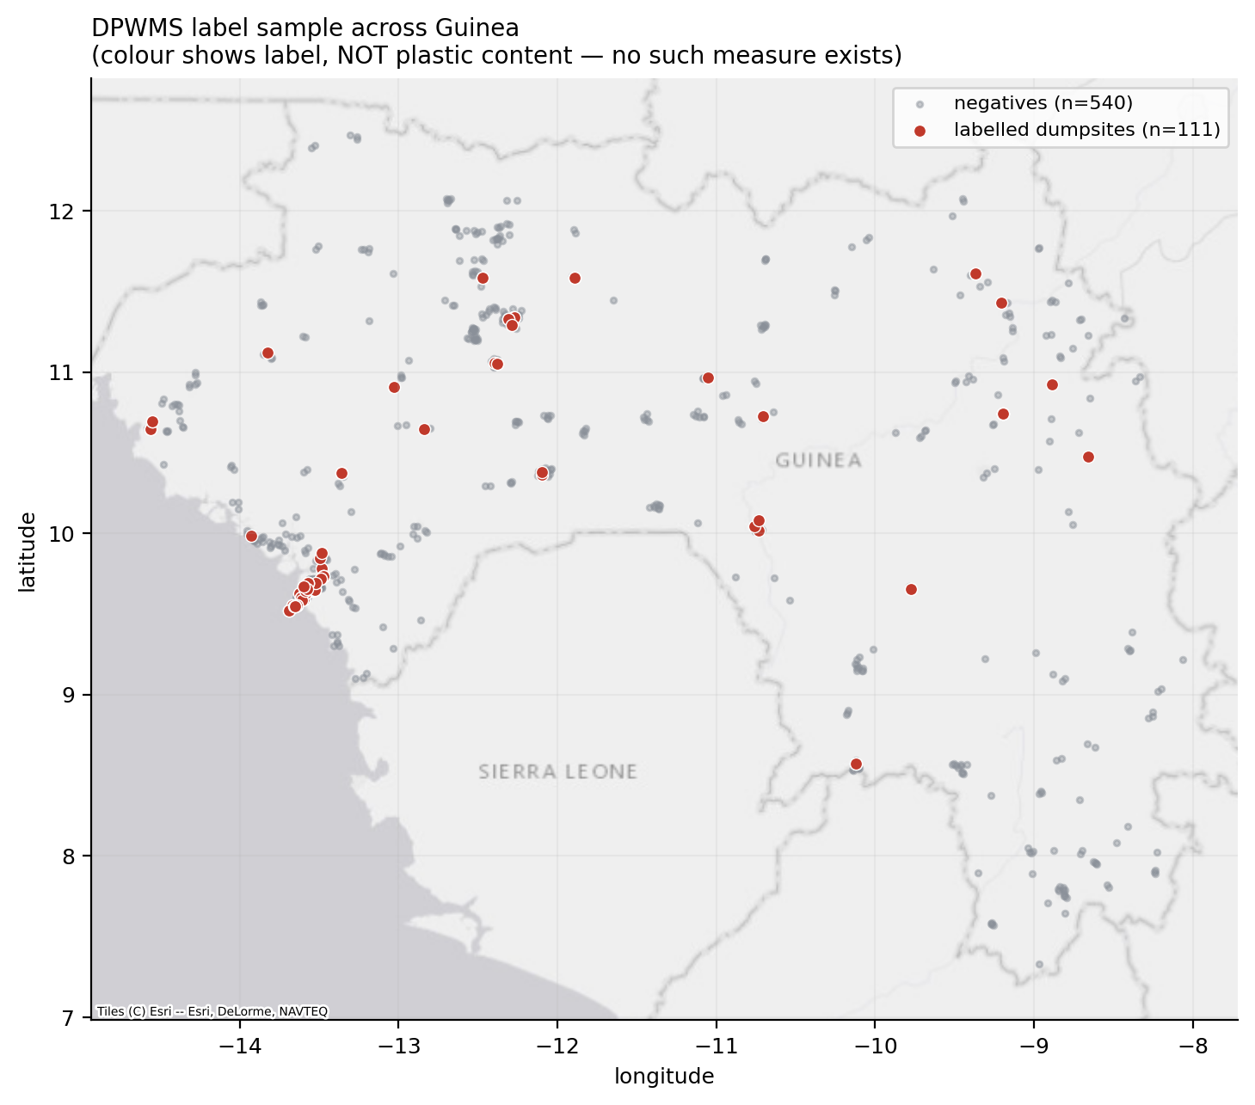
Figure 1. National labelled sample across all eight regions. Colour indicates label only; no plastic content is represented, as none is measurable.
Label confidence is itself a finding and is reported. The annotator recorded most positives as medium or low confidence, with notes such as “could be dumpsite”, and stated explicitly that certainty is not attainable from satellite imagery alone. That is an honest description of the task, and it places a ceiling on achievable measured performance: a model cannot be more consistent than its ground truth. The ceiling is unquantified and quantifying it would require independent re-labelling by a second annotator, which is the most valuable single addition to this work (§9.3).
Three classes of labelling error were found and corrected during the work: three positives that were tree canopy rather than waste, and five duplicate cells arising from random point generation, one pair carrying conflicting labels. All were identified by the annotator on review of model output, which is itself an argument for presenting contact sheets back to labellers routinely.

4. Data and Justification

4.1 Design principle
Every input and every numerical parameter is traceable to a published source or to a documented, measured decision. No threshold was tuned to produce a preferred detection count. The sources are listed with the parameters in §5.
A second principle governs the choice between sensors: each data source is used for what it can physically support. High-resolution RGB supports appearance and extent but cannot identify material. Sentinel-2 supports continuum shape in the shortwave infrared but not the diagnostic absorptions. Hyperspectral supports the absorptions but at coarse ground sampling. The gate structure in §5.3 follows directly from this, and so does the conclusion.
A third constrains deployment: imagery must cover the national footprint at a cost the programme can sustain annually, and every product must be reproducible from open sources or from a documented licensed API.

4.2 Sentinel-2 surface reflectance
For the characterization test reported in Appendix C, the imagery is a dry-season median composite over December to March, 2023 to 2025, below 60% cloud, at 20 m.
Table 4. Sentinel-2 bands used. FDI wavelengths are published by Biermann et al. (2020) and are used as given.
Band | Central wavelength | Role
B3 | 560 nm | NDWI (green); debris classifier
B4 | 664.6 nm | NDVI (red); FDI interpolation wavelength
B6 | 740.5 nm | FDI (red-edge baseline)
B8 | 832.8 nm | FDI (NIR), NDVI
B8A | 864.7 nm | Debris classifier
B11 | 1613.7 nm | FDI (SWIR1 baseline)
B12 | 2202 nm | Debris classifier; plastic indices

Cloud and shadow are masked using the Scene Classification Layer (SCL), and the two components deliberately retain different classes. Component A retains classes 4 (vegetation), 6 (water) and 11 (snow), excluding class 5 (not vegetated: bare soil and built-up). Including class 5 allowed urban rooftops, pavement and bare land to survive the cloud mask and then be thresholded exactly like open water, producing a scatter of false hotspots across dry land on the Conakry peninsula.
The characterisation test (Appendix C) retains classes 4, 5 and 7. For dumpsite work, class 5 is where the targets are. Reusing the marine constant would have masked away most positives and returned a confident null for the wrong reason, which is a failure mode worth naming: a shared configuration constant whose correct value differs by component is a latent source of exactly the kind of null result that looks like a finding.

4.3 Permanent water mask
ESA WorldCover v200 class 80 (permanent water bodies) defines the water population for component A, with class 50 (built-up) dilated by one 20 m pixel subtracted. WorldCover was selected over JRC Global Surface Water (Pekel et al., 2016) occurrence after direct measurement: a GSW-based mask with a 60 m buffer removed the shoreline itself and excluded none of five known infrastructure false positives, whereas the WorldCover formulation excluded three of five while retaining all nine confirmed debris patches in the same test.

4.4 High-resolution RGB basemaps
Table 5. Imagery sources for component B. The comparison between them is reported in §7.2.3 and is what justifies using both.
Source | Zoom | Ground sampling | Cost | Role
Esri World Imagery | 17 | ~1.2 m/px | Free | Stage-1 screen; stage-2 confirmation (deployed)
Google Maps Static API | 19 | ~0.3 m/px | Metered | Stage-2 confirmation (licensed; not deployed)

Esri World Imagery requires no key and is not metered. Its usable zoom ceiling outside Conakry is 17; higher zooms return upsampled pixels. Because resolution was shown not to matter at the working footprint (§7.2.1), that ceiling is not a constraint on the screen.
The Google Maps Static API returns one image centered on a point, so each request is sized so that the returned image covers the analysis window's ground footprint exactly. This makes Esri and Google results comparable by construction, which is a precondition for the paired test in §7.2.3 to be meaningful.
Retention caveat. Cached Google imagery is retained basemap data, and its retention and redistribution are governed by the Maps Platform terms. Cached tiles are excluded from the source repository, and the licensing position must be resolved before any interface serves this imagery onward. Whether derived vector outputs, polygons and scores may be produced and published from this imagery is part of the same determination and is not assumed: the Maps Platform terms also restrict creating content from Google Maps content and using it to train, test or validate machine-learning models.

4.5 Hyperspectral sources
These sources were acquired solely to test whether per-site plastic content can be retrieved from orbit. That test returned a negative result, and no operational layer derives from them. The instruments are listed here for completeness; the test itself is reported in Appendix C.
Table 6. Hyperspectral missions assessed for gate 1. DESIS is excluded on physics rather than coverage.
Mission | Range (nm) | GSD (m) | Bands | Sees C-H? | Access
EMIT | 381-2493 | 60 | 285 | yes | Earth Engine, open
EnMAP | 420-2450 | 30 | 224 | yes | DLR EOC, free account
PRISMA | 400-2500 | 30 | 239 | yes | ASI, no open catalogue
DESIS | 400-1000 | 30 | 235 | no | DLR EOC

DESIS is excluded on physics rather than on coverage: a 235-band cube that stops at 1000 nm cannot observe either C-H feature. Band count is not the relevant property; spectral range is. PRISMA has no open catalogue API and its coverage over Guinea remains unknown, which is an unresolved item (§8).

4.6 Ancillary terrain, rainfall and hydrology
The mobilization model (§5.3.2) draws on five further open datasets and on the WorldCover map of §4.3; Table 7 maps each to the term of the published models it reproduces, or to validation.
Table 7. Ancillary data for the mobilization model. The flood database is used only for validation and contributes to no term of the score, which is what makes that validation independent.
Dataset | Role | Source model term
CHIRPS daily, wet-season months 5-10 | Runoff driving force | Plastic Pathfinder driving force
SRTM 30 m slope | Gravitational driving force | Plastic Pathfinder driving force
ESA WorldCover v200 | Land-cover friction | Plastic Pathfinder resisting force
HydroSHEDS flow accumulation | Distance to watercourse; upstream discharge proxy | Meijer et al. geometric term 1
ETOPO1 bathymetry | Distance to sea | Meijer et al. geometric term 2
Global Flood Database (Tellman et al., 2021) | Independent validation | none - held out

4.7 Labels
All labels were produced by a single annotator using a purpose-built click-through tool over Google satellite basemap imagery.
Table 8. Labelled datasets. Every accuracy figure in this document derives from one of these, and all of them are photointerpretation.
Set | Unit | n | Positive | Purpose
National random sample | 250 m cell | 595 | 55 | Screen training; footprint prevalence
Point samples | 80 m crop | 651 | 111 | Confirmation model training and validation
Conakry blind grid | 80 m window | 422 | 110 | Deployment validation
Boké blind grid | 80 m window | 557 | 243 | Deployment validation, replication (§7.2.8)
Extent annotation | 80 m crop | 55 | 46 usable | Dumpsite size distribution
Marine photointerpretation | S2 patch chip | 36 | 7 | Precision estimation (§7.1.3)
MARIDA benchmark (Kikaki et al., 2022) | S2 pixel | 194,863 | 381 | Benchmark of the rule and the published layer (§7.1.13, §7.1.14)

5. Methodology

5.1 Component A: floating-debris detection

5.1.1 Preprocessing and compositing
Filtered, cloud-masked scenes are reduced to a per-pixel median composite over the analysis window and clipped to the region. Median compositing suppresses residual cloud edges and transient glint. The window is expressed with an exclusive upper bound following the Earth Engine convention, so 2024-01-01 to 2024-02-01 covers January in full.

5.1.2 Index computation
FDI is computed per Biermann et al. (2020) from B8, B6 and B11 with the B4 wavelength in the interpolation ratio; NDVI conventionally from B8 and B4; NDWI is computed but no longer used in the detection rule (§5.1.4). All three are computed twice, once server-side and once locally from the raw bands, and cross-checked. The duplication is a correctness check: the two implementations share no code, so agreement between them establishes that the index as deployed is the index as specified. The cross-check is reported in §7.1.2; the deployed pipeline runs a single path. The water mask is carried as an additional band so that the offline path masks on the same pixels as the server-side graph.

5.1.3 Positive water constraint
Detection is restricted to water pixels, which is a positive constraint. It is not equivalent to the vegetation and open-water exclusions. Earlier versions of this pipeline removed only vegetation and open water, so every remaining non-vegetated, non-water surface survived: bare soil, sand, concrete, port and industrial rooftops. Such surfaces have strong NIR and SWIR reflectance and a large FDI excess, and they were scoring in the highest confidence band.
Requiring that a detection lie on water is what separates floating debris from land. With the index as Biermann et al. define it, vegetated land carries a large FDI excess, because B8 rises steeply above the red-edge baseline; §C.4 shows the index tracking vegetation on land, and §7.1.10 shows the vegetated shoreline that survives the water constraint being removed by the classifier.

5.1.4 Detection rule
The rule follows Digital Earth Africa, and its detections are then filtered by a classifier:
mask to water (WorldCover class 80, minus built-up dilated 20 m)
t_FDI = mean(FDI) + 3σ over all water pixels
t_NDVI = mean(NDVI) + 3σ over the same population
debris = (FDI > t_FDI) AND (NDVI > t_NDVI)
published = debris AND P(debris | MARIDA classifier) ≥ 0.5
NDVI is used inclusively as a debris criterion, not as a vegetation exclusion: Digital Earth Africa require NDVI above its own mean plus 3σ, and Biermann et al. (2020) separate debris classes within the NDVI-FDI plane precisely because debris sits high on both axes relative to seawater. The conjunction carries selectivity. On the Conakry January 2024 composite, FDI alone flags 102,827 pixels; the conjunction with NDVI reduces this to 6,558.
NDWI is no longer used, and open water is no longer excluded. Excluding it left the threshold statistics computed over 12,972 residual pixels instead of 4,524,639. Open water is the background the anomaly is measured against; removing it removes the reference population.
The classifier is a random forest (400 trees, minimum leaf size 2, balanced class weights) trained on MARIDA's published training split (Kikaki et al., 2022) to separate Marine Debris from every other class, using only the twelve features the Guinea fetch provides: seven reflectance bands (B3, B4, B6, B8, B8A, B11, B12) and five indices derived from them (FDI, NDVI, NDWI, FAI (Hu, 2009) and PI). A pixel flagged by the rule is published only where the classifier gives P(debris) ≥ 0.5, the decision boundary of a binary classifier, not a value tuned to Guinea. The second stage is required by the index itself: with the FDI as Biermann et al. define it, vegetation raises FDI and NDVI together, and at Conakry the rule's pixels have a median NDVI of 0.47, with 83% lying within 20 m of land (§7.1.10). Biermann et al. separate such classes with a classifier trained on labelled spectra rather than with a threshold, and MARIDA is the labelled set available. The model is frozen and shipped with the code, so the workstation and the platform load the same file, and each published patch carries its mean P(debris).

5.1.5 Patch vectorization and scoring
The binary detection raster is labelled into 8-connected components and vectorized. Components below 500 m² are discarded as below the minimum mappable area. Each surviving patch carries its area, acquisition metadata and a floating-debris score.
The score is computed from FDI intensity within the patch, so that a small, intensely bright patch outranks a large, marginal one. The previous area-proportional score did the opposite and would have directed field teams to the largest features. Each patch's mean excess over the threshold is normalized against the 95th percentile of excess across all detected pixels in the same scene; normalizing by the threshold magnitude instead saturated roughly half of all patches at 1.0.
The output column is named floating_debris_score. It was renamed from plastic_concentration_score because the original name asserted a material identification the method does not make.

5.1.6 Regional execution
The national product is produced by executing the detection once per region and mosaicking the results, not by a single pass over the full coastal extent. This is a correctness requirement. Because mean plus 3σ is an anomaly threshold measured against a background population, pooling all coastal water into one population yields a single compromise threshold: too high in clear offshore water, where genuine debris is missed, and too low in turbid estuarine water, where noise is flagged. Regional detections would also cease to be comparable with one another. Digital Earth Africa applies the rule per scene for the same reason.
Each patch therefore carries its own region's FDI threshold, NDVI threshold and water-population size as attributes, so the published layer records the provenance of the rule that produced it. The reporting consequence is stated in §7.1.9: patch counts are comparable within a region across months, and between regions only with the regional threshold quoted alongside.

5.1.7 Monthly archive
The Monthly FDI Archive (one of the features on the GEDH platform) exports, per month, the raw reflectance bands alongside the FDI, NDVI and water bands, and applies the identical rule and classifier offline. The archive therefore reproduces the main path exactly (§7.1.2).

5.1.8 Upstream extension: river corridors
The detection rule is defined against a local water population, so it can be applied anywhere that population can be estimated. Extending it upstream required three changes, each forced by a failure of the coastal assumptions.
First, the analysis unit. A bounding box drawn around a river is mostly land, and a threshold estimated over such a box is taken over a mixture. River reaches are therefore clipped from HydroRIVERS v1.0 (Lehner and Grill, 2013; channel widths after Andreadis et al., 2013) at a discharge screen of 25 m³ s⁻¹, buffered by ±250 m to absorb centerline error — the HydroSHEDS 15 arc-second product carries a few hundred meters of positional uncertainty — and analyzed as corridors.
Second, fetch geometry. A corridor is not a rectangle, and a raster export is rectangular regardless of the geometry requested. Measured across Guinea's twenty systems, corridor-to-bounding-box bloat ran 10–300×; the worst case required a 61,772 km² fetch to analyse a 203 km² corridor, and the twenty systems together implied compositing 252,497 km², an area larger than Guinea. Reaches are therefore grouped into tiles by snapping reach centroids to a grid sized so that a filled cell approximates an existing coastal AOI (~2,500 km²). A winding river becomes a chain of small tiles tracing its path. Total fetch area falls to 80,752 km² and no single fetch is unbounded.
The trade-off of this approach is that each tile now carries its own threshold, not each river system. A river split into nine tiles has nine independently estimated thresholds. That is less efficient than pooling, and pooling remains a documented next step.
Third, the water-population guard. The coastal guard refuses an AOI below 10% water by area. The floor is a project convention, set from the observed behavior of the threshold statistic, which becomes unstable once the water population falls to a few tens of thousands of pixels. Every river corridor fails it by construction: a corridor is wide because the centerline is imprecise, not because the box is misplaced. Applying it unchanged would refuse every river in the country. The guard was therefore split into two tests with different purposes: a fraction test, which catches a box drawn in the wrong place and is advisory for corridors, and a count test, which catches a population too small to estimate a mean and a standard deviation from and is binding everywhere. The count floor is 1,000 pixels, at which the relative standard error of a standard deviation is about 1/√(2n) ≈ 2.2%.

5.1.9 Further guards
Two further guards apply to every tile that runs, because a threshold can look valid and still be meaningless.
- A missing water mask is not a pass. A tile with no water mask has no population from which to derive a threshold; it is reported as not assessed, never as a measurement of zero debris.
- An NDVI threshold can falsify its own water population. NDVI is (NIR−Red)/(NIR+Red) and is confined to [−1, 1] by construction, so a mean+3σ NDVI threshold outside that interval is proof that the pixels called water are not water — typically nodata and scene-edge fill, where NIR+Red approaches zero and the ratio diverges. Such a tile is reported as not assessed. In the January 2024 run three tiles failed this test and none lacked a water mask (§7.1.12).
The second test is an algebraic bound on the index itself and needs no calibration. Both are reported because a guard that silently passes missing data is a more serious defect than one that is too strict.

5.1.10 Supervised evaluation and the debris classifier
No labelled marine debris exists for Guinea, which is why the rule is an unsupervised anomaly detector. MARIDA (Kikaki et al. 2022) supplies labels elsewhere — pixel-level annotation of 63 Sentinel-2 scenes — and, more useful than its debris class, it separately labels Dense and Sparse Sargassum, Natural Organic Material, Foam, Ship, Wakes, Turbid Water and Sediment-Laden Water. These are precisely the materials that an anomaly rule over tropical water is at risk of confusing with debris.
The rule is applied unmodified. The evaluation calls the deployed index computation directly, so the benchmark scores the code that produces the operational layer and no divergence can open between what is evaluated and what runs. The threshold is derived per scene, as the pipeline derives one per AOI, and is not fitted to MARIDA. The benchmark is used to measure the deployed rule, not to train it: fitting the threshold to MARIDA would report how well the rule could perform after tuning, whereas the quantity required here is how the untuned rule performs as it runs in Guinea. The FDI arm alone and the full FDI-and-NDVI rule are both evaluated, and the classifier fitted to MARIDA is evaluated in §7.1.14, alone and as the second stage of the published layer.
A learned comparator is fitted alongside: a random forest over the eleven reflectance bands and six spectral indices, and a second restricted to the twelve features the Guinea fetch provides, which is the one deployed (§5.1.4), both using MARIDA's published split. Two properties of the comparison are load-bearing. Comparisons are made at matched recall — the forest's probability cut is moved until it finds the same fraction of true debris the rule finds, and the two are then compared on precision — because comparing a probabilistic model to a binary rule at an arbitrary cut compares operating points, not methods. And results are reported twice: on the full test set, and on geographically held-out tiles only, because 91% of the published split's test patches share a Sentinel-2 tile (in the Military Grid Reference System, MGRS) with the training set and a model can therefore recognise a location rather than a material.

5.2 Component B: dumpsite detection

5.2.1 Linear probe and object detector
With 111 labelled dump points, an object detector (like the Guatemala model) cannot be trained or honestly validated: the parameter count exceeds the sample size by orders of magnitude, and any reported accuracy would reflect memorization. This is the same reasoning that recommends linear probes under label scarcity (§2.2).
The adopted model is a logistic regression over 2048-dimensional global average-pooled features from a frozen ImageNet ResNet-50. Class weights are balanced. The inverse regularization strength C, which sets how strongly large coefficients are penalized, is selected by blocked inner cross-validation within each training fold, never on the test fold.
One methodological trap is recorded because it is easy to fall into and invisible in results. A color-histogram representation initially appeared competitive with ImageNet features. This was an artefact of holding C fixed: a single penalty term penalizes a 2048-dimensional representation far more heavily than a 19-dimensional one. With C tuned per representation by nested cross-validation, the apparent parity disappeared.

5.2.2 Analysis window
The analysis unit is an 80 m square window, rendered at 800 pixels. §7.2.2 gives evidence for this choice, which is the single most consequential decision in the workflow.
All grids are anchored to a global lattice at (-180°, -90°). A tile identifier is therefore a pure function of position on Earth: the same ground always receives the same identifier and the same footprint, in any scan area and on any run. This makes the imagery cache valid across runs, prevents adjacent scan cells from purchasing overlapping ground twice, and guarantees that every window is a full 80 m footprint. A clipped window would present the model with a different ground scale and an incomparable score.

5.2.3 Two-stage cascade
Scanning every 80 m window across the national footprint would require millions of requests. The cascade reduces this by screening with free imagery first.
Stage 1, the screen. Every 250 m cell of the footprint is scored on free Esri imagery. Cells scoring below 0.3 are discarded. This stage is deliberately the settlement detector diagnosed in §7.2.2: its only task is to discard empty country at zero cost, and it is judged on recall, not precision.
Stage 2, confirmation. 80 m windows within surviving cells are scored on free Esri imagery with a classifier fitted on Esri crops, which is the deployed configuration, or on licensed Google imagery with the Google-fitted classifier. A classifier is used only with the imagery source it was fitted on: applied to the other source it returns near-zero scores everywhere, without error. Only this stage's output is reported as a detection.
The screen's cost is explicit and permanent. At the operating threshold it retains 85.5% of true sites and discards 14.5% before stage 2 ever sees them. End-to-end recall is therefore stage 1's retention multiplied by stage 2's recall at the operating tier, never stage 2's recall alone, and any recall figure that reaches a document must say so.

5.2.4 Site formation
Adjacent flagged windows in the same confidence tier are dissolved into single polygons, so that a high-scoring window cannot label a block of lower-scoring windows as high. A site's confidence is the maximum over its constituent windows, not the mean: a dump partly covered by a weak window should not be penalized for the window's edge placement. Area is computed in hectares at each polygon's own latitude.
Windows whose imagery could not be retrieved score as missing, never as zero. A tile that could not be seen is not evidence of absence and scoring it zero would silently convert an imagery gap into a negative detection. Counts of unexamined windows are reported with every scan.

5.2.5 Confidence tiers
Following the precedents in §2.6, detections are published with their score and a tier label.
Table 9. Confidence tiers for the dumpsite layer. The tier is a display filter applied after scanning: nothing is discarded, and it can be retuned without re-scanning or re-purchasing imagery.
Tier | Threshold | Role
High | ≥ 0.90 | Field prioritization
Medium (default) | ≥ 0.70 | Analyst review queue
All | ≥ 0.50 | Maximum recall; lowest precision

The thresholds are published in the model's metadata file rather than embedded in code, which is what makes retuning a configuration change instead of a code change.
The medium tier is the default because, with free imagery at stage 2, the high tier finds only 6% to 21% of the sites present and the lowest tier falls close to the base rate (§7.2.11).

5.3 Dumpsite extent and waste mobilization

5.3.1 Dumpsite extent measurement
Site extent had not previously been digitized for Guinea, and it is required because every argument in this document about pixel filling depends on how large a site is relative to a pixel. An automated estimate was attempted first, profiling brightness and local texture in concentric annuli around each labelled point and measuring where the profile returns to background. Three radius estimators were tried against criteria fixed before inspection: dumps must read clearly larger than non-dumps, and results must not be mostly censored at the frame edge.
All three failed, and the encircled-excess estimators, which are the principled choice for a diffuse source, failed instructively by scoring non-dumps larger than dumps. With no central peak, a control's excess is background noise spread across the whole frame. The script therefore refuses to emit pixel-count figures from a failed estimator, and extent was measured manually instead. The failure is recorded because an unsupported extent figure would have propagated into every subsequent argument.
Fifty-five positive cells were then annotated manually on 80 m point-centered crops at 0.1 m per pixel, recording a bounding box, an explicit flag for sites exceeding the crop, and a flag for sites the interpreter could not judge. Of these, 46 yielded usable measurements; 9 were excluded as unclear and 0 were rejected as not dumpsites.
Because a single interpreter produced these, a blind second read of a random subsample of 12 sites was carried out as a reproducibility check. The second reader saw the crops with a metric grid and did not see the first-pass values until both were recorded. The subsample was not stratified by size, which would have conditioned it on the values under test. The second read was made by the same interpreter, re-measuring blind against the crops without sight of the first-pass values. It is therefore a reproducibility check on one interpreter's measurement procedure and not an inter-rater agreement estimate, which would require a second interpreter and is not available, and it is reported as such.

5.3.2 Waste mobilization modelling (component D input)
Characterization asks what a dumpsite is made of, which requires a per-site material measurement no satellite can supply. Mobilization asks where waste goes, which is a function of terrain, rainfall and drainage, all directly observable. It sidesteps the unmeasurable quantity, and it is the concept note's own Waste Flow and Mobilization Modeling activity.
Two published model families (§2.4) are reproduced in reduced form. The implemented score is:
risk = mass × P(mobilise) × P(reach watercourse) × P(reach ocean)
Table 10. Terms of the mobilization score and their sources. The mass term is a waste proxy, not a plastic one; see §8.
Term | Data source | Role
Wet-season rainfall | CHIRPS daily, months [5, 6, 7, 8, 9, 10] | Runoff driving force
Terrain slope | SRTM 30 m | Gravitational driving force
Land-cover friction | ESA WorldCover v200 | Resisting force (Plastic Pathfinder)
Distance to watercourse | HydroSHEDS flow accumulation | Meijer geometric term 1
Distance to sea | ETOPO1 bathymetry | Meijer geometric term 2
Waste mass proxy | Measured size class (§7.3) | Source strength

The model is validated against an entirely independent observable. Calibrating a plastic emission model requires observed plastic flux, which Guinea does not have; the mobilization mechanism itself, however, can be checked against observed flooding. The Global Flood Database (Tellman et al., 2021) holds MODIS-derived flood extents for eight rain-driven events over Guinea. A dumpsite that has been inundated has demonstrably had water move through it, and the flood data are independent of every terrain, rainfall and drainage term the score is built from. This is the only component of the module validated against something other than photointerpretation.

5.4 Component D: plastic leakage estimation
Components A and B answer where material is. Component D answers how much is generated and how much escapes, which is the quantity the concept note's leakage indicator requires and the one no detection layer can supply. The distinction of provenance is maintained throughout: satellite detection measures where material is; gravimetric sorting on the ground measures what share of it is plastic; terrain and hydrology models say where it goes. Component D is the bookkeeping that connects the second to the third, and it contains no pixel.

5.4.1 The workflow
Population is carried through six multiplications:
- generated = population × rate × 365.25 [t yr⁻¹ MSW]
- plastic = generated × plastic share
- uncollected = plastic × (1 − collection), split urban/rural
- burned = uncollected × open-burning fraction — destroyed, not leaked
- to environment = (uncollected − burned) × leakage fraction + collected × litter rate
- to water = to environment × transport probability
The fourth step is the one that distinguishes this from a naive estimate. 'Uncollected' is routinely treated as a synonym for 'leaked', which it is not: in low-income settings most uncollected household waste is burned in the open or buried in a household pit, and burned plastic is destroyed as macro-debris — it becomes an air-quality and health problem instead, which this module does not attempt to quantify. Cottom, Cook & Velis (2024) find open burning (Wiedinmyer et al., 2014) to be the dominant fate of uncollected plastic across the Global South, exceeding unburned debris emissions. Omitting the step roughly doubles the answer and is the most common reason national leakage estimates come out too high.

5.4.2 Population density surface
WorldPop's gin_pd_2020_1km_UNadj product is a population density surface — persons per square kilometer — not a count per pixel, and the '1 km' in its name invites the opposite reading. The correction is applied here. Adding its pixels gives 15.70 million against a 2020 population of about 13.13 million. The gap is geometry: the grid is 0.00833° (30 arc-seconds), which is about 0.93 km north–south and 0.91 km east–west at Guinea's latitudes, so a pixel covers roughly 0.84 km². Density is therefore multiplied by each pixel's true area, computed on the WGS84 ellipsoid and varying with latitude. The error is silent and inflates every downstream tonnage by a fifth in the direction that makes the problem look worse.

5.4.3 Urban and rural
The split exists only because the collection survey is reported that way, and the two rates are far apart: 23.7% urban against 2.1% rural (JICA 2022, via the World Bank What a Waste database (Kaza et al., 2018)). Collapsing them to the 9.7% national average would discard the structure that drives the spatial pattern. The threshold follows the UN-endorsed Degree of Urbanization (Dijkstra et al., 2021; Pesaresi et al., GHS-SMOD), which sets an urban cluster at ≥300 persons km⁻² and an urban center at ≥1,500. The survey does not state which definition its 'urban area' matches, so the choice is treated as uncertainty and sampled across that range. DEGURBA's spatial contiguity rule is not applied, because the mask only has to route each pixel to one of two collection rates; the simplification is recorded.

5.4.4 Regional uncertainties
The obvious way to combine regional uncertainties is the square root of the sum of squares. That is wrong here, and wrong in a way that worsens the more finely the country is subdivided. Quadrature assumes independent errors; these errors are not merely correlated but identical. Every region is driven by the same national generation rate, the same plastic share, the same collection survey, the same burning fraction. If the true plastic share is 15% rather than 4%, it is 15% in Boké and Kankan and Conakry simultaneously. Regional errors move in lockstep instead of partially cancelling, so quadrature manufactures spurious cancellation — and dividing a country into more pieces cannot make its total better known.
Uncertainty is therefore propagated by Monte Carlo with each national parameter drawn once per iteration and applied to every region and pixel in that iteration. Regional totals then sum exactly to the national total within each iteration, and the correlation is carried by construction. §7.6 reports the size of the error this avoids.

5.4.5 Plastic share as a scenario
One parameter moves the answer by more than all the others combined, and it is not propagated as a distribution. Guinea's only nationally representative waste composition figure gives plastic at 4.0% of municipal solid waste, from a 2007 UNSD collection; recent characterization for Conakry gives 15–22%. Averaging over that disagreement would produce a number belonging to neither world and would conceal that the disagreement is about evidence. Every result is therefore reported under each scenario separately, with the range visible.

5.4.6 Per-site allocation
The mobilization model of §5.3.2 ranks detected sites by how likely their contents are to reach a watercourse, using a dimensionless size-class mass proxy. It can say site A outranks site B; it cannot say how many tons either contributes, which is the question a clean-up budget is written against. Component D attaches tons by catchment allocation: the population within 5 km of a site — the distance band used in the UNEP/IUCN hotspot guidance, consistent with informal disposal served by head loading and handcart rather than municipal haulage — run through the same chain.
Two properties are deliberate. Catchments overlap, and summing independently computed catchments would push the site total above the national total, an impossibility that would nonetheless look plausible in a table; each pixel's population is therefore divided among the sites claiming it. And no mass is estimated from imagery: §7.3 measured these sites at roughly 14 m across, sub-pixel at Sentinel-2's 20 m shortwave-infrared bands, and Appendix C found no polymer absorption feature at these scales, so there is no spectral route from an image to a mass. Multiplying area by an assumed depth and density would produce a number whose precision is fictitious. The satellite contributes to the location, which is what it measures.

5.5 Statistical treatment
Average precision is reported, because ROC-AUC is optimistic under class imbalance (Saito and Rehmsmeier, 2015). The no-skill baseline for average precision is the positive prevalence, not 0.5, and it is stated wherever an average precision is quoted. Confidence intervals come from a cluster bootstrap resampling whole label cell, because one cell can contribute several dump points and points within a cell are not independent. For component B the resampling unit is a 250 m spatial block rather than a window: windows within a block overlap the same ground and resampling them independently would treat correlated observations as independent and yield intervals far too narrow.
Comparisons between methods use a paired bootstrap computing the difference within each replicate, because comparing overlapping marginal confidence intervals is a known error (Schenker and Gentleman, 2001). Model comparisons use 2,000 resamples. Any fitted model is evaluated under spatial blocking (Roberts et al., 2017). For component B the blocks are 1 km. For the Sentinel-2 index tests the blocks are the eight administrative regions. For the hyperspectral test the block is the dumpsite itself, so that a site appearing in several scenes lands wholly in one fold; blocking on scene or detector row would leak a site between training and test.
One post hoc choice is declared. Index orientation was selected after the fact: both an index and its negation were scored and the better reported. This is a two-way selection on the same data and mildly inflates absolute values. It does not affect the conclusions, which rest on relative comparisons against controls scored under the identical rule.

5.6 Implementation
The module is implemented in Python as plasticwaste_tool, reusing the shared infrastructure established by the Land Use module, namely Earth Engine service-account authentication, Azure Blob caching, Key Vault secrets and OSM ingestion. Each component is a subpackage: fdi_tool, dumpsite_tool and characterisation_tool, behind a single stable interface module that the platform backend calls.
The detection logic is deliberately independent of the data-fetch layer so that it can be executed and tested offline on arrays, and a synthetic end-to-end self-test exercises the full chain without network access. Both the server-side Earth Engine graph and the offline NumPy path implement the same rule and dispatch on the same configuration key, which is what makes the cross-check in §7.1.2 meaningful.

6. Validation and Accuracy Assessment

6.1 Why one figure cannot describe the whole module
No figure in this document is validated accuracy in the sense used by the Land Use and Deforestation modules, and the reasons differ by component.
Component A is unsupervised. There is no training set, no held-out test partition, and therefore no AUC, no confusion matrix against truth and no cross-validated accuracy. No field-verified plastic-accumulation points exist for Guinea. Three responses to that situation are possible: reporting no accuracy evidence at all is defensible but uninformative; reporting photo-interpretive evidence with its limits stated is defensible and is what is done here; and reporting a metric computed by comparing the detector against points derived from its own output is not defensible and is addressed in §6.2.
Component B is supervised and does produce cross-validated metrics, but three distinct problems make any single figure from them misleading. First, spatial dependence, addressed by 1 km blocked cross-validation throughout. Second, prevalence mismatch: the evaluation set is 17.1% positive by construction, because positives were sampled per dump pin and negatives per cell, whereas a sliding 80 m scan over the footprint has an estimated prevalence near 2.1%; precision measured at evaluation prevalence is therefore optimistic by a large factor, and both are reported. Third, task mismatch — scoring a model on curated crops when it is deployed on an unselected grid — is the most serious; it was identified only once a blind grid was labelled and is the subject of §6.3.
The characterization test has no ground truth at all, by construction: there is no plastic-fraction measurement for any Guinean site. Its validation is therefore internal, resting on controls, blocking and the convergence of independent methods, and the one externally validated output is the mobilization model (§5.3.2).

6.2 Component A
All 26 patches published on the Conakry reference scene were reviewed, by full enumeration, so that precision carries no sampling uncertainty. Ten randomly located unflagged water locations were reviewed as a recall-side control. Each chip was a Sentinel-2 true-color crop padded to twice the patch extent for context.
For each location the interpreter recorded a label (positive, negative or ambiguous), an interpreter’s confidence, a material guess and a free-text note on what was visible. Ambiguous was available deliberately and used freely: at the 20 m analysis scale, where patches average 8.7 pixels, a large fraction of detections genuinely cannot be adjudicated, and forcing a binary call would manufacture false confidence. Ambiguous patches are excluded from the precision denominator, and the excluded count is reported alongside. Because that convention is favorable, a worst-case figure counting every ambiguous patch as a false positive is also reported, which is a lower bound on the true value.
A circular metric was identified and excluded, and it is recorded here because it was reported internally before being caught. The review points are centroids of the detector's own patches. Passing the confirmed positives back through a reference-point precision and recall function therefore measures nothing: every point lies inside a patch by construction, so recall is 1.0 trivially and precision is the positive rate divided by all detected patches. During development this produced a recall of 1.0 and an F1 of 0.726 with no caveat attached, because the provisional-sample warning was suppressed at n of 30 or more. The function now refuses input carrying review columns, and the reference and photo-interpretation results are held in separate keys in the exported metrics so they cannot be conflated. No reference-point accuracy figure is reported in this document.

6.3 Component B
The evaluation design distinguishes two tasks:
Crop classification. “Is this 80 m crop a dumpsite?”, scored on point-centred crops where each positive is centered on a coordinate a human selected. This is what the ROC-AUC 0.911 figure measures.
Blind-grid detection. “Where are the dumpsites in this area?”, scored on every window of a regular grid, with no human having pre-selected anything. This is what deployment performs.
A model that is good at the first is not necessarily good at the second, and the difference is quantified in §7.2.6. Blind-grid validation required a separately labelled dataset: all 422 windows of a 2.4 by 1.3 km Conakry area, labelled exhaustively, none used in training.

6.4 Material characterization
A negative result carries a different evidential burden from a positive one. A positive must exclude confounds; a negative must exclude the possibility that the test was simply too weak to detect a real effect. Three design features address that.
Controls are matched rather than random (Appendix C), so a null cannot be explained by having compared dumps against terrain they never occupy. Controls with no plastic sensitivity, NDVI and NDBI, are scored under the identical rule, so the plastic indices are measured against a benchmark rather than against zero. And the test is repeated by four independent routes, vegetation indices, the plastic-mulch family, the floating-debris index and a full 218-band hyperspectral classifier, so that a null from any one of them is corroborated rather than isolated.
The measured dumpsite extent (§7.3) then supplies the mechanism. A negative result with no explanation invites the reading that the method was inadequate; a negative result accompanied by a measurement showing the target is sub-pixel at every capable sensor is a different kind of claim.

6.5 Reported metrics
For component A:
- Photo-interpreted precision by confidence band, with the ambiguity rate declared and paired upper and lower bounds (§7.1.3).
- Benchmark precision and recall of the rule and of the published layer on MARIDA's labelled test pixels, on all pixels and on geographically unseen tiles (§7.1.13, §7.1.14).
- Index verification: agreement between server-side and offline computations of the same indices, and between the archive and main composite paths (§7.1.2).
- Threshold sensitivity: change in mapped area and patch count under a plus-or-minus-10% perturbation of both thresholds (§7.1.6).
- Threshold-method consistency: confirmation that every scene in a published batch resolved to the intended rule with no silent fallback (§7.1.7).
For component B: ROC-AUC; average precision with the no-skill baseline stated; precision and recall at each operating tier, on both the point-centered and blind-grid tasks; and, for model comparisons, paired block bootstrap intervals over 2,000 resamples.
For the characterization test (Appendix C): average precision against a stated prevalence baseline, with cluster-bootstrap intervals; per-band and multivariate separability with and without brightness; rank of the diagnostic features among all bands; and, for the mobilization model, ROC-AUC against observed flooding with a permutation p-value.

7. Results

7.1 Component A: floating debris on water

7.1.1 Conakry reference scene
The reference scene fixes the working numbers that later comparisons are made against. The rule resolved to an FDI threshold of +0.06804 over a water population of 4.52 million pixels and flagged 6,558 pixels, of which the classifier kept 242, returning 26 patches covering 9.04 ha at a mean patch area of 0.35 ha. Both thresholds are properties of this scene: they are re-derived for every region and every month, so no value in this table transfers to another scene unless its own threshold is quoted alongside it.
Table 11. Detection summary, Conakry area of interest, January 2024. Thresholds are derived from this scene's own water population and are not transferable to other scenes or dates.
Quantity | Value
Detection rule | de_africa_3sigma, then MARIDA classifier (P(debris) ≥ 0.5)
FDI threshold | +0.06804
NDVI threshold | +0.09524
Water population | 4,524,639 px
Rule pixels kept by the classifier | 242 of 6,558
Patches detected | 26
Total mapped area | 9.04 ha
Mean patch area | 0.3477 ha
Largest patch | 2.04 ha
Mean debris score | 0.683
Confidence distribution | High 13, Medium 12, Low 1
SAR fallback recommended | No

Both thresholds are positive, as in Digital Earth Africa's published run (0.0409 and 0.2721); here the FDI threshold is about 1.7 times higher and the NDVI threshold about three times lower. Each threshold is set by the variability of its own scene's water, so the difference reflects the two water populations rather than an error, and it is why a published threshold cannot be imported.
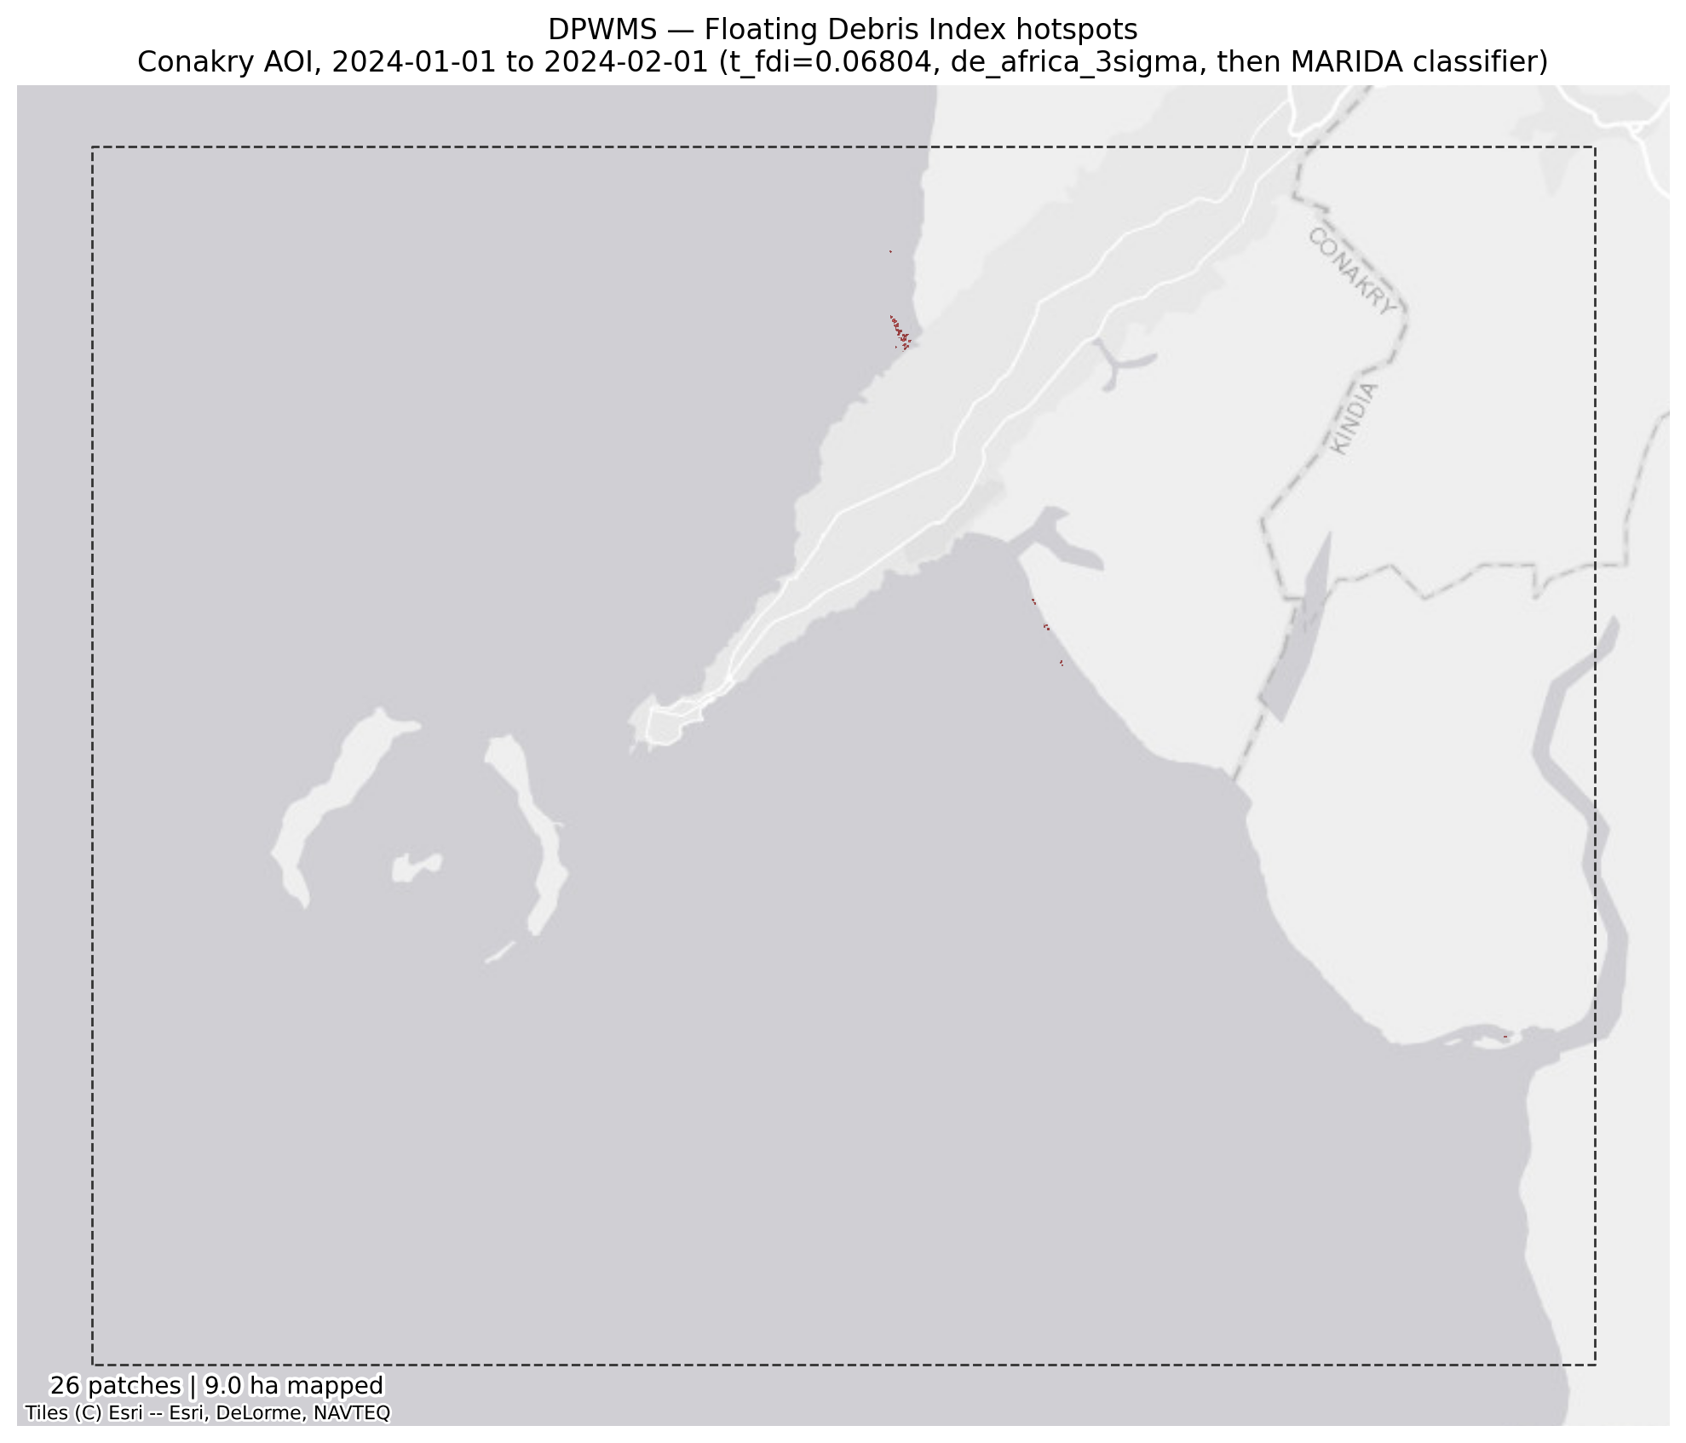
Figure 2. Published floating-debris patches, Conakry area of interest, January 2024. Patches are small and coastal; the largest is 2.04 ha, about 0.001% of the area of interest.
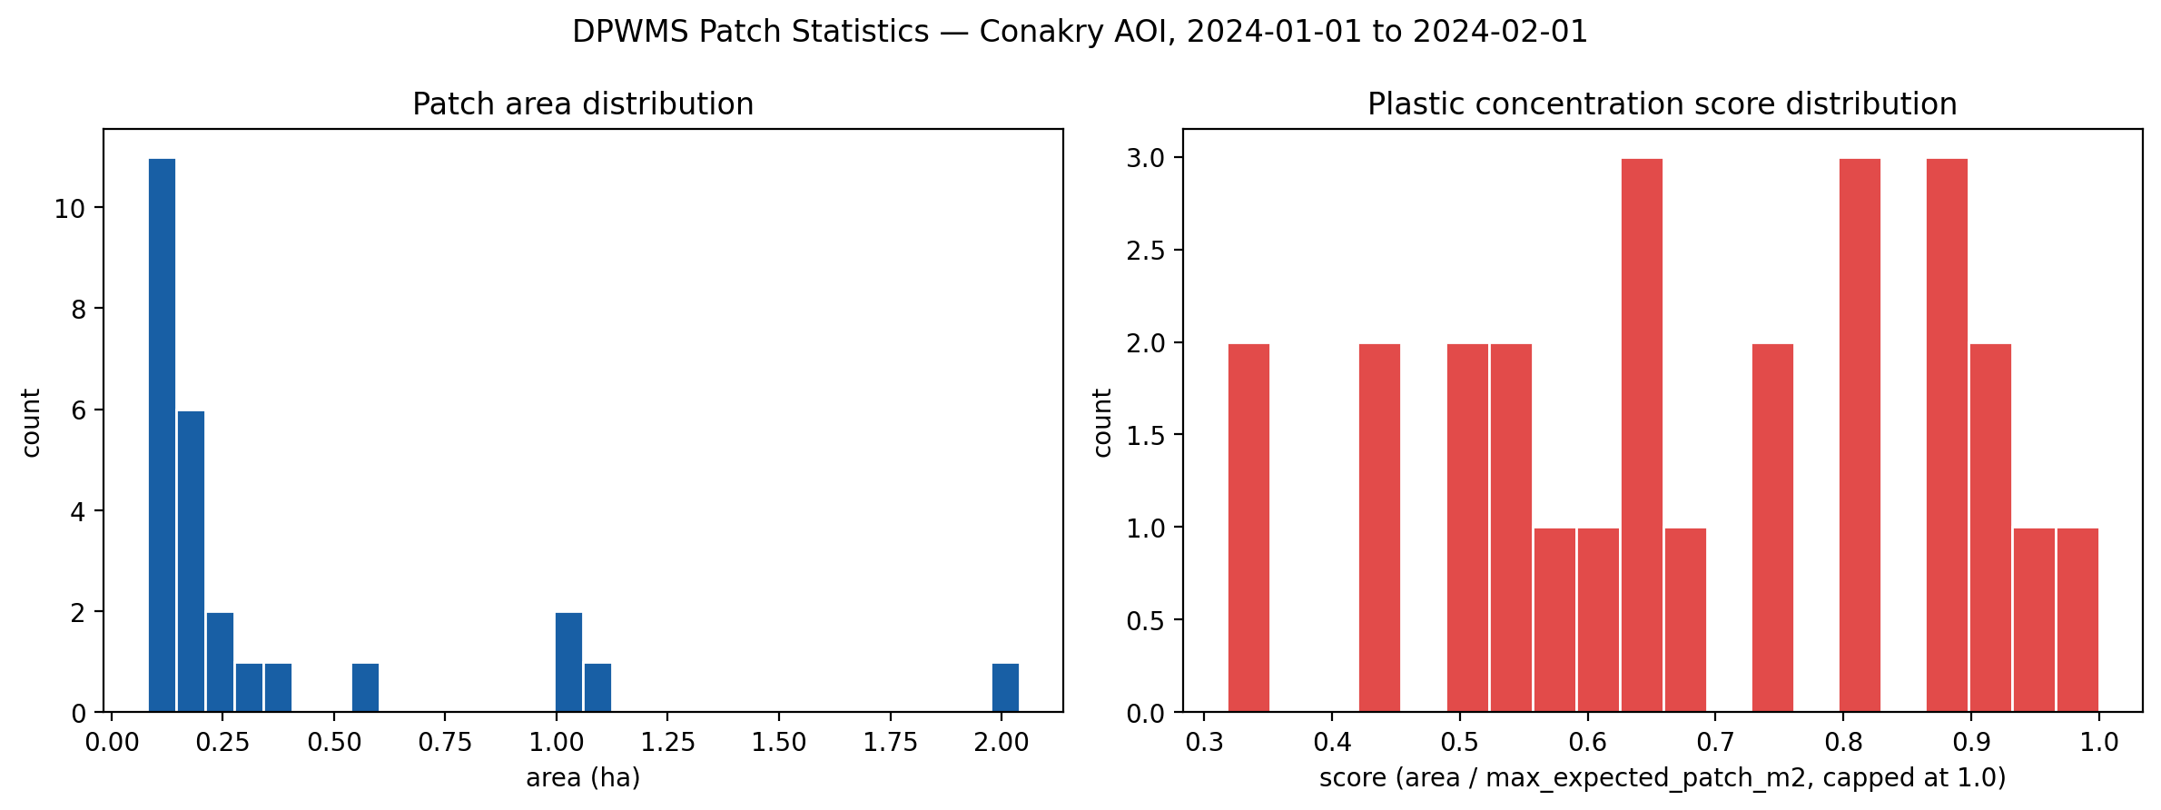
Figure 3. Patch-size and debris-score distribution. Patches average 8.7 pixels at 20 m, close to the practical limit of visual adjudication, which is the direct cause of the 27% ambiguity rate in §7.1.3.
The detection set is dominated by small patches close to the resolution floor, which is what limits how many of them can be adjudicated from imagery alone.

7.1.2 Index and path verification
Three checks compare pairs of paths that share no code, so agreement between them tests the implementation. The index recomputed offline from raw bands matches the server-side computation to within floating-point tolerance, and the monthly-archive path reproduces the main composite path exactly on patch count and area. These establish that the deployed layer is the layer this document describes; they are not evidence about detection accuracy, which is addressed separately below.
Table 12. Internal verification. Each row compares two independently computed paths, and agreement is the evidence. Each of these checks failed at some point during development and each failure revealed a genuine defect.
Check | Result | Interpretation
FDI: offline recompute vs Earth Engine | max |Δ| = 5.96e-08; mean |Δ| = 1.16e-09 over 5,169,355 px | Floating-point equivalence. The two implementations agree.
Monthly archive vs main composite, same month | 26 patches / 9.04 ha on both paths; 0.00% difference | Independent confirmation: the main path recomputes indices locally from raw bands, the archive reads Earth Engine's own index bands.
Sensitivity population vs published detection | 226 px / 26 patches on both | The robustness check measures the detector that is actually published.

7.1.3 Photo-interpreted precision, Conakry
Precision is reported as a bounded interval by confidence band, because 7 of the 26 patches could not be adjudicated at this resolution. Excluding ambiguous patches from the denominator gives 36.8%; counting every one as incorrect gives 26.9%, a lower bound; counting every one as correct would give 53.8%, an upper bound.
Table 13. Photo-interpreted precision by confidence band, full enumeration of all 26 patches on the Conakry scene. “Precision” excludes ambiguous patches from the denominator; “worst case” counts every ambiguous patch as a false positive. The worst case is a lower bound; the precision column assumes ambiguous patches are debris at the same rate as decided ones.
Band | n | Positive | Negative | Ambiguous | Decided | Precision | Worst case
High | 13 | 2 | 8 | 3 | 10 | 20.0% | 15.4%
Medium | 12 | 5 | 4 | 3 | 9 | 55.6% | 41.7%
Low | 1 | 0 | 0 | 1 | 0 | — | 0.0%
All | 26 | 7 | 12 | 7 | 19 | 36.8% | 26.9%

The confidence bands do not rank the patches. The high band is the weakest, at 20.0% on ten decided patches against 55.6% for the medium band on nine, and the single low-band patch is ambiguous. With so few decided patches per band the ordering is not established either way, so on this evidence the confidence level must not be used to prioritize field visits.
The ten unflagged control locations returned no debris-like material (three negative, seven ambiguous), so there is no evidence of obvious misses. That is not a recall figure: there is no positive denominator.
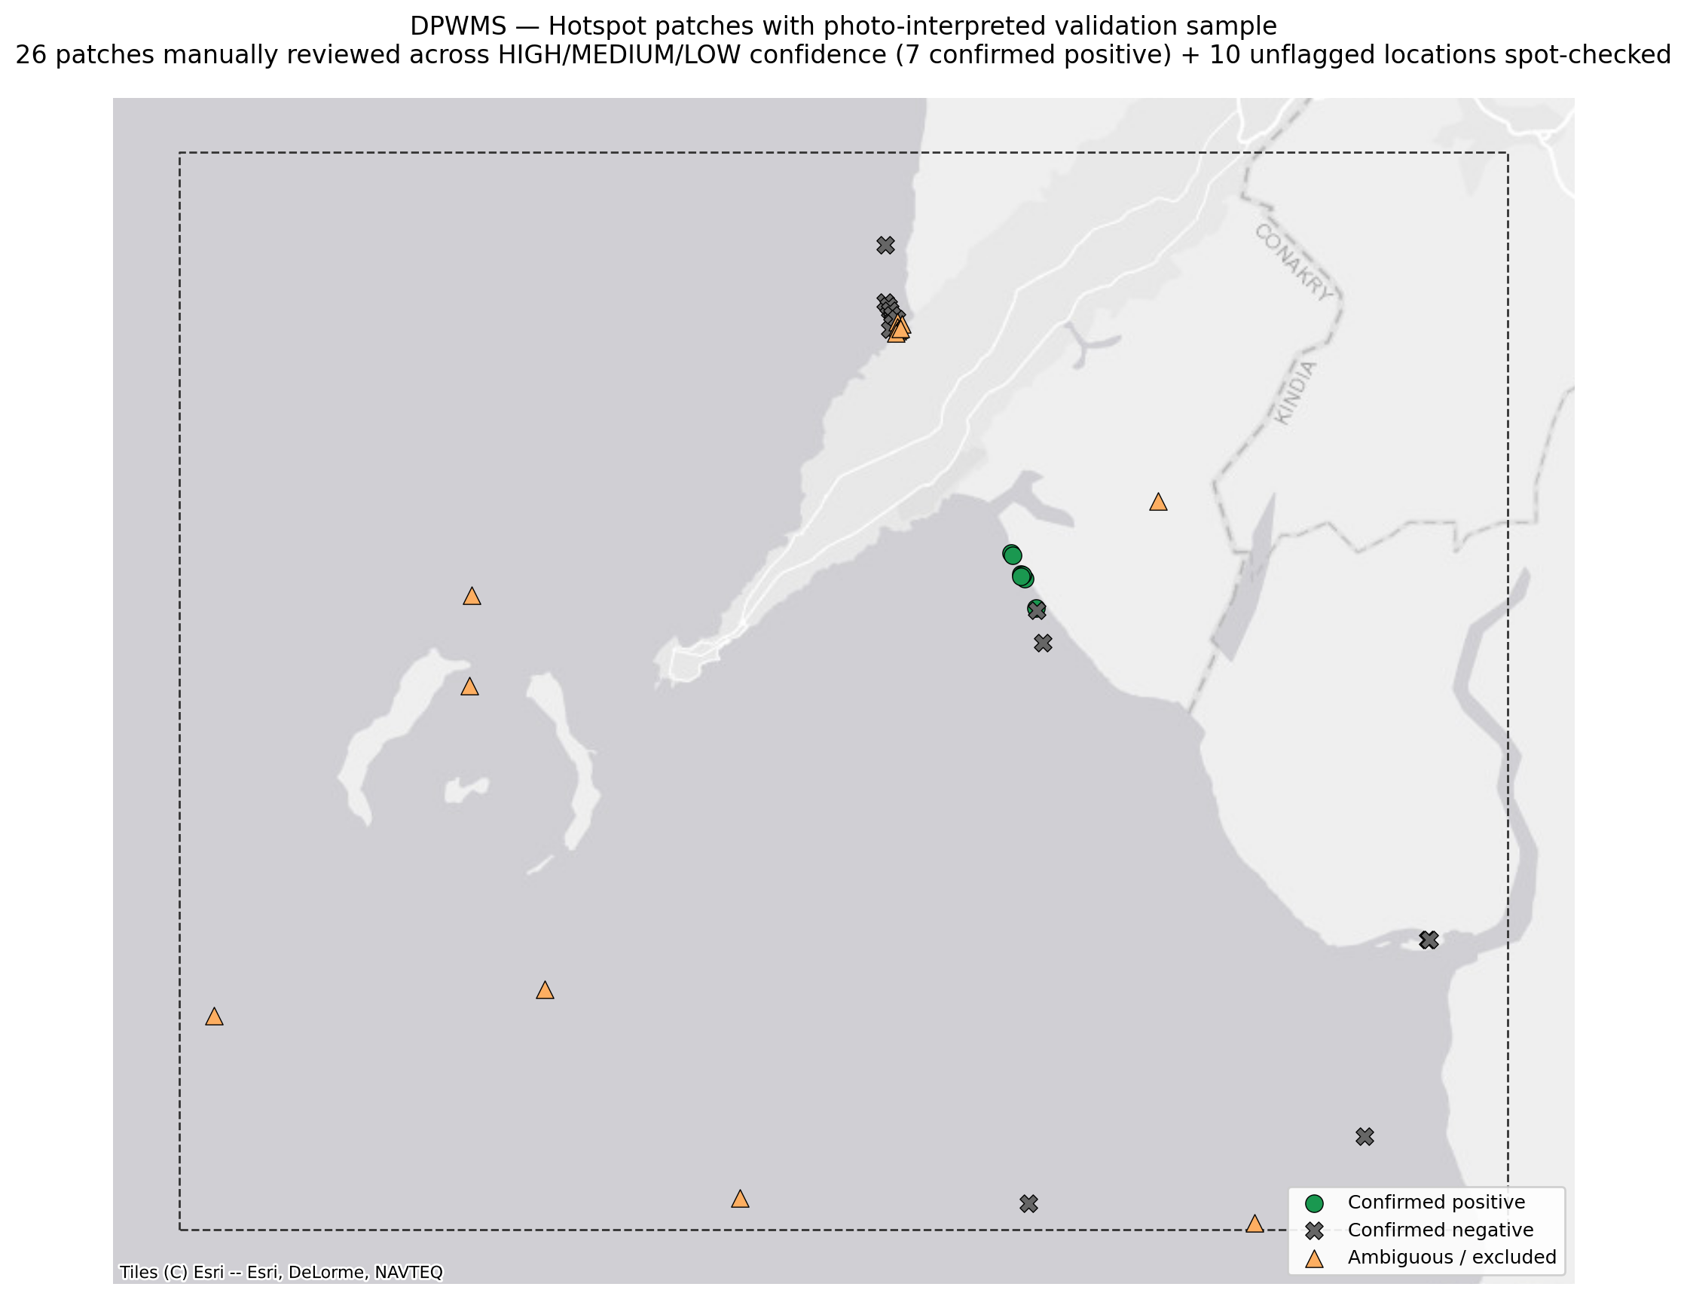
Figure 4. Published patches with the photo-interpretation outcome overlaid: confirmed positive, confirmed negative, and ambiguous. Every negative is near-shore water, the spatial signature of the mechanism in §7.1.4.

7.1.4 Characterization of false positives
The interpreter recorded all twelve confirmed negatives as coast area: near-shore water in which the outlined patch does not differ visibly from the water around it in the monthly-median chip. None was recorded as infrastructure, a vessel, turbidity or open water. Whether these patches are false detections or floating material below what a 10 m monthly-median chip can show cannot be settled by eye; they are counted as negatives because nothing visible supports them.
Table 14. The interpreter's material calls on the 12 confirmed negatives and 7 ambiguous patches, Conakry. A single class accounts for all of them.
Interpreted material | n | Addressable by masking?
Coast area (near-shore water), negative | 12 | No — the pixels are water
Infrastructure over water | 0 | No — quays and jetties genuinely are on water
Open water / turbidity | 0 | No — spectral ambiguity, not a masking failure
Vessel | 0 | No — requires vessel detection
Coast area (near-shore water), ambiguous | 7 | —

The distinction matters operationally. None of the negatives is a structure or vessel built over water, the class no water mask can remove; all are near-shore water. The classifier has already removed the vegetated shoreline the rule flags (§7.1.10), so the remaining negatives are not land leakage either. Structures over water remain a permanent property of the layer wherever they occur (§7.1.5, §8).

7.1.5 Port exclusion: built, tested, and rejected as a filter
A port-and-harbor exclusion zone is built from OpenStreetMap features (harbor, pier, quay, dock, breakwater, ferry terminal) buffered by 150 m. Removing detections inside it would be a filter with a cost, because harbors are where floating waste accumulates, so the zone was tested against the labelled Conakry patches before any decision was made.
Table 15. Photo-interpretation outcome inside and outside the OSM port exclusion zone, Conakry, January 2024. One reviewed patch lies in the zone.
Patches | In port zone | Outside port zone
Confirmed positive | 0 | 7
Confirmed negative | 0 | 12
Ambiguous | 1 | 6
Precision (decided) | — | 36.8%

In January 2024 a single published patch lies in the zone, and it is ambiguous, so this month gives no evidence either way on what the zone would remove. Removing harbor detections would delete part of what the layer exists to find wherever debris collects against quays, and a hard mask leaves no trace of what it removed.
Patches are therefore flagged with in_port_zone and published, not dropped. The flag is surfaced as an attribute so an analyst can filter on it and a reviewer can audit what a filter would have removed, which a hard mask does not allow. On the national layer, 1 of 30 patches (3.3%) carries the flag, in Conakry.
One caveat on coverage: OpenStreetMap is uneven in Guinea. A region containing a known port that returns no flagged patches indicates missing OSM data, not a clean port, and should be checked before the flag is relied upon.

7.1.6 Threshold sensitivity
Perturbing both thresholds by ten per cent simultaneously moves the patch count by +23.1% and -46.2% and mapped area by +102.2% and -61.9%, in the expected direction. The response is monotonic but large: raising the thresholds removes nearly half the patches. A reported patch count therefore inherits a relative uncertainty of the order of tens of per cent from the threshold that produced it.
Table 16. Sensitivity to a plus-or-minus-10% perturbation of both thresholds simultaneously. Patch count is the decision-relevant quantity for a hotspot map: mapped area can shift while the same locations remain flagged.
Perturbation | FDI threshold | Area (px) | Δ area | Patches | Δ patches
-10% | +0.06123 | 457 | +102.2% | 32 | +23.1%
base | +0.06804 | 226 | - | 26 | -
+10% | +0.07484 | 86 | -61.9% | 14 | -46.2%

A 10% threshold change produces a 23% to 46% change in patch count. The failure mode this check is designed to detect is a large or non-monotonic swing, which indicates the threshold is landing in a dense part of the distribution and that the detection should be treated as provisional for that date and area. The swing here is monotonic but large, so the January 2024 Conakry count carries that qualification.
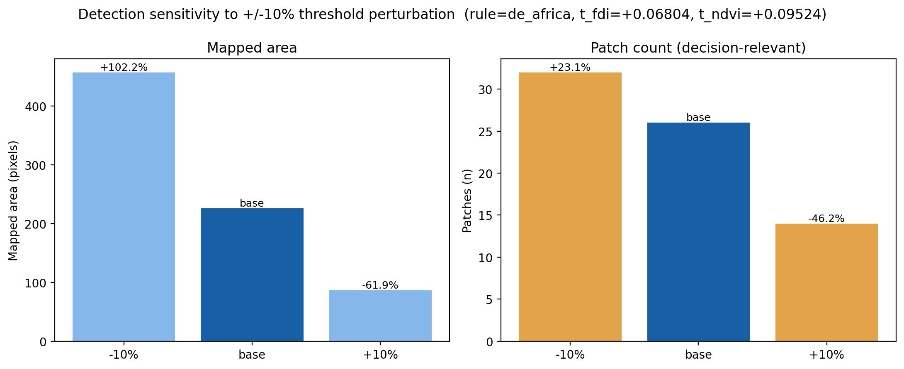
Figure 5. Mapped area and patch count under plus-or-minus-10% threshold perturbation. The patch-count panel is the one to read for operational purposes.

7.1.7 Monthly archive
Each month derives its own threshold. The FDI thresholds of the three back-run months are close (+0.06804 to +0.06981); the NDVI thresholds differ more (+0.09524 to +0.14795). Patch counts do not follow the thresholds simply: December, with the highest NDVI threshold, has no published patches, while November has 44. A month-on-month change in count therefore mixes real change in the water with movement of the criterion, and the series cannot be read as a trend unless the thresholds are displayed with it.
Table 17. Monthly archive back-run, Conakry. Every month resolved to the intended mean plus 3σ rule with no fallback and none returned an empty water population, which is the threshold-method consistency check of §6.5 passing. Note that each month has its own threshold.
Month | FDI threshold | NDVI threshold | Patches | Area (ha)
2023-11 | +0.06969 | +0.11487 | 44 | 10.56
2023-12 | +0.06981 | +0.14795 | 0 | 0.00
2024-01 | +0.06804 | +0.09524 | 26 | 9.04

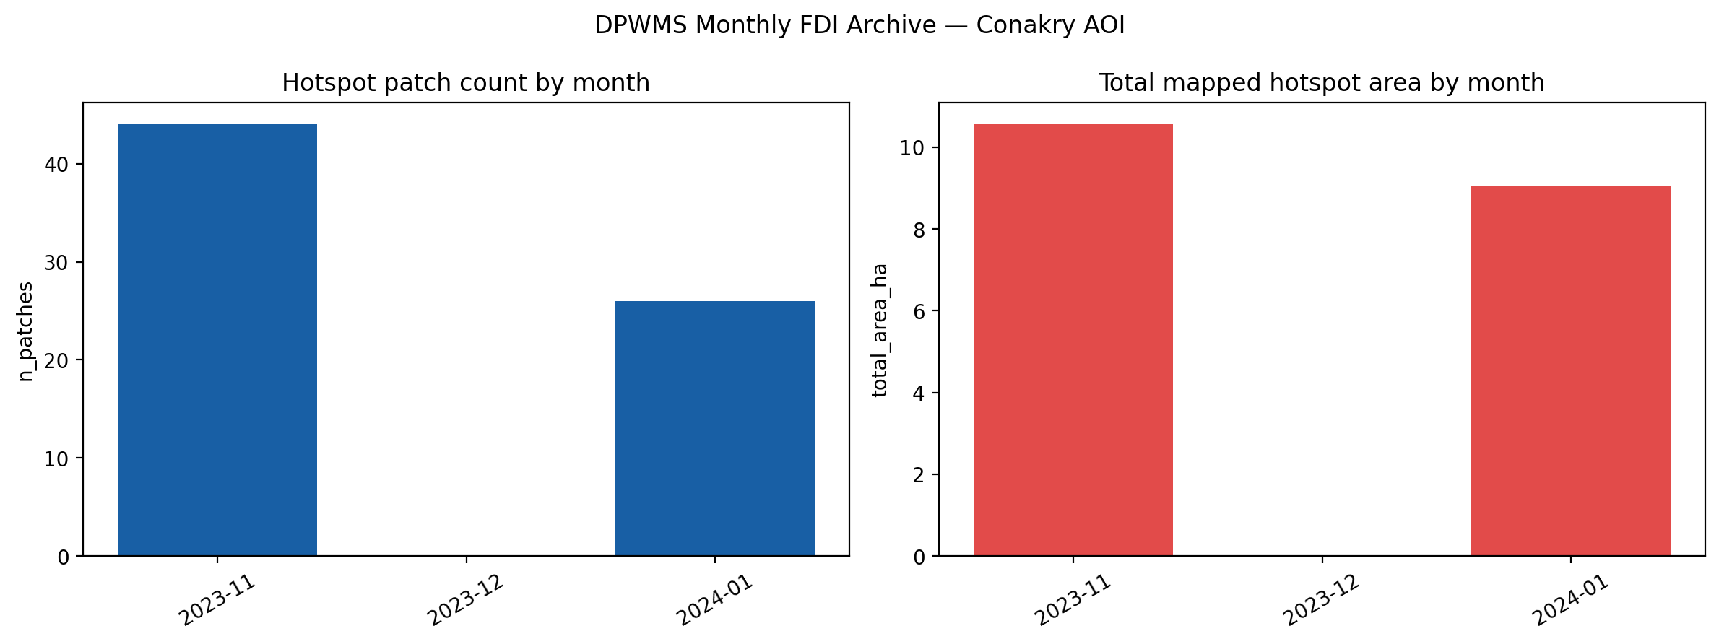
Figure 6. Monthly patch count and mapped area, Conakry. Read alongside the table above: the three months use different thresholds, so this is not a like-for-like time series.
A caveat governs the trend figure, and it is a property of the method. Each month derives its own threshold, by design, because that is what makes the rule an anomaly detector. The series therefore compares counts produced under three different criteria, and the movement from 44 patches to none and back to 26 mixes real change in the scene with movement of the detection thresholds. The archive should be presented with the per-month thresholds displayed alongside each count or additionally recomputed under one fixed reference threshold for a like-for-like series.

7.1.8 Outlier verification
A dominance check flags any month in which a single patch accounts for more than 10% of that month's mapped area, on the basis that one outlier can move the monthly total by itself. Only January 2024 is flagged. Its largest patch was photo-interpreted against the true-color composite, and November's largest patch is shown for reference.
Table 18. Outlier-patch verdicts. Verdicts are recorded in manual_qa/fdi/outlier_verdicts.md.
Month | Largest patch | Share of month | Verdict | Confidence | Interpretation
2023-11 | 1.04 ha | 9.8% | — | — | Below the dominance flag; shown for reference
2023-12 | — | — | — | — | No published patches
2024-01 | 2.04 ha | 22.6% | Ambiguous | Medium | Near-shore water with land in view (patch_HIGH_8 in §7.1.3)

The January verdict is the honest outcome for the month's dominant patch: it belongs to the same near-shore class as most of the January review and cannot be adjudicated at 10 m. The January total of 9.04 ha should therefore be quoted with the review's precision bounds (§7.1.3), not as a measured area of debris.
December has no published patch to verify, and November's largest patch falls below the dominance flag, so neither month requires an outlier verdict.
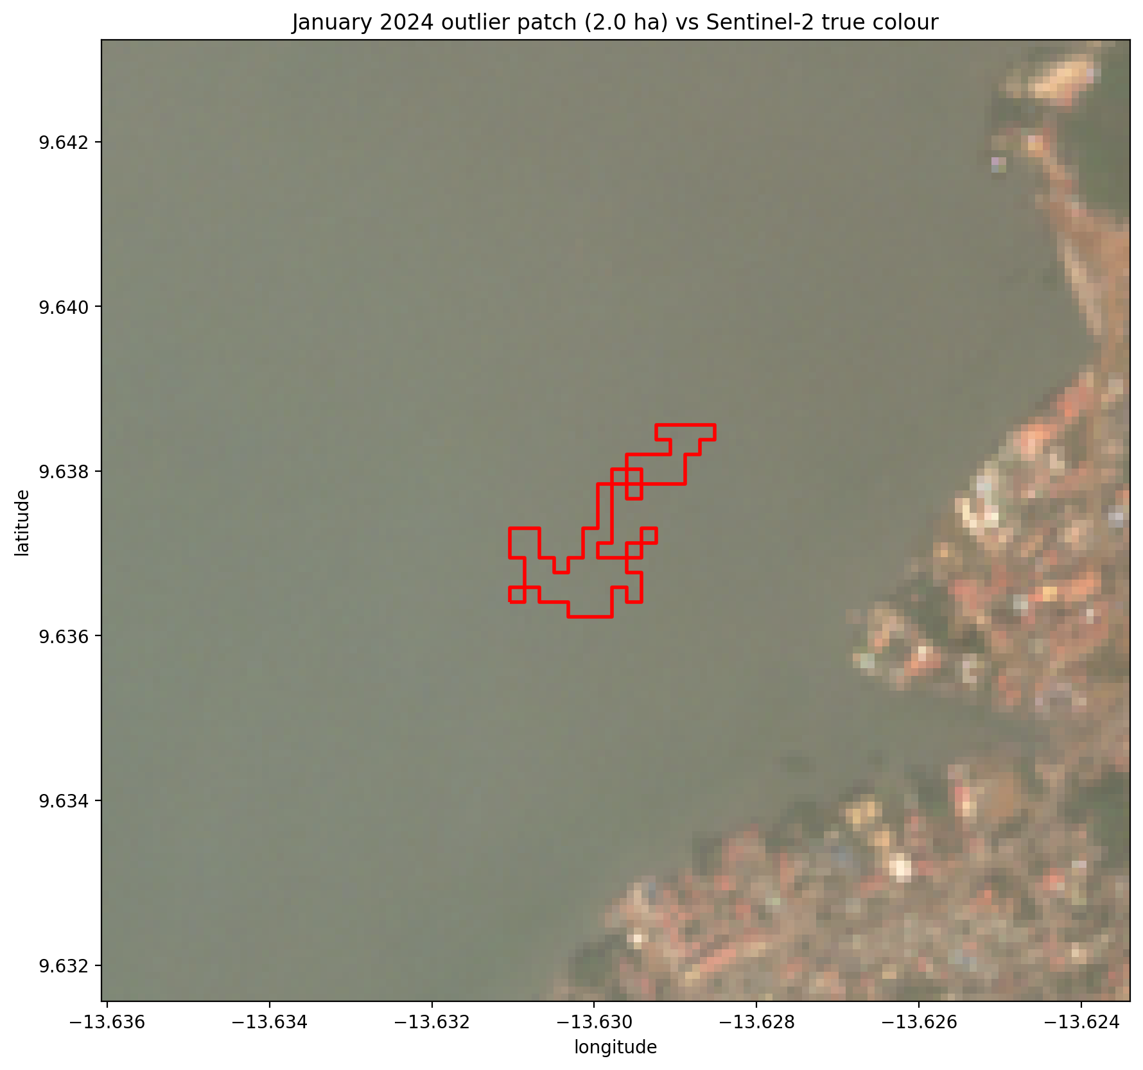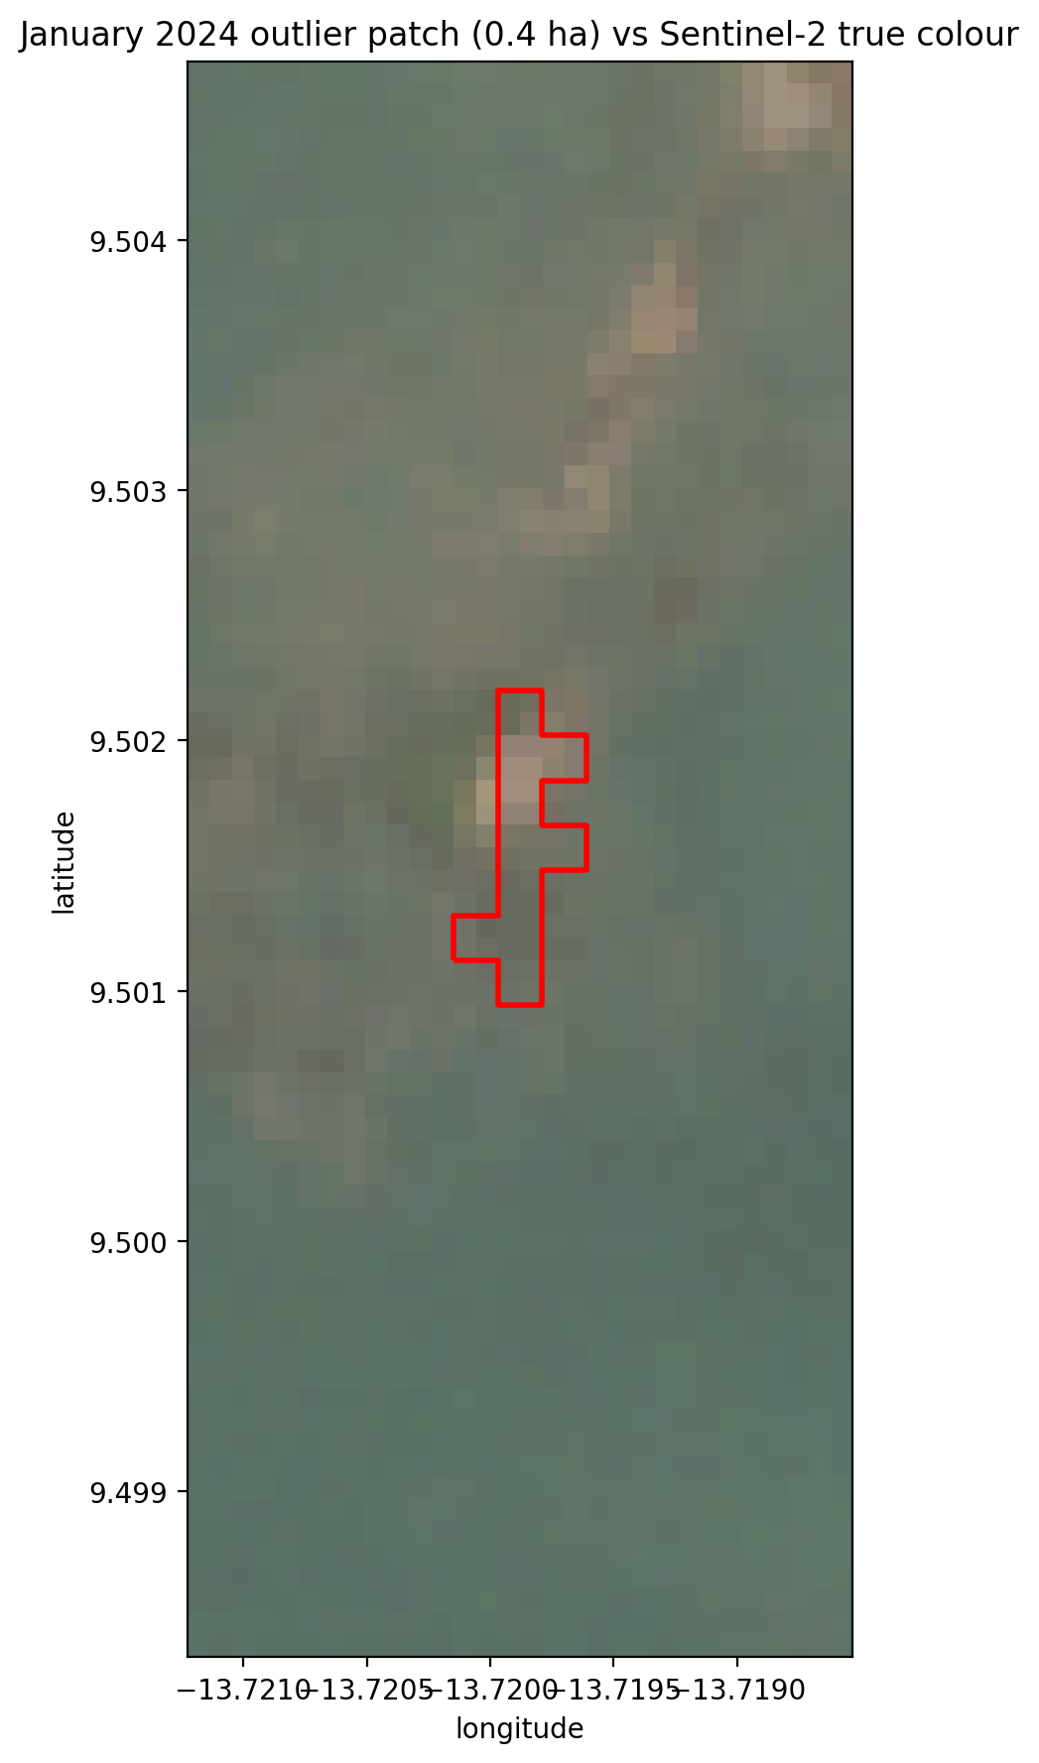
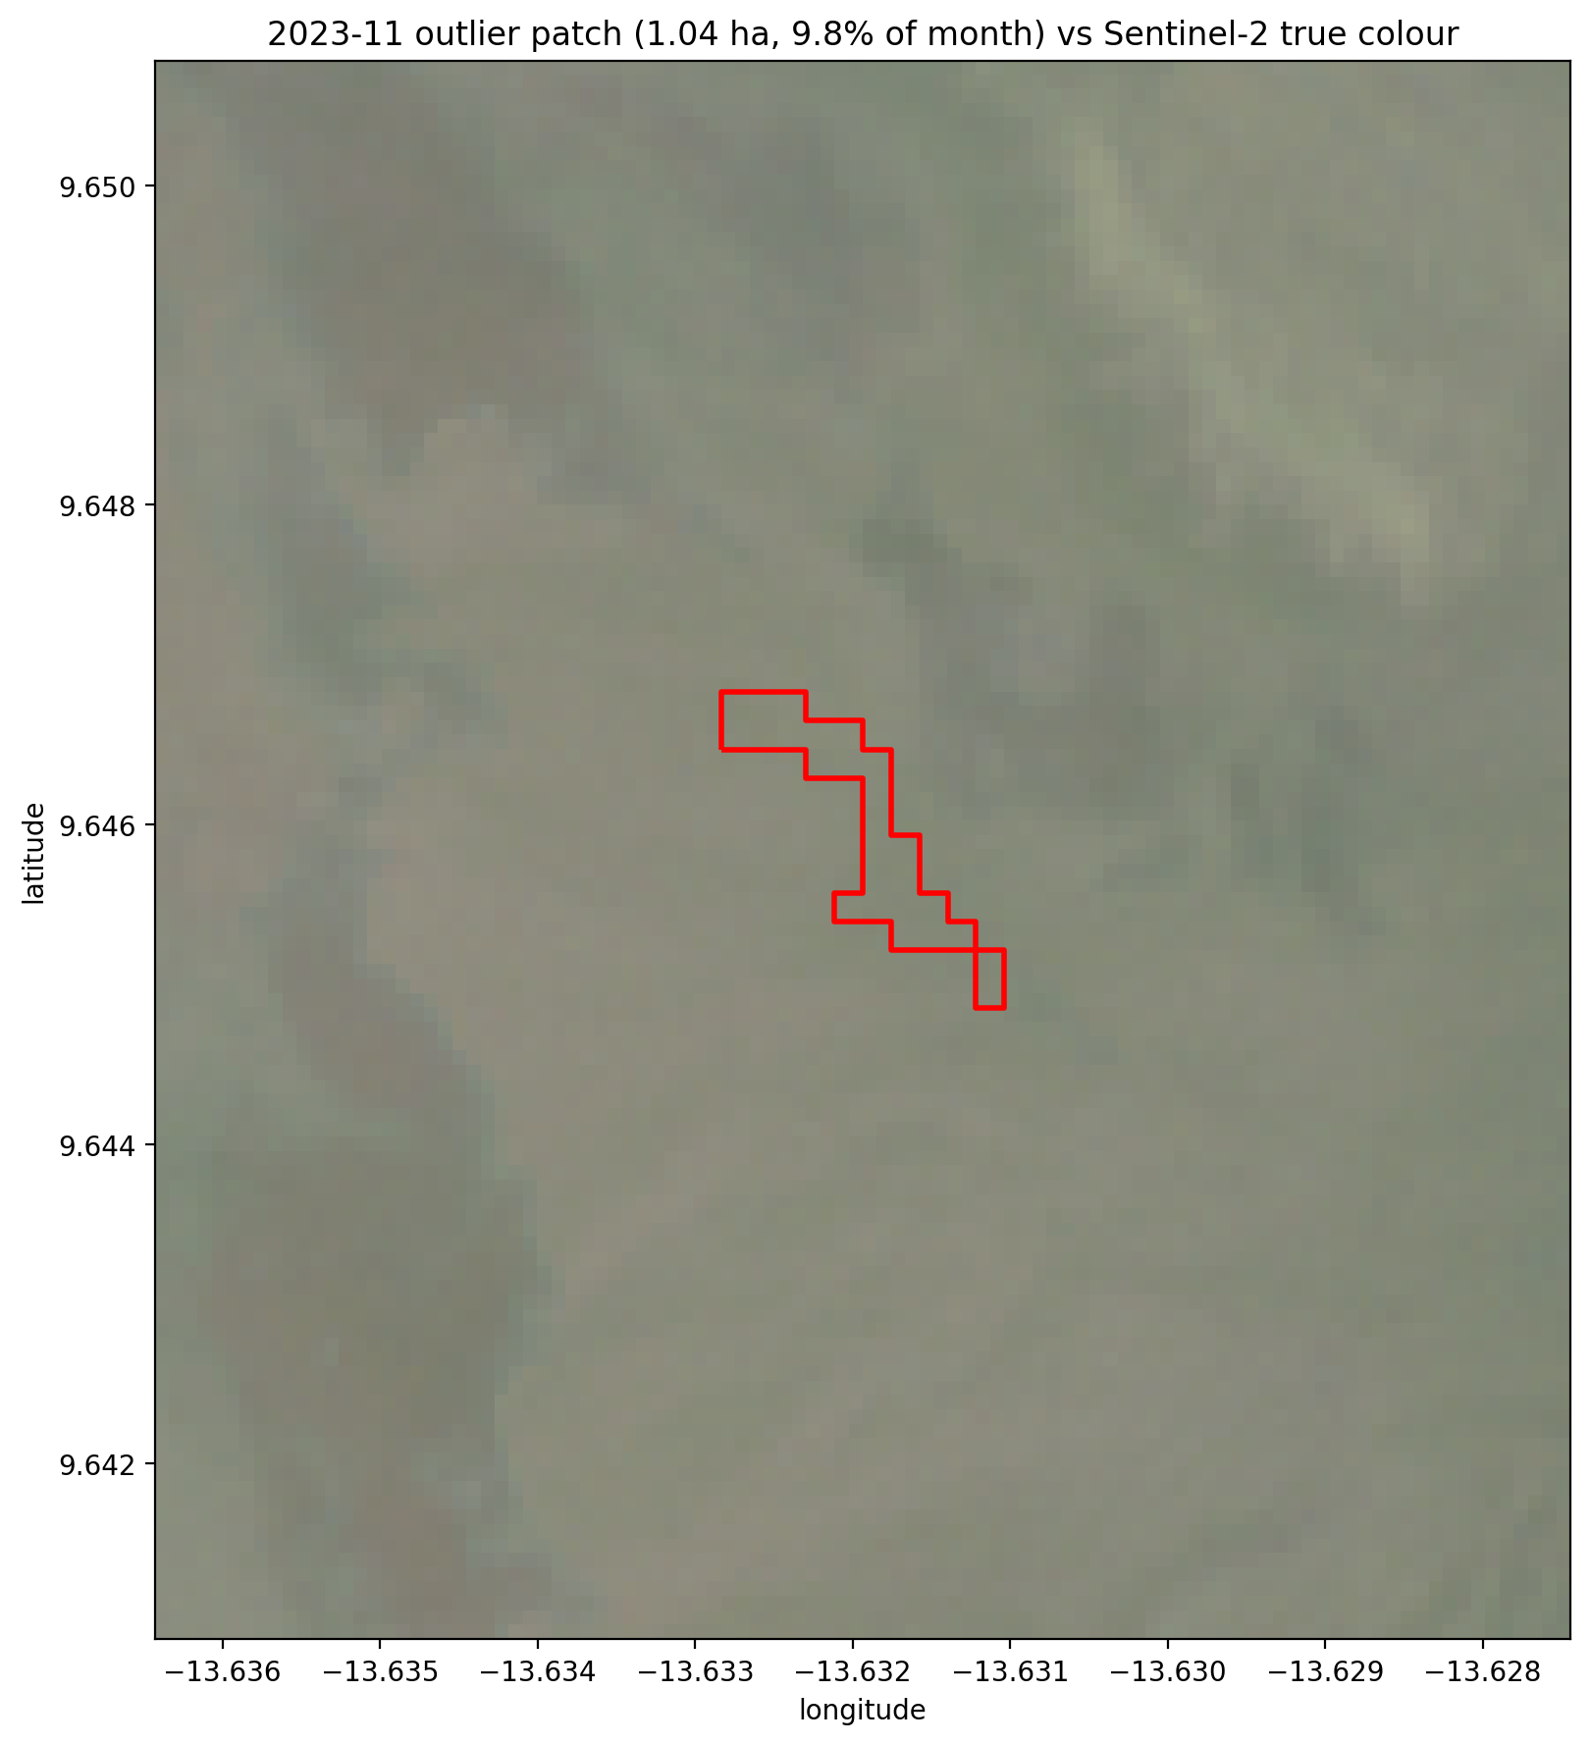
Figure 7. Dominant monthly patches against the Sentinel-2 true-color composite. January 2024 (top), the month flagged by the dominance check, interpreted as ambiguous; November 2023, below the flag, shown for reference.

7.1.9 National coastal run
The national product executes the detection per region and mosaics the result. All four regions were completed without error.
Table 19. National coastal run, January 2024; all four regions were assessed. Each region's thresholds are derived from its own water population and are carried as attributes on its patches. Counts are comparable within a region across months, and between regions only with the regional threshold quoted alongside.
Region | t_FDI | t_NDVI | Water population (px) | Water share of AOI | Patches | Area (ha)
Conakry | +0.06804 | +0.09524 | 4,524,639 | 73.0% | 26 | 9.04
Konkouré | +0.04842 | +0.14914 | 6,020,562 | 53.9% | 0 | 0.00
Fatala | +0.09674 | +0.08633 | 601,331 | 15.8% | 4 | 0.44
Southern offshore | +0.04304 | +0.07403 | 5,042,469 | 32.5% | 0 | 0.00
Total | - | - | - | - | 30 | 9.48

The spread of thresholds across regions is the clearest illustration of why the rule is applied per region. The highest regional FDI threshold (+0.09674, Fatala) is 2.2 times the lowest (+0.04304, southern offshore). A single pooled threshold would sit between them and be simultaneously too permissive in one region and too strict in the other.
A region with too little water returns zero for want of sensitivity, not for want of debris, and that result must be withheld. A Fatala box drawn inland contained only 2.2% water, and its small, heterogeneous population of narrow channels inflated the standard deviation and with it the threshold. Positioned on the Fatala mouth at Boffa, the box holds 15.8% water and returns 4 patches covering 0.44 ha.
Three procedural safeguards follow from that episode, all now implemented. The pipeline computes each region's water fraction and marks any region below 10% as not assessed. A candidate bounding box can be tested for water share before it is committed, at the cost of one reduction. And the raster cache key, previously region and date only, now includes a hash of the bounding box: the first attempt to fix Fatala returned the cached raster for the previous bounding box and reported the old population unchanged. A stale cache is more dangerous than a slow one, because the numbers it returns look entirely plausible.
The southern offshore region and Konkouré returned no published patches in January 2024. The rule flagged 476 pixels in the southern region and 2,202 in Konkouré; the classifier kept 4 and none respectively, and the 4 do not form a patch above the minimum mappable area. Both regions carry ample water populations (Table 19), so these are measured zeros, not refusals. The southern area is configured under a key naming it a mangrove fringe although it is mostly open Atlantic water, and that name should not be used in published material.

7.1.10 What the classifier removes, by region
The classifier's effect is measured directly by counting what each stage keeps. Across the four regions it keeps between 0% and 4% of the pixels the rule flags (Table 20). At Conakry it is the difference between a layer dominated by vegetated shoreline and a layer of open-water features (Table 21).
Table 20. Pixels flagged by the FDI-and-NDVI rule and kept by the classifier, January 2024. The classifier keeps a pixel where P(debris) ≥ 0.5.
Region | Rule pixels | Kept by classifier | Share kept | Published patches
Conakry | 6,558 | 242 | 3.7% | 26
Konkouré | 2,202 | 0 | 0.0% | 0
Fatala | 4,286 | 20 | 0.5% | 4
Southern offshore | 476 | 4 | 0.8% | 0

The rule's pixels at Conakry are vegetation-like: a median NDVI of 0.47, almost half above 0.5, and 83% within 20 m of land. The classifier keeps 242 of them, with a median NDVI of 0.10 and 2.5% within 20 m of land. With the index as Biermann et al. define it, the NDVI conjunction selects vegetated shoreline, and the classifier is what removes it.
The same filter removes all of Konkouré's 2,202 rule pixels and all but 4 of the southern region's 476. A zero there states that nothing the rule flagged looked like debris to a classifier trained on labelled debris; it does not mean the region went unexamined.
Table 21. What each stage keeps at Conakry, January 2024. Open water has a median NDVI near −0.2; plant canopy lies above about 0.5.
Stage | Pixels | Median NDVI | NDVI above 0.5 | Within 20 m of land
Rule alone | 6,558 | 0.47 | 46% | 83%
Rule, then classifier (published) | 242 | 0.10 | 0% | 2.5%

7.1.11 The deployment layer and attribution
Every patch carries the rule that produced it alongside the measurement itself. The provenance fields exist so that a count can never be separated from its threshold in downstream use, and the judgement fields — the port-zone flag and the administrative distance — are published as filterable attributes, so that a user can see what any filter would remove before removing it.
Table 22. Attributes on the deployment-ready marine layer. Every patch carries the provenance of the rule that produced it.
Attribute | Purpose
region, threshold_fdi, threshold_ndvi, threshold_population_px | Provenance: which rule produced this patch, over what background
floating_debris_score, confidence_level | Prioritization within a region
in_port_zone | Filterable flag for over-water structures (not a removal)
admin_name, admin_distance_km | Prefecture filters; distance qualifies the join
area_m2, mean_fdi, p90_fdi | Patch magnitude and intensity
acquisition_date, cloud_cover_pct, source | Scene metadata

Administrative units in Guinea do not extend offshore, and these are marine detections, so patches are joined to the nearest prefecture within 25 km, with the distance recorded so that direct and proximity-based attributions remain distinguishable. In January 2024, 25 of 30 patches lie inside a unit and the other 5 within 0.72 km of one.
Table 23. Patches per prefecture under nearest-unit attribution, January 2024.
Prefecture | Patches | Share of national
Conakry | 24 | 80%
Boffa | 4 | 13%
(unattributed) | 0 | 0%
Forecariah | 2 | 7%
Coyah | 0 | 0%

In this month the attribution is unproblematic, because every patch lies at or near the coast. It becomes a trap whenever offshore patches are published: the Conakry peninsula projects seaward and is the nearest land to a large stretch of open water, so nearest-unit attribution would assign offshore detections to Conakry and inflate its count without any connection to the city's waste burden.
Two consequences for the Hub. The National Overview's per-area hotspot counts should either exclude patches attributed by proximity beyond some threshold or report offshore detections as a separate category. And any report generated through the Custom Report Builder with a prefecture filter should state the attribution rule, because a user selecting Conakry will otherwise receive offshore detections that lie closer to the open Atlantic than to the city.

7.1.12 Upstream extension: what the corridors returned
Twenty river systems were screened into 117 fetchable tiles covering 5,972 km of corridor. Of these, 49 tiles carrying 3,295 km (55% of corridor length) produced a threshold that survives both guards of §5.1.9. The remainder is reported as not assessed.
Table 24. Disposition of Guinea's screened river corridor. Only the first row carries a measurement; the other three are absences of evidence, not evidence of absence.
Disposition | Tiles | Corridor km | Share of length | Patches
Assessed (threshold usable) | 49 | 3,295 | 55% | 0
No water mask returned | 0 | 0 | 0% | 0
NDVI threshold outside [−1,1] | 3 | 206 | 3% | 0
Refused by water-population guard | 65 | 2,470 | 41% | 0

No patch was published on the assessed length in January 2024.
The per-tile thresholds are the substantive finding. Their median is 0.08103 (range 0.01013–0.20120) against 0.06804 for the coastal Conakry reference — 1.2 times higher, and up to three times on individual tiles.
The mechanism is the one §7.1.9 identified at Fatala, one level down. A river corridor's water population is mixed with turbid, shallow and bank-adjacent pixels, which inflates σ and raises the bar debris must clear. Floating material must therefore be more anomalous to be flagged upstream than on the coast, by about a fifth at the median tile and by up to three times on the most demanding. The operational consequence must be stated wherever the upstream layer is shown: a low patch count upstream measures reduced sensitivity, not a clean river.
With no published patches upstream, this run cannot show whether detections would follow the threshold or the observable water area. The zero is read with both qualifiers: thresholds above the coastal reference, and 45% of corridor length not assessed.

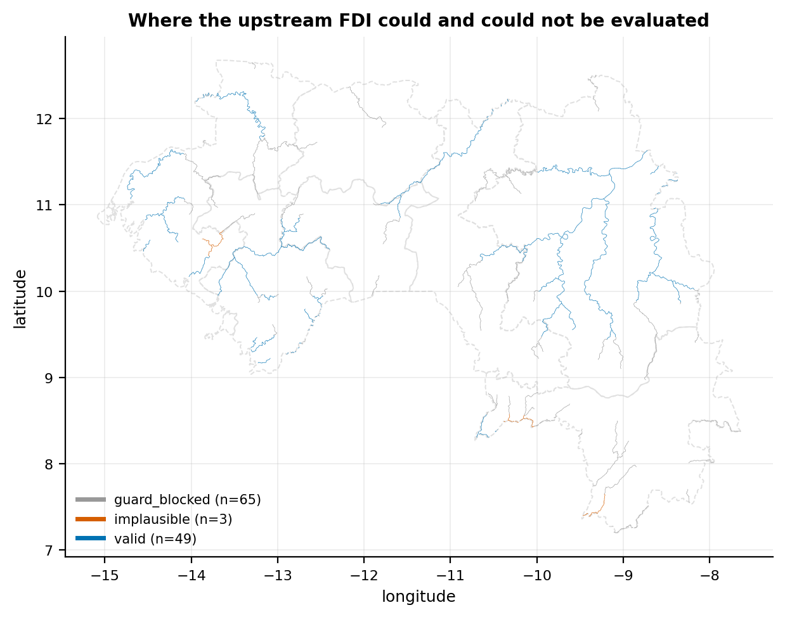
Figure 8. River corridor tiles by evaluation verdict. Only tiles carrying a usable threshold (blue) constitute a measurement; no patch was published on any of them in January 2024.
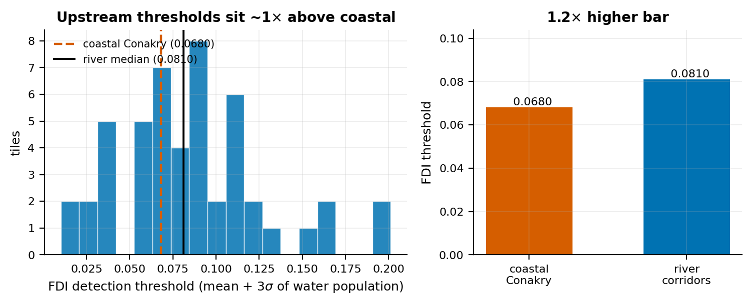
Figure 9. Per-tile FDI detection thresholds against the coastal Conakry reference. The upstream median sits 1.2 times higher, and individual tiles up to three times, so equivalent debris is correspondingly harder to flag.
Corridor thresholds sit well above the coastal reference across almost the whole set of tiles, which is the quantitative form of the comparability warning stated in §8.
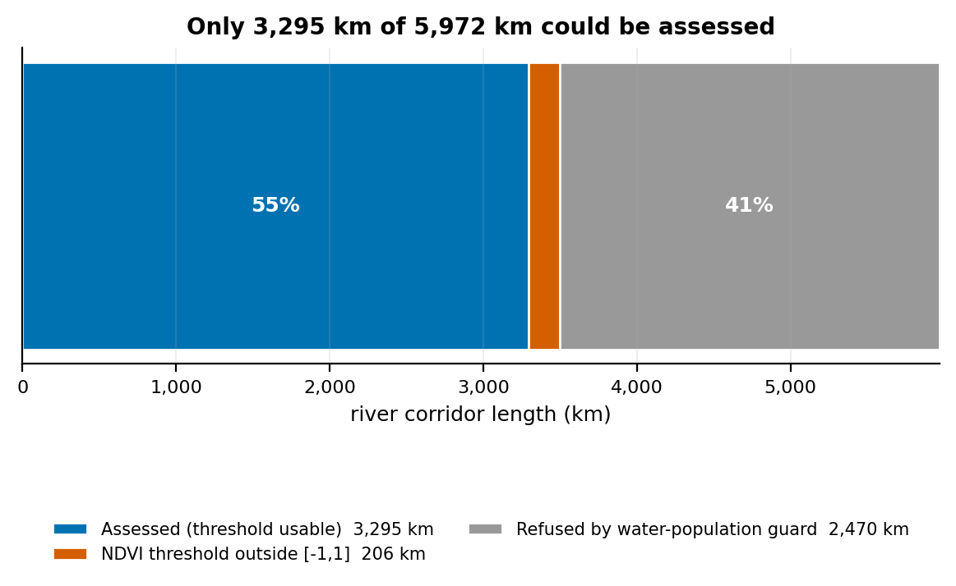
Figure 10. Disposition of Guinea's 5,972 km of screened river corridor. 55% carries a usable FDI threshold; the rest is reported as not assessed, not as zero detections.
The not-assessed share is set by how much permanent water WorldCover maps at 20 m in dry-season channels, not by the method.

7.1.13 The detection rule on the MARIDA benchmark
Applied unmodified to MARIDA's test set (194,863 labelled pixels, 381 of them annotated marine debris), the FDI arm of the deployed rule achieves precision 0.106 at recall 0.627. Lift is precision divided by debris prevalence among the pixels the rule actually scores — the 156,506 that pass the water mask, of which 381 are debris, a prevalence of 0.243% — giving 43×. Computed against all 194,863 test pixels instead, the same precision would read 54×; the water-masked denominator is the operative one because the rule is never applied off water. The full rule, with the NDVI conjunction, reaches precision 0.076 at recall 0.247 on all test pixels and 0.654 at recall 0.886 on the geographically unseen tiles.
Table 25. Composition of the FDI rule's detections on labelled data. Sargassum is the largest category; annotated marine debris is about one detection in ten.
Class | Role | Pixels flagged | Share of all detections
Sparse Sargassum | floating confuser | 718 | 31.8%
Ship | floating confuser | 392 | 17.3%
Dense Sargassum | floating confuser | 376 | 16.6%
Marine Debris | target | 239 | 10.6%
Foam | floating confuser | 205 | 9.1%
Wakes | floating confuser | 121 | 5.4%
Shallow Water | water background | 68 | 3.0%
Turbid Water | water background | 61 | 2.7%

Two readings follow, and both belong in any description of the layer.
The rule is informative. A lift of 43× means debris is forty-three times more concentrated among flagged pixels than in the test set at large, achieved with no training data whatsoever. That is the honest defense of an unsupervised index and it should be quoted alongside the precision figure.
And the rule is not specific to debris. About one flagged pixel in ten is annotated marine debris; more than eight in ten are floating material that is not debris, led by Sargassum, vessels and foam. A count from the rule alone is therefore a count of floating-debris candidates, which is why the published layer passes the rule's detections through a classifier (§7.1.14).
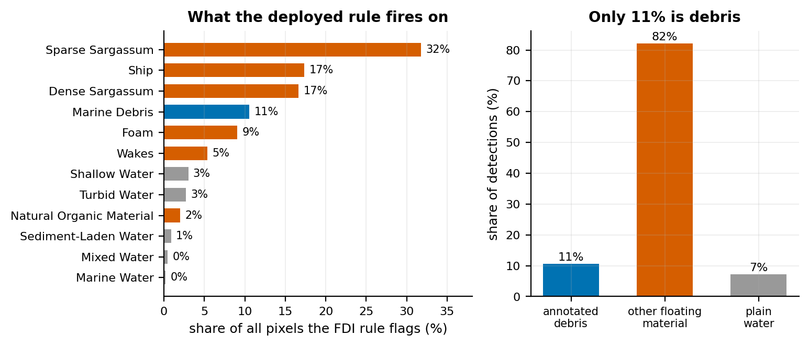
Figure 11. Composition of the FDI rule's detections on the MARIDA test set. Sargassum, vessels and foam outnumber annotated marine debris; more than eight in ten detections are floating material other than debris.

7.1.14 The MARIDA classifier as the second stage
A random forest over the same pixels, compared at matched recall and using only the twelve features the Guinea fetch provides, raises precision from 0.106 to 0.909 on the full test set and from 0.322 to 0.874 on geographically held-out tiles. Because the held-out result rests on 79 debris pixels in 30 patches, it is bootstrapped by resampling patches — pixels within a patch are spatially autocorrelated, and a pixel bootstrap would treat one debris field as hundreds of independent observations.
Table 26. Learned classifier against the deployed rule at matched recall. Intervals are 90% from a patch-level bootstrap; the gain favors the model in 100% of draws.
Evaluated on | Rule precision | Model precision | Gain | Model ROC-AUC
Full test set | 0.106 | 0.909 | 8.59× | 0.9973
Held-out locations only | 0.322 | 0.874 | 2.71× | 0.9963
Held-out, patch bootstrap | — | — | 2.63× [1.56, 4.78] | 0.9965 [0.9928, 0.9992]

The gain is not an abstract improvement in score but the removal of specific, nameable confusions: ship detections fall from 392 pixels to 9, Sargassum from 1,094 to 0 and foam from 205 to 0, while debris detections are unchanged by construction. Feature importances place the floating-matter and vegetation indices (FAI, FDI, NDVI, PI) above every raw band, which is the expected physics — the model keys on whether floating material is chlorophyll-bearing, which is what separates Sargassum from debris — and a useful check that it is not keying on brightness alone.
A model restricted to the seven bands the Guinea fetch downloads (B3, B4, B6, B8, B8A, B11, B12) and the five indices derived from them performs indistinguishably from one using all eleven bands, so adoption costs no additional imagery.
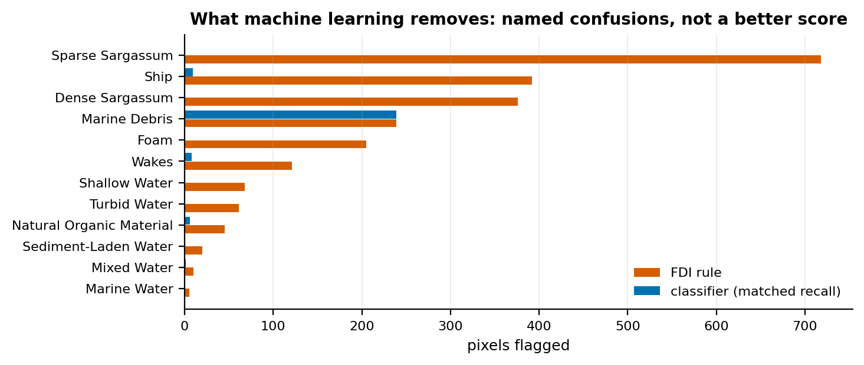
Figure 12. Pixels flagged by the deployed rule and by the classifier at identical recall. The gain is the removal of named confusions, principally Sargassum, vessels and foam.
The published layer applies this classifier, frozen, to the detections of the full FDI-and-NDVI rule (§5.1.4). Measured on MARIDA's test split exactly as deployed, it raises precision from 0.076 to 0.895 on all test pixels and from 0.654 to 0.921 on the unseen tiles, without losing any debris pixel the rule finds (Table 27). Of what it keeps, 89.5% is annotated debris; the remainder is ship (4.8%), natural organic material (3.8%), wakes and mixed water.
Table 27. The published layer on MARIDA's test split: the FDI-and-NDVI rule, then the classifier at P(debris) ≥ 0.5. The classifier leaves recall unchanged.
Evaluated on | Detector | Flagged pixels | Precision | Recall
All test pixels | FDI-and-NDVI rule | 1,243 | 0.076 | 0.247
All test pixels | Rule, then classifier (published) | 105 | 0.895 | 0.247
Unseen tiles | FDI-and-NDVI rule | 107 | 0.654 | 0.886
Unseen tiles | Rule, then classifier (published) | 76 | 0.921 | 0.886
Whether the classifier can be applied to Guinea is a question about distributions, answered here in the units the model was fitted in.
Atmospheric level passes. Guinea composites come from COPERNICUS/S2_SR_HARMONIZED, which is Level-2A surface reflectance. Top-of-atmosphere reflectance cannot be negative; MARIDA contains negative values in 0.07% of pixels, which is the signature of an atmospheric correction. There is no Level-1C/Level-2A mismatch.
Table 28. Raw band medians over water. The shortwave-infrared ratios look large; the comparison that governs a tree ensemble follows below.
Band | MARIDA water median | Conakry water median | Ratio
B03 | 0.0632 | 0.0548 | 0.87×
B04 | 0.0427 | 0.0362 | 0.85×
B06 | 0.0330 | 0.0283 | 0.86×
B08 | 0.0305 | 0.0245 | 0.80×
B8A | 0.0329 | 0.0244 | 0.74×
B11 | 0.0060 | 0.0144 | 2.40×
B12 | 0.0040 | 0.0114 | 2.88×

Ratios are the wrong unit for this question. Shortwave-infrared reflectance over water is a small number: MARIDA's median B11 is 0.006 and Conakry's is 0.014. A ratio of 2.4× sounds decisive, and since the Floating Debris Index anchors its baseline on SWIR, it appears to strike at the feature the method rests on. But a ratio is scale-free, and scale is precisely what matters: MARIDA's own B11 distribution over water is wide enough that 0.014 sits about half a training spread from its center, comfortably inside the range the model was fitted on.
The test therefore compares like with like, in the units the model was fitted in. What governs a tree ensemble is not whether a feature's median moved but whether deployment pixels fall outside the training range, since that is the only regime in which a tree cannot interpolate. A second subtlety applies: the classifier only ever scores pixels the rule has already flagged, and flagged pixels are by construction the upper tail of the water FDI distribution. Comparing them against the training set's water population therefore reports 100% out-of-range on FDI no matter how well the two settings agree — a tautology, not a shift. Flagged pixels must be compared against flagged pixels.
Table 29. Like-for-like comparison: pixels the rule flags in MARIDA against pixels it flags at Conakry, expressed in training spreads. No feature reaches even one spread.
Feature | MARIDA flagged median | Conakry flagged median | Shift (training spreads) | Severity
B03 | 0.0585 | 0.0790 | +0.22 | ok
NDWI | 0.0025 | 0.1459 | +0.22 | ok
FAI | 0.0061 | -0.0083 | -0.21 | ok
PI | 0.5034 | 0.4297 | -0.20 | ok
NDVI | 0.0068 | -0.1405 | -0.20 | ok
B04 | 0.0570 | 0.0783 | +0.19 | ok

On that comparison no feature shifts by as much as one training spread, the largest being 0.22, and 98% of Conakry's flagged pixels lie inside MARIDA's flagged range on every feature simultaneously. The model is therefore interpolating instead of extrapolating across the great majority of what it scores.
Applied to the 102,827 pixels the FDI rule flags on the Conakry January 2024 composite, the classifier returns a median debris probability of 0.047, and a multi-class model on the same features assigns the following classes.
Table 30. What a multi-class MARIDA model calls the pixels Conakry's FDI rule flags. These class names are not used by the platform.
Class assigned | Pixels | Share of flagged
Ship | 64,185 | 62.4%
Marine Debris | 25,043 | 24.4%
Foam | 3,794 | 3.7%
Sediment-Laden Water | 3,707 | 3.6%
Dense Sargassum | 3,422 | 3.3%
Natural Organic Material | 1,870 | 1.8%
Clouds | 751 | 0.7%

The debris probability corroborates §7.1.13 on Guinea's own imagery: most of what the FDI rule flags at Conakry is not debris-like. The class names are another matter. No local observation supports reading most Conakry detections as vessels, and the published layer uses P(debris) alone; the class assignment is neither used nor exported.
Three caveats remain that no distributional check can address. First, compositing: Guinea runs a monthly median while MARIDA annotates single acquisitions, and a median suppresses transient floating material while preserving turbid plumes, shallow bathymetry and moored vessels; this is tested below. Second, MARIDA contains no West African scene, so the water optical type is unverified even though the feature values overlap. Third, MARIDA's debris label is expert visual interpretation, not physical sampling.
None of the three changes how the layer may be described: monthly-composite patches are counts of floating material the classifier judges debris-like, not counts of plastic.
Since the deployed rule is immune to a level shift by construction — it thresholds against each scene's own water population — the obvious way to make the classifier equally immune is to express every feature relative to that same population before the model sees it, as a z-score against the local water median and interquartile range.
This was implemented and tested, and it makes performance substantially worse. On geographically held-out locations, scene-relative features give ROC-AUC 0.72 against 0.996 for absolute reflectance; centring without rescaling gives 0.81. Standardising removes a level shift that, as shown above, was never large enough to matter, while discarding genuine absolute information — debris is bright in the near infrared in absolute terms, and dividing by the interquartile range of a homogeneous water population amplifies noise. The remedy is recorded here so that it is not attempted again in the belief that it is obviously correct.
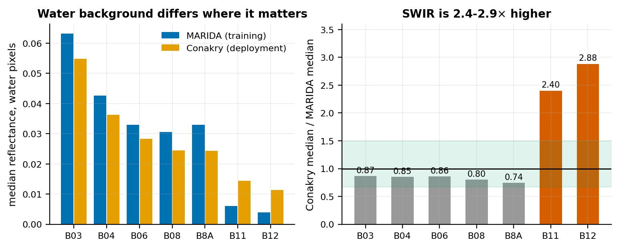
Figure 13. Water-pixel reflectance in MARIDA against the Conakry monthly composite. Shortwave infrared runs 2.4–2.9 times higher at Conakry, and the Floating Debris Index anchors on that region.
Monthly median compositing was the leading candidate explanation for the low debris share at Conakry, and it makes a falsifiable prediction. A median over a month keeps what is present on most dates and discards what is present on few; debris is transient and the confusers are persistent, so the composite should under-represent debris. Scoring a single acquisition should then raise the debris share.
Table 31. Monthly composite against single cloud-free acquisitions inside the same window, Conakry. Single dates carry about three times the composite's median debris probability.
Product | Threshold | Water px | Flagged px | Median P(debris) | Top class assigned
Monthly composite (Jan 2024) | 0.06804 | 4,524,639 | 102,827 | 0.047 | Ship (62%)
Single date 2024-01-11 | 0.08441 | 4,517,101 | 108,520 | 0.163 | Sediment-Laden Water (54%)
Single date 2024-01-26 | 0.09790 | 4,503,815 | 101,788 | 0.149 | Ship (48%)

The prediction holds for the debris probability. Both cloud-free January acquisitions return a median P(debris) about three times the composite's, 0.163 and 0.149 against 0.047, from a similar number of flagged pixels, so a monthly median does suppress some transient debris, and §8 carries this as a limitation. The layer stays on monthly composites because the archive is monthly (GEDH-FR-0507). On the published layer the comparison does not run the same way: the 11 January acquisition yields no published patch where the composite yields 26.
Local annotation is the evidence that does not depend on MARIDA being representative. An annotation tool builds a queue from the published patches of a single acquisition and asks what each most resembles, with no debris category, so that confusers can be confirmed without anyone certifying a pixel as plastic. Under the current detector the 11 January 2024 acquisition has no published patch, so there is nothing to annotate; the local evidence for the published layer is the photo-interpreted review of the 26 composite patches (§7.1.3).
Proximity to the water-mask boundary can be measured for the entire flagged population with no human at all. The water mask is ESA WorldCover class 80 (Zanaga et al., 2022); a Euclidean distance transform gives every water pixel its distance to the nearest non-water pixel, and the question becomes arithmetic — are flagged pixels closer to that boundary than water pixels in general?
The mechanism is not in doubt. A 20 m pixel straddling the land–water boundary contains land reflectance; land is bright in the near infrared; and the Floating Debris Index is built on near-infrared excess over a water baseline. Boundary pixels must sit in the FDI tail. What was in doubt is the magnitude, which is what decides whether this is a footnote or the dominant failure mode of the layer.
Table 32. Proximity of the FDI rule's detections to the water-mask boundary at Conakry. Detections are 3–14 times over-represented near the boundary relative to water in general.
Product | Within | Of flagged px | Of all water px | Enrichment
Monthly composite (operational) | 20 m | 6.6% | 0.5% | 14×
Monthly composite (operational) | 40 m | 8.8% | 1.0% | 9×
Monthly composite (operational) | 60 m | 10.5% | 1.6% | 7×
Single date, 11 Jan 2024 | 20 m | 3.7% | 0.4% | 9×
Single date, 11 Jan 2024 | 40 m | 4.3% | 0.9% | 5×
Single date, 11 Jan 2024 | 60 m | 4.9% | 1.4% | 3×

The FDI rule alone is mildly enriched at the boundary: 8.8% of the composite's 102,827 flagged pixels lie within 40 m of the mask boundary, against 1.0% of water pixels generally, a 9-fold enrichment that leaves most of its detections in open water. The full rule is not: adding the NDVI conjunction concentrates detections on the shoreline, where 83% of its pixels lie within 20 m of land, because vegetated mixed pixels pass both tests. The classifier removes them, leaving 2.5% of published pixels within 20 m of land (§7.1.10).
On the single date the FDI rule's enrichment is lower, 4.3% within 40 m against 0.9% of water (5-fold), and the composite carries about twice as many boundary-adjacent FDI pixels, roughly 9,000 against 4,700.
Table 33. The classifier's reading of the FDI rule's detections in the monthly composite, split by distance to the mask boundary.
Population | n | Mean P(debris) | Most-assigned classes
Within 40 m of the boundary | 9,012 | 0.147 | Dense Sargassum 37%, Marine Debris 21%, Natural Organic Material 20%
Beyond 40 m | 93,815 | 0.179 | Ship 67%, Marine Debris 25%, Sediment-Laden Water 4%

A distance field would be bookkeeping, not a filter. Mean debris probability is 0.147 within 40 m of the boundary against 0.179 beyond it, and the classifier already removes the vegetated shoreline the full rule flags. The class mix differs — vegetation classes at the edge, vessel-like signatures in the interior — so the two populations are distinguishable, but not in a direction that would justify a further filter.
What this does not show. A detection near the boundary is not automatically wrong. Floating material accumulates against shorelines, and in a tidal estuary receiving a city's drainage accumulates there preferentially — which is precisely where component D predicts leakage to enter the water. Mixed-pixel contamination and genuine strandline material produce the same geometric signature, and a distance transform cannot separate them. What is established is that the two are confounded in the present product, which is why §9.3 recommends exporting the distance as a field.

7.2 Component B: dumpsite detection on land

7.2.1 Resolution effects
Imagery was degraded from 0.29 to 1.18 m per pixel by downsampling and re-upsampling before feature extraction, holding everything else fixed.
Table 34. Controlled resolution ablation. No detectable effect.
Ablation | ΔROC-AUC | P
0.29 → 1.18 m/px | -0.011 | 0.70

An earlier recommendation to procure higher-resolution commercial imagery rested on a comparison of two regions with overlapping confidence intervals. The controlled ablation above overturned it, and the recommendation was withdrawn before any procurement was requested.

7.2.2 Analysis footprint
Analysis footprint determines what the terrestrial model responds to. At a 250 m cell the model scores residential land marginally above real dumpsites, 0.626 against 0.618, which makes it a settlement detector; at an 80 m crop the ordering reverses decisively, 0.649 against 0.446. Imagery, features and protocol are identical across the two rows, so the footprint is the only thing that changed.
Table 35. Effect of the analysis footprint, holding imagery, features and protocol fixed. At 250 m the model scored residential land above real dumpsites; at 80 m the ordering reverses.
Window | Mean score, real dumps | Mean score, residential negatives | Verdict
250 m cell | 0.618 | 0.626 | Settlement detector
80 m crop | 0.649 | 0.446 | Waste detector

At 250 m the model's apparent 52% precision came entirely from the fact that dumpsites sit in settlements. At 80 m the ordering reverses and the model responds to waste. Resolution and footprint had been conflated for a substantial part of the project; only footprint mattered, and correcting it required no additional imagery spend. This result is also why the Sentinel-2 index tests in §C.3 report three footprints.

7.2.3 Imagery source
Licensed imagery outperforms free imagery on identical samples, features and protocol, by 0.079 ROC-AUC and 0.153 average precision. That 0.153 is the difference between the two marginal average precisions computed on the full sample; the paired block bootstrap reports +0.144, because it averages the within-block differences and so weights blocks equally rather than weighting points equally. The two are consistent and the paired figure is the one carrying the confidence interval. The gap is widest where it matters operationally: precision over the top forty ranked sites rises from 50% to 68%. This is the measurement that justifies the two-stage design, in which licensed imagery is purchased only for windows that survive a free screen.
Table 36. Free against licensed imagery on identical samples, identical features and identical protocol. Only the imagery differs. n = 651, 111 positive, evaluation prevalence 17.1%.
Metric | Esri z17 | Google z19
ROC-AUC | 0.832 | 0.911
Average precision | 0.543 | 0.696
Top-40 precision, per window | 70% | 85%
Top-40 precision, per site | 50% | 68%

Paired block bootstrap: ΔAP +0.144, 95% CI [+0.036, +0.250], P = 0.004. The interval excludes zero, so licensed imagery is significantly better at the working footprint. Before the footprint was corrected, the same comparison showed no meaningful difference, which is the sequence that matters: the value of licensed imagery is conditional on the analysis window being right. The platform cannot license that imagery for this use, so the deployed stage 2 uses free imagery and is measured on its own terms (§7.2.11).

7.2.4 The stage-1 screen
The screen is fitted on a national random sample under blocked cross-validation and is deliberately permissive. At an operating threshold of 0.3 it discards about two thirds of candidate cells while retaining 85.5% of true sites. That trade is what makes a national scan affordable, and the retained fraction is the first of the two multiplicands in the end-to-end recall figure in §8.
Table 37. Stage-1 screen, fitted on the national random sample under blocked cross-validation. It is judged on recall, not precision: its only job is to discard empty country for free.
Quantity | Value
Training cells | 595
Positive cells | 55
Blocked-CV ROC-AUC | 0.856
Operating threshold | 0.3
Cells retained at threshold | 31.6%
True sites retained | 85.5%

In dense urban areas the screen retains nearly everything, 95% of cells in the Conakry validation area, because there is no empty land to discard. The cascade saves cost across the national footprint, not uniformly within it.

7.2.5 National scan cost
The cost of a national scan is bounded, because a licensed second stage bills one request per window. Stage 1 is unmetered; with a licensed stage 2 the cost falls between approximately US$480 and US$690 at the published tiered list rate (US$2.00 per 1,000 requests to 100,000, US$1.60 per 1,000 beyond it, before any monthly free allowance), depending on how densely the retained cells pack over the settled footprint, and with the free Esri stage 2 the platform runs, a national scan carries no imagery cost (§7.2.11). For a licensed scan the bound is enforced in the pipeline as a required budget parameter.
Table 38. Cost of one national scan over the adopted 89,336-cell footprint with a licensed stage 2. The range reflects how clustered the retained cells turn out to be, since adjacent cells share windows and shared windows are fetched once.
Quantity | Value
Stage 1 | Free (Esri, unmetered)
Stage 2 billable requests | 276,000 – 404,000
Stage 2 cost | ≈ US$480 – 690

Scanning every 80 m window without the screen would cost several times this. Rescans should be imagery-driven: basemap imagery over these towns is 17 to 19 months old and static, so re-scoring monthly would re-purchase identical pixels twelve times a year. The appropriate trigger is a cheap imagery-freshness check, re-scanning only where imagery has changed, which makes the figures above approximately annual.

7.2.6 Blind-grid validation
422 windows over Conakry, labelled exhaustively by hand: 110 positive, 312 negative, base rate 26.1%. No window was used in training.
Table 39. The same frozen model on the two tasks of §6.3. The gap is the single most important number in this component.
Task | ROC-AUC | Average precision
Crop classification (point-centred) | 0.911 | 0.696
Blind-grid detection | 0.682 | 0.477

The same model is scored on two tasks that are easy to confuse. Classifying a crop already centered on a location a person selected gives ROC-AUC 0.911; finding sites on a grid nobody pre-selected gives 0.682. The second is the task a national layer performs, and the difference between the two figures is the single most important quantity in this section.
Table 40. Operating points on the blind grid, against a base rate of 0.261.
Threshold | Flagged | True | False | Precision | Recall
0.90 | 77 | 45 | 32 | 0.584 | 0.409
0.70 | 140 | 61 | 79 | 0.436 | 0.555
0.50 | 200 | 72 | 128 | 0.360 | 0.655

At the high tier, precision 0.584 against a no-skill baseline of 0.261 is approximately 2.2 times better than chance. That is a usable screening signal. It is not the performance the 0.911 figure implies.
Why the tasks differ. The training set draws 43% of its positives from Conakry but only 9% of its negatives, so “dense urban” correlates with the positive label. Against the mostly rural negatives of the evaluation set this separates cleanly; inside a city, where every window is dense urban, it does not. Scoring the frozen model on its own training tiles shows the mechanism: Conakry negatives it was trained on score 0.216, while unseen urban windows score above 0.99. With 2048 features and 651 samples, the model memorized the 50 urban negatives available to it and never formed a general representation of urban without waste.
Cross validation could not have detected this, and that is the generalizable point. Spatial blocking prevents a training tile leaking into the adjacent test fold. It does nothing about a dataset-wide correlation between terrain type and label, and every fold shared the same mostly rural negative distribution. The discrepancy is covariate shift between the sampled and the deployed negative distributions, and only a blind-grid test exposes it.
A caveat on the base rate. This area was selected because it contained a cluster of labelled dumps, so its 26.1% prevalence is enriched relative to a randomly chosen urban area, and precision elsewhere would be lower. A second validation area, not selected for known dumps, was therefore required; it was built at Boké (§7.2.8).

7.2.7 Attempted remedies
Both experiments were evaluated on the spatially separated east half of the review area (220 held-out windows), which is why the baseline reads ROC-AUC 0.692 and AP 0.485 here instead of the 0.682 and 0.477 measured over all 422. The two are not interchangeable and should not be quoted against one another.
Hard-negative training. 202 hand-labelled urban windows, 49 of them positive, were added to training and the result frozen as separate heads.
Table 41. Hard-negative retraining against the shipped model on the held-out half. The apparent precision gain is not an improvement; see below.
Model | ROC-AUC | Average precision | prec@0.90 | recall@0.90 | flagged@0.90
current (probe.joblib) | 0.692 | 0.485 | 0.561 | 0.377 | 41
retrained (+urban) | 0.688 | 0.504 | 0.667 | 0.131 | 12

ΔROC-AUC -0.004. The apparent rise in precision at the 0.90 threshold is not an improvement: recall fell from 0.377 to 0.131 and flagged windows from 41 to 12. The model became more conservative, not more discriminating, and ROC-AUC, which is threshold-free, did not move. The retrained head is retained for provenance, does not overwrite the shipped model, and is loaded by nothing.
Changing the training mixture. Since the deployment footprint is settlements, a model trained only on urban windows was tested, dropping the 651 mostly rural base samples.
Table 42. Training-mixture variants on the held-out half. The urban-only variant leads in absolute terms despite using under a third of the data.
Variant | n | ROC-AUC | Average precision
A: rural-heavy base only | 651 | 0.692 | 0.485
B: base + urban west | 853 | 0.688 | 0.504
C: urban west only | 202 | 0.747 | 0.555

A paired block bootstrap over 34 spatial blocks tests whether the training mixture is the constraint. Adding urban imagery to the rural-heavy base leaves performance unchanged within noise (0.692 to 0.688 ROC-AUC), and the urban-only variant scores higher (0.747) from a much smaller training sample, though the difference is not significant (Table 43). The training composition is therefore not what limits this model.
Table 43. Paired block bootstrap over 34 spatial blocks, urban-only against the shipped model. Both intervals include zero.
Metric | Δ | 95% CI | P
ROC-AUC | +0.055 | [-0.048, +0.143] | 0.277
Average precision | +0.069 | [-0.093, +0.208] | 0.385

The lead is not distinguishable from sampling noise on a 220-window test set. It is additionally confounded: the two halves are adjacent parts of one 1.9 km area, so the urban-only model was trained on the neighborhood beside the one it was tested on, and an unknown share of its advantage is local adaptation. The variant is retained and documented but not adopted; the original model remains the model of record.

7.2.8 Independent replication at Boké
The first draft of this methodology recorded, as its principal outstanding requirement, that blind-grid performance had been measured in exactly one city in an area chosen because it contained known dumps. That requirement has now been discharged. A second blind grid was built over Boké, 557 contiguous 80 m windows covering 90% of the requested area of interest, exhaustively hand-labelled by a single annotator who could not see the model's scores. Boké lies about 170 km north-west of Conakry in a straight line, some 250 km by road, is an inland mining town and was not selected for known dump density.
The criterion in §9.3 was fixed in code before the Boké imagery was purchased, in `26_blind_grid_protocol.py`, and is reported here exactly as declared.
Table 44. The two blind grids. The pre-declared criterion required lift at or above 1.5×; Boké returned 1.48×, so the criterion is not met as declared. The text explains why lift understates Boké, and §9.3 sets out the terms on which the national layer is published.
Measure | Conakry | Boké
Windows | 422 | 557
Positive windows | 110 | 243
Base rate | 26.1% | 43.6%
ROC-AUC | 0.682 | 0.738
Average precision | 0.477 | 0.640
Precision at 0.90 | 0.584 | 0.645
Recall at 0.90 | 0.409 | 0.202
Lift over base rate | 2.24× | 1.48×

The criterion is not met, but the reason is not the one the bare verdict suggests, and the distinction matters enough to state explicitly. Lift is precision divided by the area's own base rate, so it is bounded above by the reciprocal of that base rate: 2.29× at Boké's 43.6% prevalence against 3.84× at Conakry's 26.1%. A grid over a dirtier town is therefore scored against a lower ceiling for arithmetic reasons unconnected to the model. On ROC-AUC, which is invariant to prevalence, discrimination did not degrade between towns but improved, 0.682 to 0.738. Selecting a base-rate-invariant criterion would have been the better choice; having declared this one in advance, we report it as declared and publish the invariant comparison beside it.
On the prevalence-invariant measure, the Conakry result is therefore replicated. That raises a sharper question, which a blind grid alone cannot answer: a ROC-AUC near 0.7 is equally consistent with a model that detects waste imperfectly and with one that detects something merely correlated with waste and never sees waste at all. Those two readings imply opposite deployment decisions, and the Boké review set can separate them.
The Boké annotator recorded more than a binary verdict. Every positive window carries hand-digitized point coordinates for each waste feature visible within it, 752 points across 243 windows and up to nine in a single window. This converts the grid from a label set into a record of quantity and position, and quantity is what any genuine detector must be sensitive to: among windows that contain waste, a model that sees waste should score a window holding nine features above one holding a single feature.
The test is confined to the positive class. It never compares positives against negatives and is therefore independent of where the positive/negative boundary was drawn and of how confident the annotator was in drawing it — the two questions that otherwise dominate any discussion of a hand-labelled grid.
Table 45. Model score against the quantity of waste actually present, Boké positives. The strata below cover the 242 windows carrying a digitised waste-feature count; the 243rd labelled-waste window is the single waste-on-water window of Table 46, which has no point count and so falls outside them. Spearman ρ = -0.027, P = 0.68.
Waste features in window | Windows | Mean score | Median score | At or above 0.90
1 point | 59 | 0.613 | 0.697 | 20%
2-3 points | 104 | 0.590 | 0.655 | 17%
4-6 points | 64 | 0.585 | 0.702 | 23%
7+ points | 15 | 0.505 | 0.437 | 27%

There is no dose-response. Nine times the waste produces no rise in score, and the point estimate of the correlation is marginally negative. A second test asks whether a target near the center of the window scores above one at its edge, the point-centered configuration on which the 0.911 crop-classification figure depends; within this grid that effect is also absent (P = 0.39, 85 central against 157 off-center positives).
The annotator also recorded, in free text, what each window contained. These notes were written before any score was visible and are used here to group windows for reporting only; every figure in this section is computed from the label and the model score alone.
Table 46. Model score stratified by recorded land cover at Boké. The ordering, not any single value, is the finding.
Window contents | Windows | Labelled waste | Mean score | At or above 0.90
forest | 83 | 0 | 0.004 | 0%
water | 27 | 0 | 0.013 | 0%
bare or sparse | 14 | 0 | 0.152 | 0%
plantation | 3 | 0 | 0.279 | 0%
waste on water | 1 | 1 | 0.348 | 0%
quarry borrow pit | 3 | 0 | 0.350 | 0%
settlement no waste | 178 | 0 | 0.496 | 13%
possible waste | 243 | 242 | 0.591 | 20%
construction site | 5 | 0 | 0.902 | 80%

The ordering is unambiguous. Forest and water, 110 windows between them, score 0.006 on average and not one reaches the high tier. Settlement carrying no visible waste scores an order of magnitude higher, and 12.9% of such windows are flagged at the high tier. Construction sites — bare, disturbed, and containing no waste at all — return the highest mean score of any category in the grid, above every waste category, with four of five flagged at the high tier.
Taken together with the absent dose-response, these results identify what the classifier has learned. It separates disturbed anthropogenic ground from natural land cover, and it does so well. It does not separate waste from other disturbed anthropogenic ground. Windows containing waste outscore forest because waste is deposited on bare, disturbed, accessible ground, not because the waste is visible to the model; the classifier is responding to the setting. The blind-grid ROC-AUC is a real measurement, and it is not a measurement of waste detection.
The result is not an artefact of one imagery provider or one training run. Re-scoring all 557 windows on free Esri imagery, using a head independently fitted on Esri crops rather than the Google-fitted head, reproduces the same ordering in a narrower range: water 0.232, forest 0.278, bare ground 0.374, settlement without waste 0.544, labelled waste 0.583, quarry 0.603, construction site 0.757, with 40% of construction sites above the high tier against 7% of waste windows. Two sources and two independently fitted classifiers place waste barely above settlement and construction above everything, which is what makes this a property of the feature representation.
This is the same failure that §7.2.2 documented at a 250 m footprint, where the classifier ranked residential land above confirmed dumpsites and was in effect a settlement detector. Reducing the window to 80 m reversed that ordering, and the reversal was read at the time as having solved the problem. The Boké evidence shows it narrowed the margin without closing it: dumps now outscore settlements, by 0.10 in the mean, but construction sites still outscore dumps. The footprint change moved the model along a gradient of surface disturbance; it did not give it access to a different signal.
The conclusion is consistent with the independent finding in §7.3 that the median dumpsite in this inventory presents an area-equivalent side of roughly 14 m. Such a feature occupies about three per cent of an 80 m window. A classifier pooling features over the whole window is dominated by the remaining ninety-seven per cent, which is the surrounding ground — precisely the quantity the results above show it to be measuring.
The practical consequence is stated in §9.3. The national layer cannot be read as a waste inventory: it measures disturbed anthropogenic ground in which waste is commonly deposited, and no amount of additional labelling at this footprint would change that. It is therefore published only as a prioritization aid for analysts, carrying its measured bounds and naming the land covers that score above waste.

7.2.9 Ablation to a different architecture
Section 7.2.8 attributed the failure to spatial dilution: a 14 m dumpsite (§7.3) occupies about three per cent of an 80 m window, the probe averages features over the whole window, and the target is swamped by the remaining ninety-seven per cent. That is a mechanism, and a mechanism makes a prediction which can be tested before any redesign is commissioned.
It is also the mechanism that distinguishes the best-performing model published in this area. The AerialWaste classifier (Torres and Fraternali, 2023) pairs a ResNet-50 backbone with a Feature Pyramid Network (Lin et al., 2017), whose contribution is not the classifier head but the carrying forward of earlier, higher-resolution layers so that small objects are represented at a scale where they still occupy a meaningful share of a unit's receptive field. Adopting that architecture was therefore the obvious next step, and the purpose of this ablation is to establish whether the constraint it removes is the one that binds here.
Everything is held fixed except the representation: the same frozen backbone, the same windows, the same labels, the same spatially blocked split between the two halves of the grid, and the same regularized logistic probe. Two factors are varied. The first is scale, meaning which layer the features are drawn from, reported as the receptive field converted to ground distance. The second is pooling, comparing the average over all positions that the shipped model uses against the mean of the five strongest positions, which is the natural non-diluting alternative and corresponds to roughly the same share of the window as the target itself.
Table 47. Architecture ablation on the Boké grid (n = 557). The pyramid row concatenates all three layers and is the closest approximation to the AerialWaste architecture obtainable without retraining. The last two columns are the decisive ones.
Representation | Receptive field (m) | ROC-AUC | Average precision | Dose-response ρ | P
layer2, average | 10 | 0.744 | 0.647 | -0.050 | 0.44
layer2, top-5 | 10 | 0.702 | 0.599 | -0.093 | 0.15
layer3, average | 29 | 0.720 | 0.637 | -0.010 | 0.88
layer3, top-5 | 29 | 0.699 | 0.601 | -0.028 | 0.67
layer4, average (shipped) | 48 | 0.736 | 0.631 | +0.014 | 0.82
layer4, top-5 | 48 | 0.680 | 0.570 | -0.068 | 0.29
pyramid, average | 10–48 | 0.729 | 0.635 | +0.021 | 0.74
pyramid, top-5 | 10–48 | 0.701 | 0.595 | -0.061 | 0.34

The accuracy column is nearly flat. Every variant lies between ROC-AUC 0.68 and 0.74, the finest scale is indistinguishable from the coarsest, and the pyramid is no better than the single layer it replaces. Non-diluting pooling is consistently slightly worse.
The dose-response column is the one that settles the question, and it gives the same answer for every variant. Not one of the eight variants produces a score that rises with the quantity of waste present; every correlation is indistinguishable from zero and several are nominally negative. Accuracy near 0.7 is obtainable simply by ranking disturbed ground above vegetation, so a variant reaching 0.744 has not thereby demonstrated that it sees waste, and none of them does.
The §7.2.8 diagnosis therefore requires amendment, and the amendment changes what should be done next. Spatial dilution is not the binding constraint. Generic ImageNet features do not encode waste as a category distinct from disturbed anthropogenic ground at any scale available in the network, so there is nothing for a finer representation to recover and nothing for a localization mechanism to localize. A Feature Pyramid Network tells a model where in an image the evidence lies; it cannot supply evidence the features do not carry.
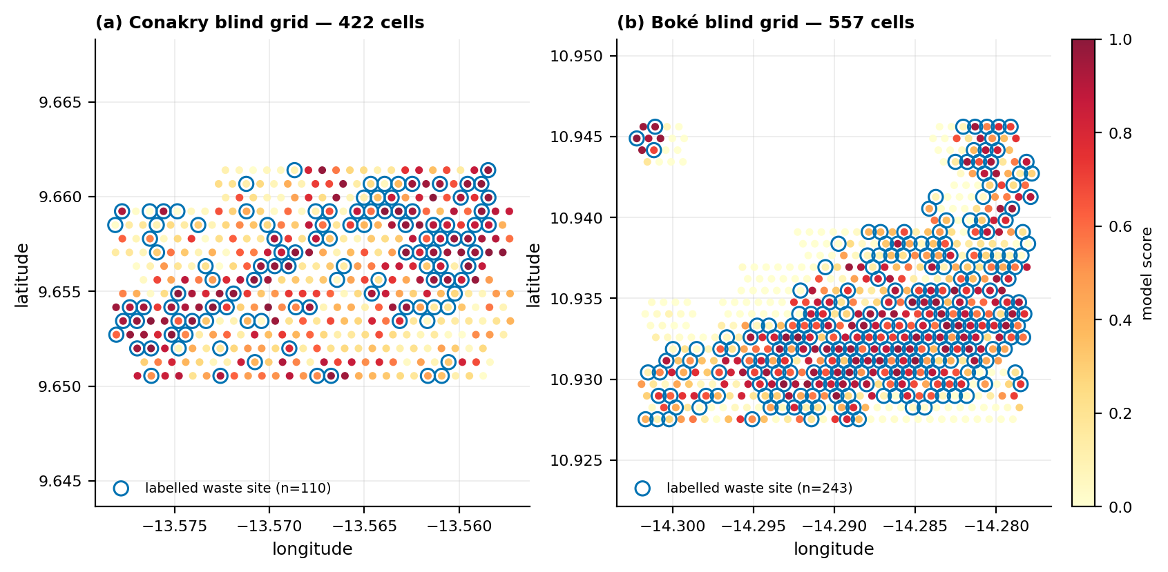
Figure 14. Blind-grid evaluation of the terrestrial detector at Conakry (422 windows, 110 labelled as containing waste) and Boké (557 windows, 243 labelled as containing waste). Fill color is the model score for each window; blue rings mark windows a human annotator labelled as containing waste. The grids were laid down without reference to known sites, so this is the detector's behavior on windows nobody pre-selected.
This also explains, without contradiction, why the same architecture succeeds elsewhere. AerialWaste's features are not generic: they were trained under supervision on a large dedicated corpus of labelled waste imagery, so they discriminate waste before the pyramid is applied, and the pyramid then localizes what they already separate. The present project has a few hundred labelled samples, which is why a frozen backbone with a linear probe was the appropriate and honestly validatable choice (§2.2, §5.2.1) and why importing the architecture without the supervision that fills it would import the cost and none of the benefit. The binding constraint on terrestrial detection is the volume of task-specific labelled data, not the architecture, and that is a data-collection undertaking.
Two related results already pointed the same way and are consistent with this reading. A checkpoint from the Lab's Guatemala project degraded performance on Guinean imagery, and features derived from AerialWaste itself did not outperform generic ImageNet features (§7.2.7, where both tests are reported with their figures); in both cases supervision acquired in one landscape failed to transfer to another. The conclusion is not that the published models are weak, but that waste detection from overhead imagery appears to depend on locally acquired supervision to a degree that limits reuse across regions.

7.2.10 Benchmark against the Lab's Guatemala implementation
The Joint Concept Note proposed adapting the SDG AI Lab's Guatemala illegal dumpsite work (§1.2, §5.2.1), so that implementation is the natural reference point for what this module achieves. The comparison below is a benchmark and not a controlled experiment: the two studies use different countries, different imagery providers and zoom levels, different label protocols and different test sets. No causal claim is made about which design choice is responsible for any difference. It is offered to situate this work within the Lab's portfolio, which is the purpose it can legitimately serve.
Table 48. Point-centered assessment in both cases: a set of candidate locations is supplied and the model scores them. The Guinea row is taken at the 0.50 threshold, the operating point whose recall is closest to Guatemala's, so the two are compared at comparable sensitivity.
Measure | Guatemala | Guinea
Model | Polimi classifier, adapted | ImageNet ResNet-50 + linear probe
Imagery | Google z18 | Google z19
Windows / positives | 208 / 68 | 651 / 111
Base rate of the test set | 32.7% | 17.1%
Recall | 0.691 | 0.631
Precision, as measured | 0.681 | 0.534
Lift over its own base rate | 2.08× | 3.13×

Read naively, the precision row says the Guinea model is the weaker of the two, 0.534 against 0.681. That reading is an artefact of the test sets and not a property of the models. Precision is not an attribute of a classifier alone: it depends on how common positives are in the data the classifier is shown. The Guinea evaluation set is 17.1% positive, and the Guatemala set is 32.7% positive, so the Guinea model is being asked to find needles in roughly twice as much hay. Any classifier's precision falls under that change even if nothing about it has altered.
Two corrections make the comparison meaningful. The first is lift, precision divided by the base rate of the set on which it was measured, which is 2.08× for Guatemala and 3.13× for Guinea. The second, and the more direct, is to recompute the Guinea model's precision at Guatemala's base rate. Recall and false-positive rate are themselves invariant to prevalence, so precision at any other base rate follows from them by Bayes' rule.
Table 49. The Guinea model's precision restated at the Guatemala study's base rate. The final column is what the model would report if it were evaluated on a test set of Guatemala's composition; it is the column that may be compared with Guatemala's 0.681.
Guinea threshold | Recall | False-positive rate | Precision at its own 17.1% base rate | Precision at Guatemala's 32.7% base rate
0.50 | 0.631 | 0.113 | 0.534 | 0.731
0.60 | 0.595 | 0.091 | 0.574 | 0.761
0.70 | 0.523 | 0.059 | 0.644 | 0.811
0.80 | 0.450 | 0.031 | 0.746 | 0.874
0.90 | 0.324 | 0.011 | 0.857 | 0.934
0.95 | 0.234 | 0.007 | 0.867 | 0.939

At the 0.50 threshold, where recall is 0.631 against Guatemala's 0.691, the Guinea model's prevalence-matched precision is 0.731 against Guatemala's 0.681. At comparable sensitivity it is the more precise of the two, and the ordering strengthens at stricter thresholds, where recall is traded for precision.
The appropriate summary is therefore that this module's point-centered performance is at least comparable with, and on a prevalence-matched basis somewhat better than, the Lab's previous implementation, achieved with a simpler model on comparable commercial imagery. The caveats of the first paragraph stand, and the finding of §7.2.8 is not displaced by it: this is a comparison of two systems on the point-centered task, and neither constitutes evidence that either detects waste.

7.2.11 Stage 2 on free imagery
The deployed cascade confirms at stage 2 on free Esri imagery at zoom 17, scored by a classifier fitted on Esri crops (point-centered ROC-AUC 0.832, Table 36). Its blind-grid performance cannot be assumed from the Google figures, and it was measured on both hand-labelled grids with the same labels and the same metrics as §7.2.6 and §7.2.8.
Table 50. Blind-grid performance of stage 2 on free Esri imagery against licensed Google imagery. Precision is cumulative over windows at or above the threshold; end-to-end recall includes the 85.5% of sites retained by the stage-1 screen.
Grid, threshold | Esri precision | Esri end-to-end recall | Google precision | Google end-to-end recall
Conakry, ≥ 0.90 | 0.351 | 21.0% | 0.584 | 35.0%
Conakry, ≥ 0.70 | 0.347 | 45.8% | 0.436 | 47.4%
Conakry, ≥ 0.50 | 0.285 | 66.0% | 0.360 | 55.9%
Boké, ≥ 0.90 | 0.680 | 6.0% | 0.645 | 17.2%
Boké, ≥ 0.70 | 0.586 | 22.9% | 0.636 | 38.7%
Boké, ≥ 0.50 | 0.561 | 58.0% | 0.614 | 53.8%
ROC-AUC (Conakry / Boké) | 0.594 / 0.687 | — | 0.682 / 0.738 | —
Free imagery costs 0.05 to 0.09 of ROC-AUC. Its high tier is too strict to be useful — it finds 21% of sites at Conakry and 6% at Boké — and at the lowest tier Conakry precision falls to 0.285 against a base rate of 0.261. The medium tier keeps precision at 0.347 and 0.586, about 1.3 times the base rate in both towns, while finding 46% and 23% of sites, and it is the default display tier (Table 9). These are the figures the layer's legend quotes; the point-centered figures describe the on-demand check only.

7.3 Measured dumpsite extent
Manual annotation of 55 cells yielded 46 usable measurements, 9 excluded as unclear and 0 rejected as not dumpsites. No site exceeded the 80 m crop, so the distribution is uncensored.
Table 51. Measured dumpsite size distribution, n = 46. This is the first measured dumpsite size distribution for Guinea.
Statistic | Longest side (m) | Area-equivalent side (m)
p25 | 10.5 | 9.9
median | 16.4 | 14.0
p75 | 25.1 | 19.5

The area-equivalent side is the operationally relevant figure, because what matters for a pixel-count argument is the fraction of a pixel filled, not the longest dimension. A 60 by 5 m roadside strip is 60 m across and fills almost nothing.
Table 52. Pixel coverage of a median dumpsite at each sensor's ground sampling distance. Every labelled dumpsite is sub-pixel at every openly available sensor capable of observing the diagnostic wavelengths.
Sensor | GSD (m) | Pixels on a median dumpsite | Verdict
Sentinel-2 SWIR (B11/B12) | 20 | 0.49 | sub-pixel
EnMAP | 30 | 0.22 | sub-pixel
EMIT | 60 | 0.05 | sub-pixel

No pixel contains only dumpsite, so any approach that matches an observed spectrum against a plastic spectral library is unavailable in principle. Prior reasoning in this project assumed a 50 m site, which would have given 6.25, 2.78 and 0.69 pixels respectively; the measured figures are an order of magnitude smaller. This is the single measurement that explains gates 2 to 4, and it is why it was worth stopping to make it.
Measured site extent is small everywhere and varies only modestly between regions, so the sub-pixel argument does not depend on any one part of the country.
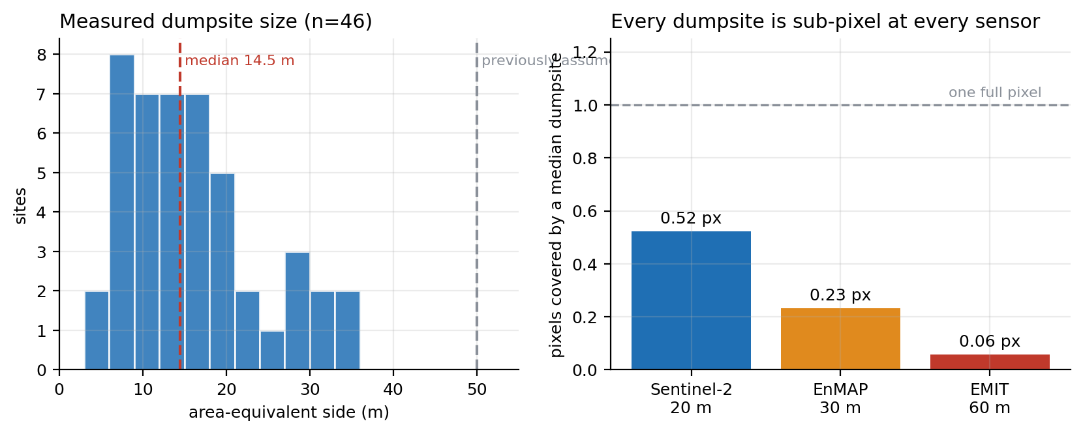
Figure 15. Measured dumpsite size distribution and the resulting pixel coverage at each sensor's ground sampling distance.
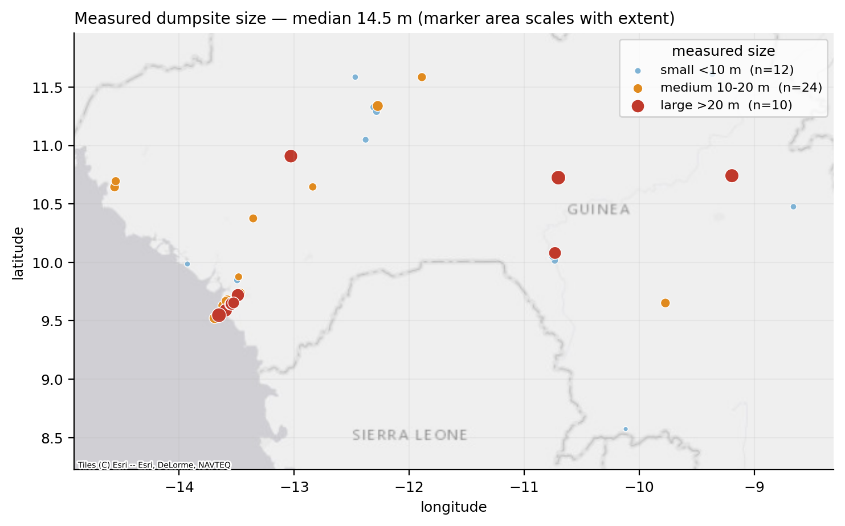
Figure 16. Measured dumpsite size in space. Regional medians range from 9.2 to 17.7 m, so the distribution is not a Conakry artefact.
Reproducibility of the extent measurement. A random subsample of 12 sites was measured a second time, blind.
Table 53. Blind second read against the first. Agreement is poor in absolute terms and moderate in ranking.
Statistic | Value
Bias (second − first) | -3.96 m
95% limits of agreement | [-19.1, 11.2] m
Mean absolute difference | 6.9 m
Median relative difference | 42%
Lin's concordance (CCC) | 0.49
Pearson r | 0.71

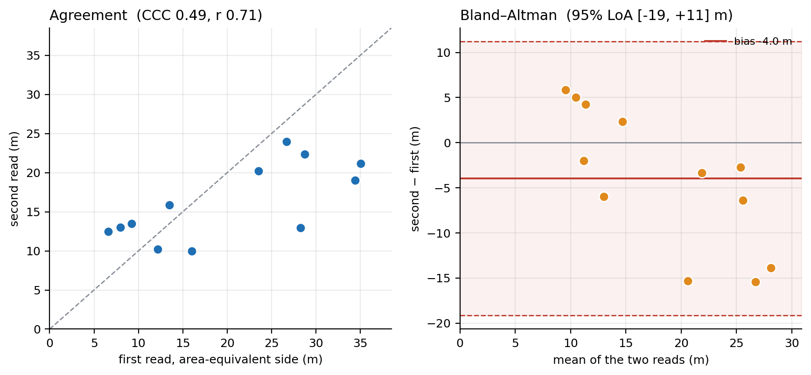
Figure 17. Blind second read against the first. Left: agreement against the 1:1 line. Right: Bland-Altman, showing bias and 95% limits of agreement.
The interpretation is that the disagreement is definitional. The site notes show the largest disagreements about where a diffuse debris scatter ends, not about measuring a well-defined object, which is the same ambiguity that defeated the automated estimator in §5.3.1. A per-site area figure should therefore not be published; the distribution should be reported as a size class.
That imprecision does not reach the conclusion, and this is worth demonstrating. A dumpsite must reach 30 m to fill one EnMAP pixel. In the 12-site subsample, the median under the first read is 19.8 m (95% CI [10.7, 28.5]) and under the second 14.7 m (95% CI [12.7, 20.7]); the two medians do not differ significantly. The paired comparison is made site by site rather than between the two summary medians: the median of the 12 paired differences is −4.4 m (95% CI [−13.5, 2.4]), which is not the same quantity as the difference of the medians (−5.1 m) and is the appropriate one here because each site is measured twice. The probability that the median site reaches 30 m is 0.5% under the first read and 0.0% under the second.

7.4 Waste mobilization and leakage risk (component D)
This is an input to component D that is both deliverable and externally validated, and the route by which the program’s underlying question is answered without the unmeasurable quantity.
Table 54. Relative leakage risk class over 111 labelled dumpsites. The ranking is relative and uncalibrated; see the constraints below.
Leakage risk class | Dumpsite points
low | 54
moderate | 32
high | 20
very high | 5

Mean OCEAN-LEAKAGE risk by region, which weights proximity to the coast and is the score that ranks estuarine regions first: Kindia 31.7; Conakry 18.8; Nzérékoré 13.9; Boké 13.2; Mamou 5.9; Faranah 4.1; Kankan 1.8; Labé 1.2. The mobilisation score orders the regions differently — Nzérékoré 53.3; Kankan 39.2; Kindia 33.4; Faranah 24.9; Conakry 15.8; Mamou 15.1; Boké 11.6; Labé 4.5 — which is consistent with 11 of the 13 observed flood sites lying in Kankan, where the median mobilisation score is 48.3. Both are post-inundation-correction values from the same model run; they are reported separately because they answer different questions and must not be read as one ranking.
Kindia and Conakry dominate: they are coastal, close to watercourses and in the wettest part of the country. Kankan and Faranah score near zero despite holding real dumpsites, because they lie hundreds of kilometers inland from the Atlantic. That ordering is the product: it indicates where a river trap or a clean-up would most reduce plastic reaching the ocean.
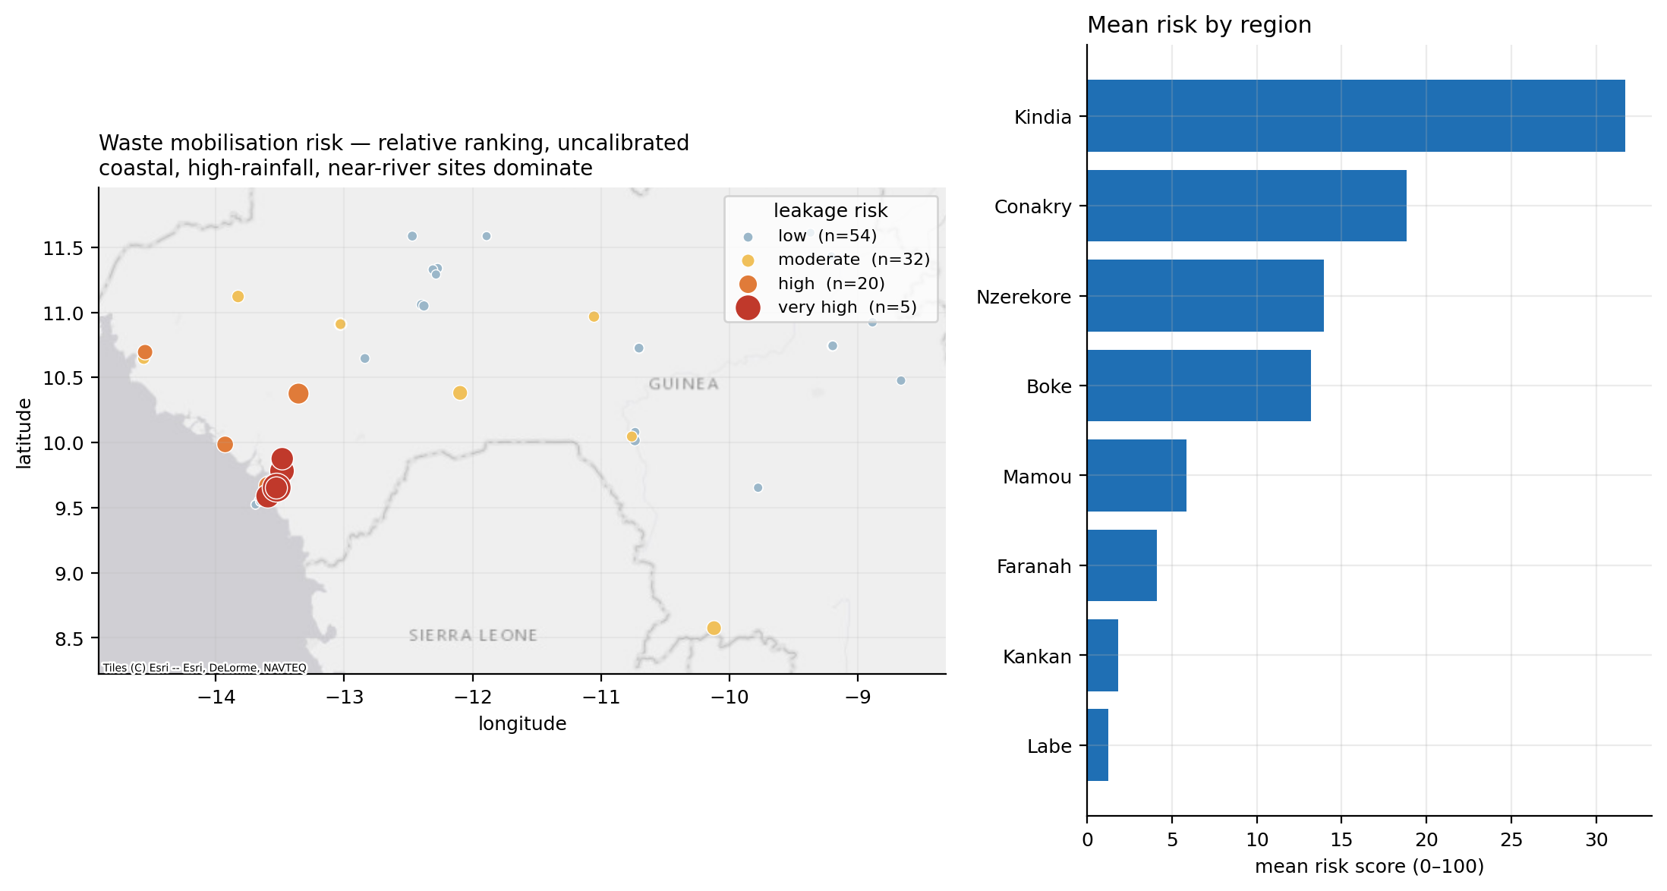
Figure 18. Relative waste mobilization and leakage risk. Uncalibrated ranking; see the two constraints below.
Independent validation against observed flooding. Thirteen of 111 dump points were inundated in the Global Flood Database record, 11 in Kankan, 2 in Conakry.
The first version of the model failed this test, at ROC-AUC 0.469, and the failure produced the model's main correction. Eleven of the thirteen flooded sites lie on the Niger and Milo floodplain in Kankan, where local wet-season rainfall is lower (1278 mm) than in coastal Conakry (2961 mm). Ranking those sites by the rain falling on them placed them at the bottom. A floodplain site is not inundated by local rain; it is inundated by upstream catchment discharge, which is why Meijer et al. use river discharge as an input.
Waste can therefore enter a watercourse by two physically distinct pathways with different drivers: wash-off, where rain falls on the site and runoff carries waste downslope, driven by local rainfall, slope and land-use friction; and inundation, where the river rises over the site, driven by upstream catchment discharge. The corrected model represents both and combines them as a union (either mechanism suffices) rather than as a product, which would wrongly require both. Upstream discharge is proxied by HydroSHEDS flow accumulation, taken as a focal maximum over 1 km so that a site set back from the channel still registers its river's catchment.
Table 55. Validation against observed flooding, before and after the structural correction. No weight was tuned against the thirteen flooded sites: the change is a structural correction taken from the source model, not a fit to the validation set.
Component | Before fix (AUC) | After fix (AUC) | p | Reading
mobilisation_risk | 0.469 | 0.771 | 0.001 | validated
p_mobilise | 0.247 | 0.725 | 0.004 | validated
p_inundation (new) | — | 0.766 | 0.001 | validated
p_washoff | 0.247 | 0.247 | 0.998 | untested by this data
ocean_leakage_risk | 0.203 | 0.245 | 0.999 | inverted, correctly

Median mobilization risk is 48.3 at observed-flooded sites against 10.2 at unflooded ones.
One qualification travels with the 0.771, and it is the strongest objection available to this validation. The inundation pathway was added because the first model failed on these same thirteen sites, so although no weight was fitted to them, the validation data informed the model's structure and the figure is not out-of-sample in the strict sense. Two things limit how far that concern reaches. The correction is a term taken from Meijer et al., where upstream discharge is an input of the published model, rather than a parameter tuned to fit Guinean observations; and it was adopted because the physical reading of the failure was unambiguous, a floodplain site being inundated by catchment discharge rather than by the rain falling on it. A clean test nevertheless requires flood observations the model has not already been shaped by: the next event added to the Global Flood Database over Guinea, or a withheld subset once the record is large enough to split. Thirteen positives also cannot support a narrow interval around an area under the curve, so 0.771 is read here as evidence that the mechanism is right in direction, and not as a calibrated performance figure.
Two components remain inverted and both should be. The wash-off term is the local-rain pathway, and flood observations exercise only the riverine one; there is no observational dataset for waste washed off a site by local rain, so that pathway is untested. The distance-to-sea term is inverted because most flooded sites lie about 495 km from the Atlantic: it answers a different question from whether a site floods.
Table 56. Status of the two mobilization layers. They rank differently, and that is the intended behavior: ordered by mobilization the leading regions are riverine, ordered by ocean leakage Conakry leads because it is coastal.
Layer | Question | Validation | Status
mobilisation_risk | Does waste enter a watercourse? | AUC 0.771, AP 0.424 vs 0.117 baseline, p = 0.001 | shippable
ocean_leakage_risk | Does it reach the Atlantic? | Not testable against flood data | plausible, unvalidated

The two scores rank differently, and the observed flood locations score high on mobilization rather than on ocean leakage, which is the basis for reporting them as complementary.
One constraint travels with both outputs. The plastic fraction of each dump is not measured here, so the mass term is a waste proxy. That is a data-sourcing gap rather than a remote-sensing limit: Meijer et al., following the land-to-ocean accounting of Jambeck et al. (2015), derive it from population density, per-capita waste generation, the mismanaged fraction and the proportion of plastic in solid waste, the last taken from national waste-composition statistics. The two Guinean plastic shares used in component D (4.0% and 18.5%, §5.4.5) cannot be substituted here without a further assumption: they describe the plastic fraction of the waste stream a population generates, whereas this term requires the plastic fraction of what is actually present at a given site, and the two differ wherever collection, burning or scavenging act selectively. A Guinean figure from the World Bank What a Waste database or from ANASP would convert the mass term from waste to plastic. Until then these layers rank sites by waste mobilization, and neither supports an emission figure in tons per year.
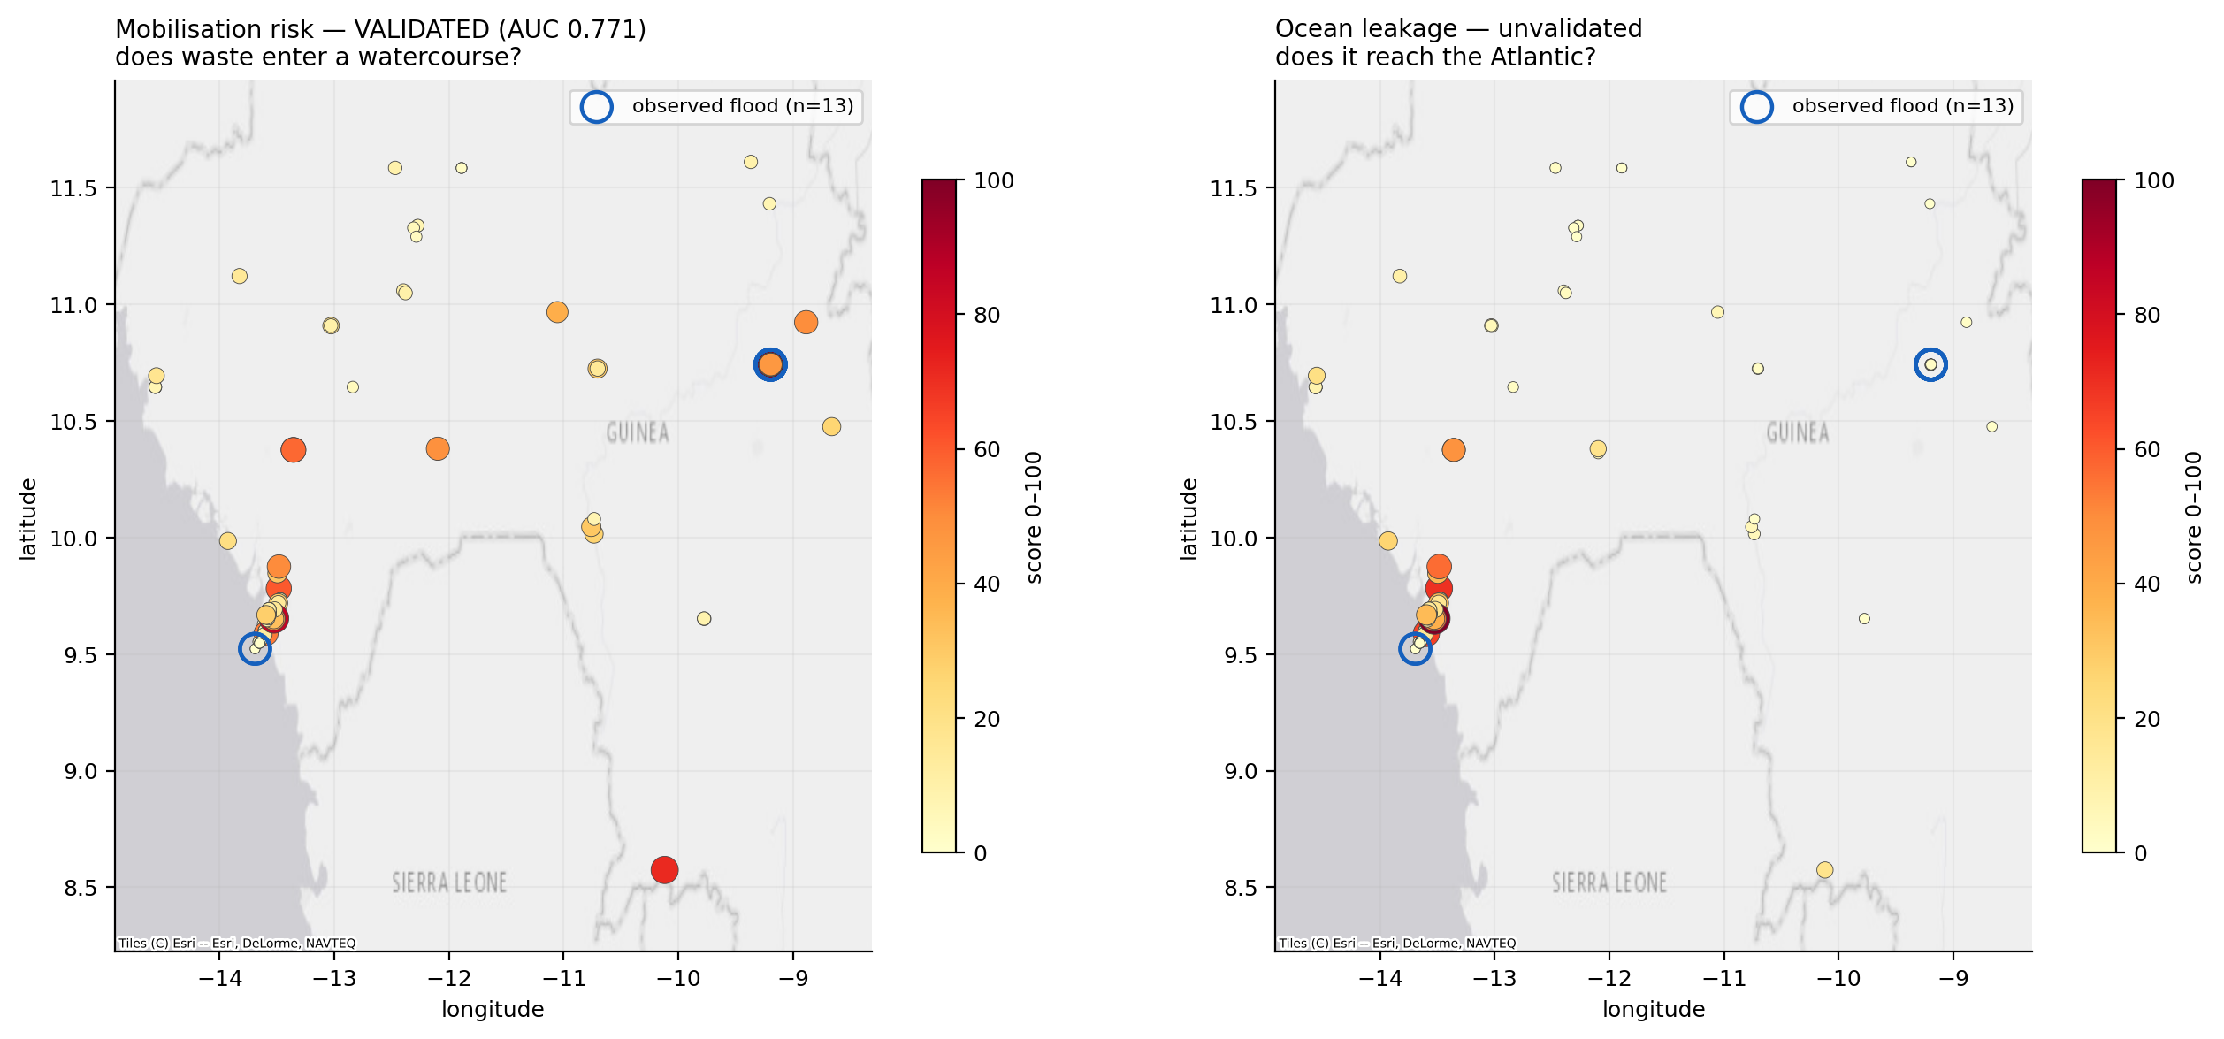
Figure 19. The two scores compared, with observed flood sites ringed. Left: mobilization risk, validated. Right: ocean leakage, unvalidated.

7.5 Waterside dumping: a link between components B and D
Sampling ESA WorldCover at the labelled dump points places 19 of 111 points (17%) on water, wetland or mangrove classes: 13 on permanent water, 3 on herbaceous wetland and 3 on mangrove.
These sites are the land-to-ocean pathway the program is concerned with, they connect the terrestrial dumpsite layer to the existing marine layers, and they are a direct input to the mobilization model in §7.4. The flag is computed per labelled point and is available as an analysis output; the deployment documentation discusses what would be required to carry it on the published layer.
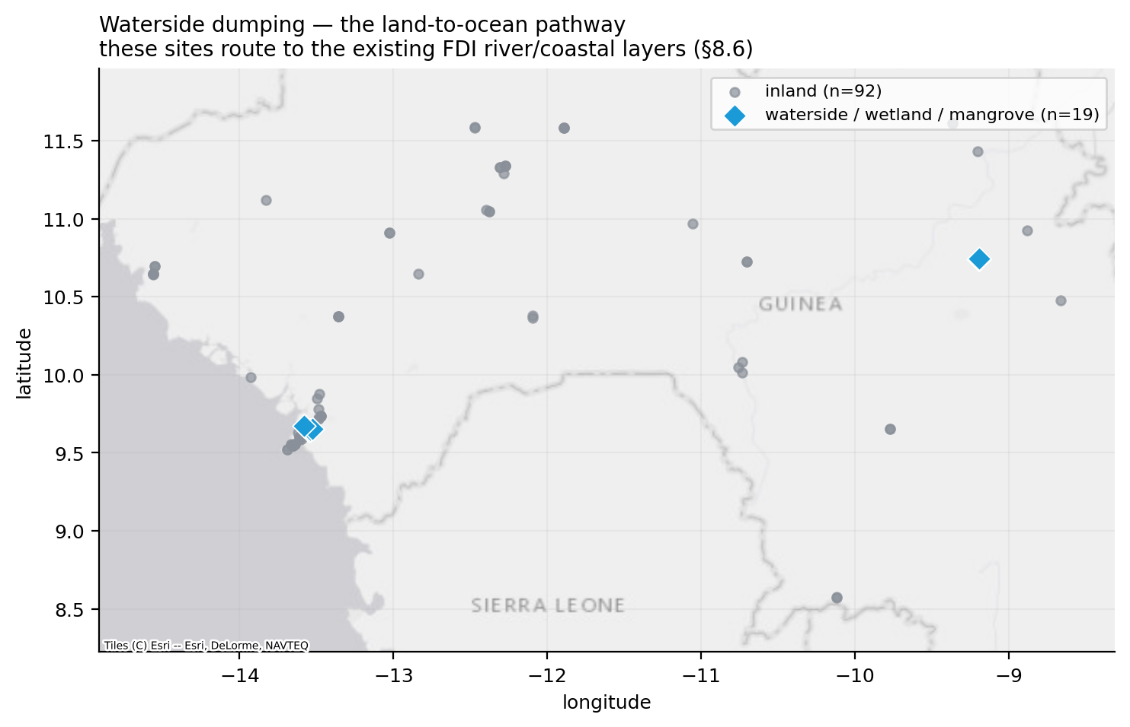
Figure 20. Waterside dumping. These sites route to the existing FDI river and coastal layers without modification.

7.6 Component D: plastic leakage quantification

7.6.1 Three checks the model could have failed
None of the three uses its own answer as an input, and all three exercise the front of the chain — the part for which Guinean evidence exists.
Table 57. Out-of-sample checks on component D. The second row is the density-versus-count error of §5.4.2, shown to quantify what the area weighting prevents.
Check | Modelled | Independent figure | Agreement
Population, area-weighted | 13,211,010 | 13,132,795 (UN WPP 2020) | +0.6%
Population, naive pixel sum | 15,698,904 | 13,132,795 | +19.5% — the error avoided
National collection rate | 10.5% implied | 9.7% reported | +8.5%
National MSW tonnage | 1,493,437 t yr⁻¹ | 1,568,192 t yr⁻¹ (What a Waste) | -4.8%

The collection check is the most informative of the three. The 9.7% national rate is a separate entry in the same survey and is never used as an input, so agreement is evidence that the urban/rural classification routes people to approximately the right rate. Disagreement would have indicated a wrong density threshold.
No check exists for open burning, environmental leakage or transport to water, because no Guinean measurement of them exists. That absence is not a gap in this document's diligence; it is the state of the evidence, and §7.6.3 shows that it is also where the uncertainty is concentrated.

7.6.2 The estimate, with its range intact
The two scenarios share every input except the plastic share of municipal waste, so the difference between the columns isolates that one parameter. Plastic reaching the environment differs by a factor of 4.6, from 18,166 to 84,017 tons per year, and the quantity reaching a watercourse differs by the same factor. The mass balance closes in both columns, which confirms the arithmetic without saying anything about which column is nearer the truth.
Table 58. Central estimates under both composition scenarios, tons per year. The mass balance closes in both: burned plus leaked plus contained equals plastic generated.
Quantity | 2007 composition (4.0% plastic) | Recent Conakry composition (18.5% plastic)
MSW generated | 1,493,437 t yr⁻¹ | 1,493,437 t yr⁻¹
Plastic in waste stream | 59,737 | 276,286
Uncollected | 53,452 | 247,216
Open burned (destroyed) | 29,399 | 135,969
Reaching the environment | 18,166 | 84,017
Reaching a watercourse | 545 | 2,521

Plastic reaching the Guinean environment is therefore 18,166–84,017 t yr⁻¹ depending on which composition figure is believed, a factor of 4.6. Within either scenario the 90% Monte Carlo interval spans roughly ±60%. The scenario gap exceeds either scenario's own interval and the two intervals do not overlap, so the binding constraint on this estimate is not statistical: no additional computation narrows it. Guinea has no recent national waste composition survey.
The scenario range must be quoted first and the statistical interval second. Quoting a single central value would misrepresent what is known.
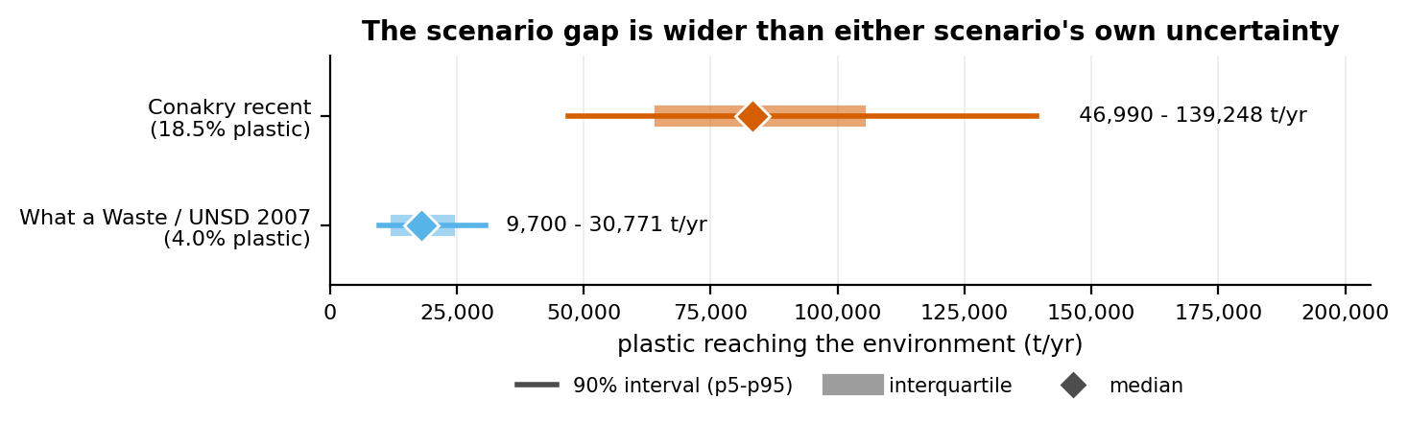
Figure 21. Monte Carlo distributions of annual plastic leakage under the two composition scenarios. The intervals do not overlap.
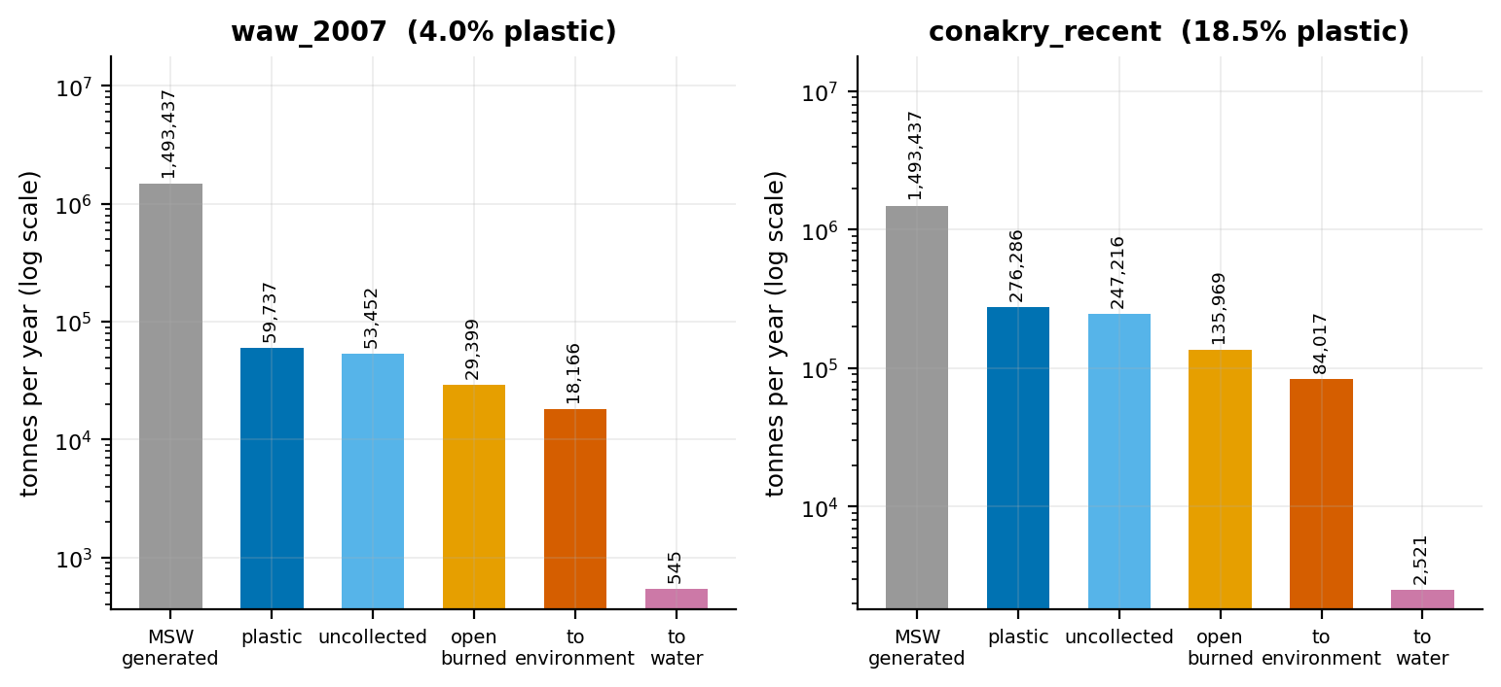
Figure 22. The waste chain under both composition scenarios, logarithmic. The open-burning step removes roughly 55% of uncollected plastic as macro-debris; omitting it would about double the leakage figure.
The two scenario distributions barely overlap, which is why the range between them is the quantity that governs how precisely national leakage can be stated.

7.6.3 What the estimate is limited by, and the monitoring implication
Global sensitivity was computed as squared Spearman rank correlation between each input draw and the output, normalized (Saltelli et al. 2008); rank instead of linear correlation because the chain is multiplicative. The result inverts the usual monitoring priority.
Table 59. Global sensitivity of the leakage estimate. The best-measured parameter contributes least.
Parameter | Share of variance | Guinean measurement exists?
open_burn_fraction | 36.0% | no
msw_rate | 25.8% | yes
plastic_share | 20.4% | yes
leak_to_env | 17.5% | no
collection_urban | 0.1% | yes
urban_density_threshold | 0.1% | no

Open burning alone accounts for roughly 36% of the variance and has never been measured in Guinea. Collection coverage — the single best-measured parameter in the model, from an actual field survey — accounts for about 0.1%, because at 9.7% national coverage its uncertainty cannot move the answer.
The recommendation follows directly and is not an opinion: another collection survey would buy almost no precision, while a waste composition survey and a disposal-practice survey would buy a great deal. This falls out of the model, and it is carried into §9.3.
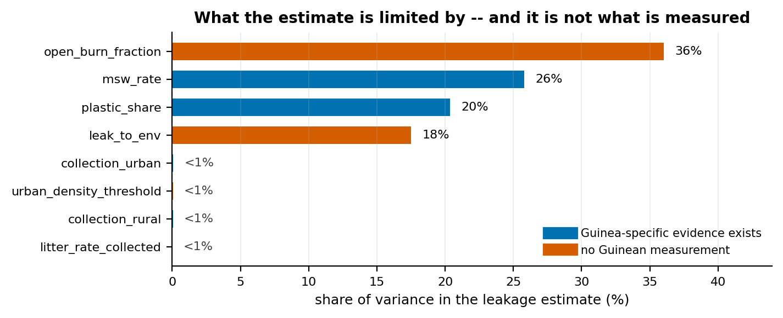
Figure 23. Global sensitivity of the leakage estimate. Parameters with no Guinean measurement dominate the uncertainty; the surveyed collection rate is invisible on this axis.

7.6.4 The size of the error that quadrature would introduce
Summing regions within each Monte Carlo iteration — the treatment of §5.4.4 — gives a national 90% interval of 9,466–30,063 t yr⁻¹. Combining the same regional uncertainties in quadrature gives 13,666–21,389. The correct interval is 2.7× wider.
That factor is the cost of the independence assumption. It is not a rounding difference but most of the uncertainty, and it would have been invisible in any table that reported regional error bars without stating how they may be combined.

7.6.5 Regional distribution
Absolute totals follow population. Per-capita leakage runs higher in rural regions, because rural collection coverage is 2.1% against 23.7% urban — a structural result, not a statistical one, and the reason the urban/rural split is carried through the whole chain.
Error bars on regional totals are perfectly correlated across regions by construction and must not be combined in quadrature; see §7.6.4.
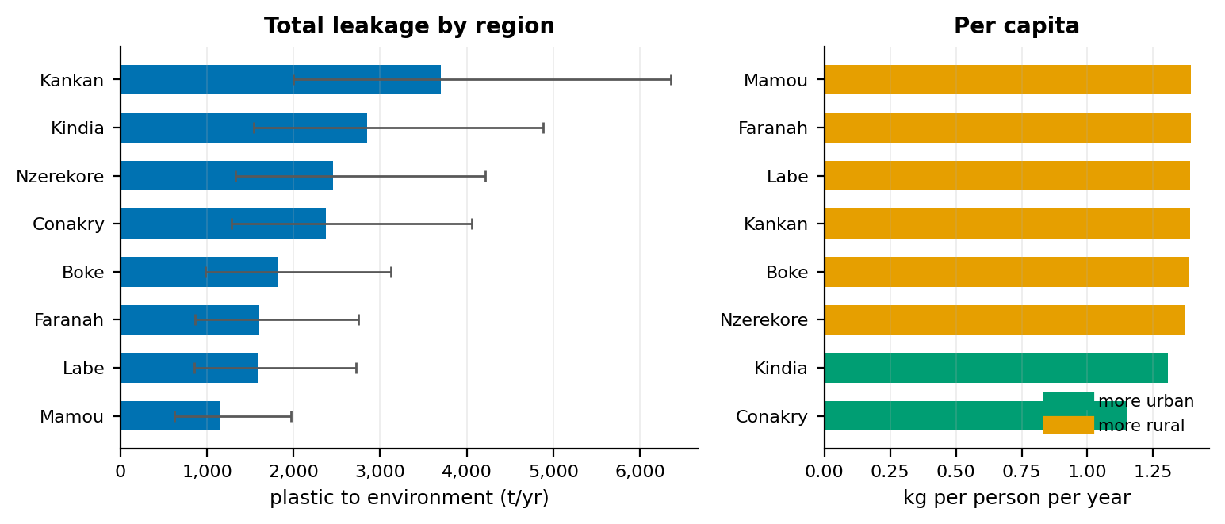
Figure 24. Plastic leakage by ADM1 region under the 2007 composition scenario. Error bars are 90% intervals from shared national parameter draws and are therefore perfectly correlated across regions.
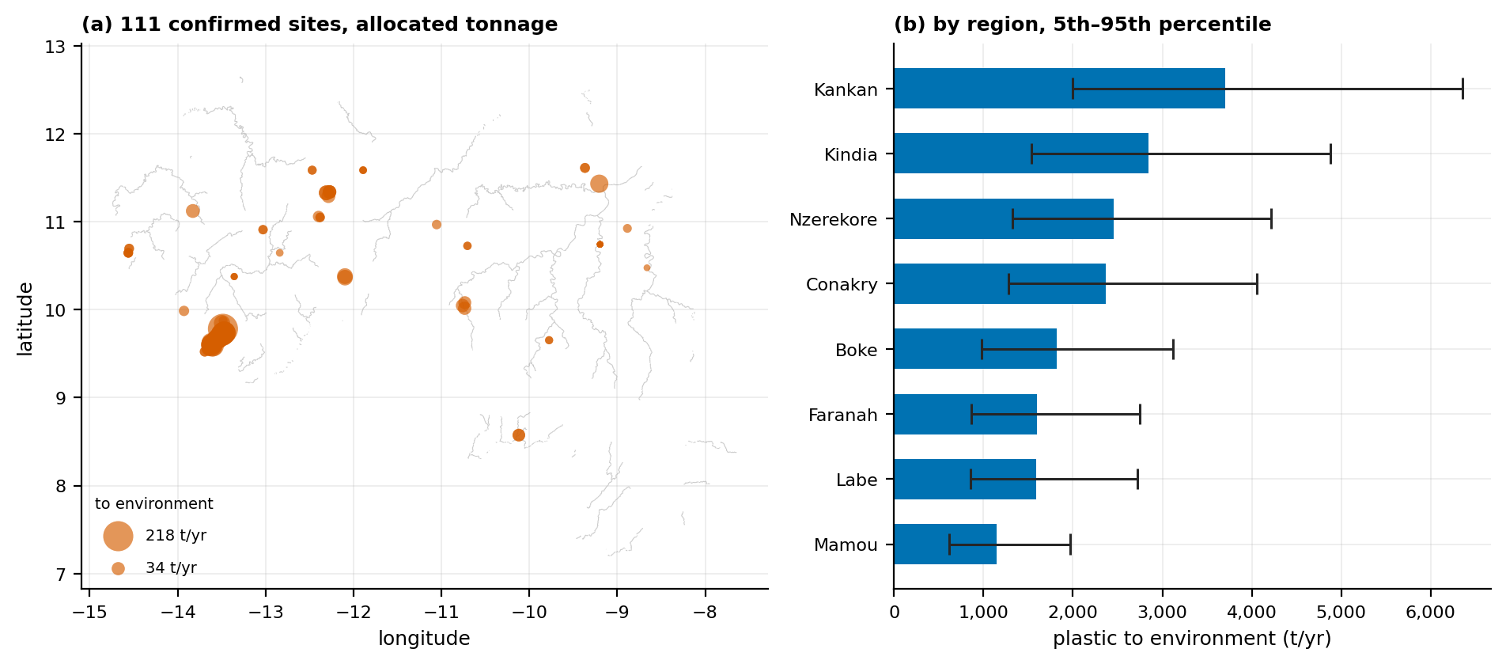
Figure 25. Modelled plastic leakage, 2007 composition scenario (4.0% plastic). (a) The 111 labelled sites, marker area proportional to allocated tonnage entering the environment, with the river network for context. (b) Regional totals with 5th–95th percentile Monte Carlo intervals. Both panels are modelled quantities, not measurements.
Allocated tonnage concentrates sharply around the largest population centers, and the regional intervals overlap substantially, so the ordering between adjacent regions should not be treated as resolved.

7.6.6 Per-site tonnage, and a different ordering from mobilization risk
Allocating leakage to the 111 labelled sites over 5 km catchments attributes 4,092 t yr⁻¹ (23% of the national figure) to populations amounting to 26% of Guinea's population. The shared-catchment correction removed 25.0 million person-claims, overwhelmingly in Conakry where catchments overlap heavily; without it the site total would have exceeded the national one.
Per-site tonnage and the mobilization risk score of §7.4 rank sites differently: Spearman ρ = 0.33, and the top fifteen lists share only four sites. The disagreement is informative. Mobilization risk is driven by terrain and hydrology; tonnage is driven by catchment population. A steep site above a stream in a thinly populated area ranks high on the first and low on the second.
Both therefore belong in the layer, answering different operational questions: mobilization risk asks how urgently a site would leak if left, tonnage asks how much material is at stake.
One limitation must travel with every per-site figure. The estimate is a property of the catchment, refined by the site's size class and transport terms — not an observation of the site. Two adjacent sites with the same catchment receive the same mass estimate however different they look, because no remote-sensing product can distinguish them by mass at 14 m extent. The site inventory is also a labelled sample from a national random grid, not a census, so the coverage above must not be read as implying the rest of the country has no sites.
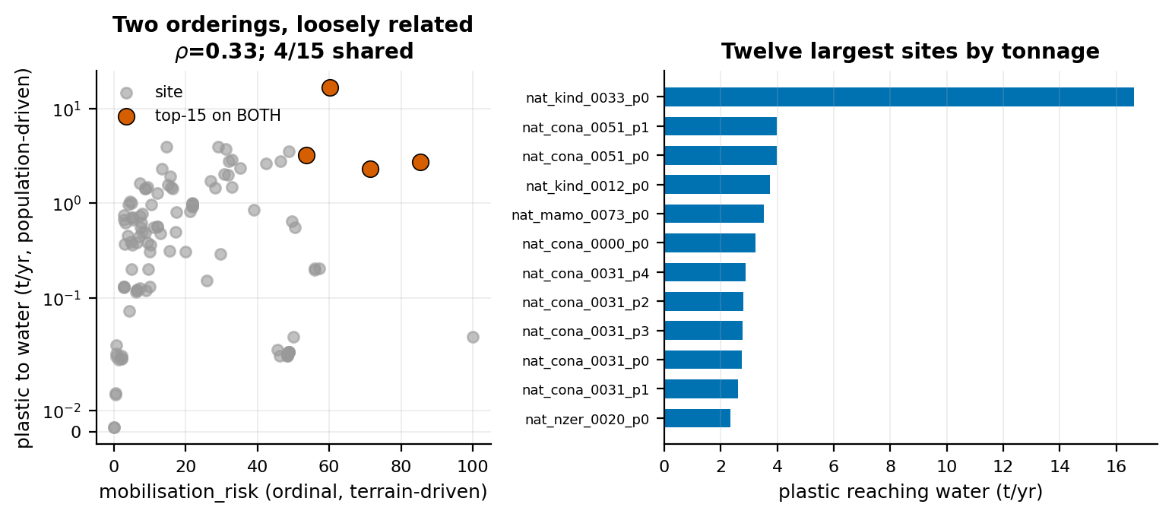
Figure 26. Per-site plastic tonnage against the ordinal mobilization risk score. The two orderings are related but far from identical, because they are driven by different variables.

7.6.7 What component D must not be used to claim
Component D estimates an annual flow in tons. Components A and B report a count of locations where material is visible, with no mass attached. A flow and a count have no arithmetic relationship, and dividing one by the other produces a number with units but no meaning.
The only consistency statement available is an upper bound: if every ton entering the environment passed through a detected site, each site would handle a computable throughput. It does not — detection is incomplete, much leakage is diffuse littering that never forms a visible accumulation, and the inventory is a sample. The figure is useful for sanity-checking order of magnitude and nothing else, and component D therefore does not validate components A or B, nor they it.

8. Limitations and Uncertainty
The limitations below are ordered by how much they constrain use of the outputs. The first is binding on everything in this document; the rest qualify individual components. Each is stated once, with the section that measures it.
- Neither operational layer measures plastic, and this is measured. The Floating Debris Index responds to any material raising near-infrared reflectance above the water baseline, so seaweed, algae, timber, vegetation and sea foam raise it as macroplastic does. A classifier trained on labelled debris removes most of these confusers — on benchmark data the published layer reaches precision 0.90 to 0.92 — but what it keeps is floating material that looks like debris, not plastic (§7.1.13, §7.1.14). The terrestrial layer carries no spectral information about material at all. Interface copy, reports and public communication should therefore read waste accumulation sites on land and floating-debris candidates on water.
- All accuracy evidence is photo-interpretive and provisional. No detection has been confirmed in the field, and a single interpreter produced every Guinean label, so no inter-rater agreement estimate is available. Conakry marine precision is 36.8% on decided patches and 26.9% in the worst case, far below the 0.90 to 0.92 measured on MARIDA; the two measure different things and both must be reported. Only Conakry has been reviewed under the current detector, and no recall figure exists for the marine layer.
- Terrestrial recall must be quoted with the screen folded in. End-to-end recall is the stage-1 screen's 85.5% retention multiplied by stage 2's blind-grid recall. For the deployed free-imagery scan at the medium tier that is 45.8% of sites at Conakry and 22.9% at Boké (§7.2.11); with licensed imagery at the high tier it is approximately 35% and 17% (Table 50). Recall does not depend on prevalence (§7.2.10), so the lower Boké figures are not the base-rate effect that lowered its lift. Both are lower again for sites that are small, canopy-covered or inside walled compounds. Quoting stage 2 alone, or the point-centered recall in place of the blind-grid recall, overstates performance.
- The terrestrial classifier responds to surface disturbance, and whether a given detection contains waste cannot be settled without field verification. Across the 243 waste-containing windows of the 557 exhaustively labelled at Boké, the score shows no association with how much waste a window contains (Spearman ρ = −0.027, P = 0.68) and is highest over bare construction ground (§7.2.8). High-scoring windows do frequently contain waste — that is what the precision figure reports — but the score is tracking disturbed anthropogenic ground. Scale is not the explanation: although a median 14.0 m site (§7.3) occupies roughly three per cent of an 80 m window, an architecture ablation across three scales and two pooling operators recovered no response to waste quantity (§7.2.9), and two attempted remedies produced no improvement (§7.2.7). Generic image features do not separate waste from other disturbed ground.
- False positives over water cannot be masked away. Structures built over water — quays, jetties and moored vessels — are correctly classified as water by every available water product because they are on water. A port exclusion zone is therefore published as a flag rather than applied as a removal (§7.1.5); one of thirty national patches carries it in January 2024.
- A nil return from an anomaly detector is not evidence of absence. Because the threshold is derived from each region's own water population, a region containing little water produces an inflated threshold and can return zero detections regardless of what is present (§7.1.9). Regions below 10% water coverage are marked not assessed, and any zero must be qualified by the water fraction and threshold that produced it.
- Counts are not comparable across time or between regions without their thresholds. Per-scene thresholds are inherent to anomaly detection, but they mean a monthly series compares counts produced under different criteria (§7.1.7), and the measured spread across the four coastal regions is 2.2×.
- Upstream sensitivity is lower than coastal, and unevenly so. Corridor thresholds run about 1.2 times the Conakry threshold, and up to three times on individual tiles, because a corridor's water population is mixed with turbid, shallow and bank-adjacent pixels that inflate σ. Only about 55% of screened corridor length carries a usable threshold, the remainder being reported not assessed for want of mapped permanent water at 20 m. Within the assessed length, detections track observable water area, so every upstream figure must carry three qualifiers: the threshold, the assessed length, and the statement that a low count measures reduced sensitivity (§7.1.12).
- Resolution floors, imagery age and cloud bound what is visible. Marine patches average 8.7 pixels at 20 m and accumulations below roughly 500 m² are not mappable, which is the direct cause of the 27% adjudication ambiguity rate. A monthly median also suppresses transient material: single acquisitions carry about three times the composite's median debris probability (§7.1.14). Optical detection is unreliable above roughly 70% cloud cover; scenes in that condition are flagged, advisory only, as no synthetic-aperture radar cross-check is currently wired in. Terrestrial basemaps are 17 to 19 months old over the towns examined and the imagery API does not report capture date, so detection date and imagery date are distinct fields, and a new detection means newly detected, not newly appeared.
- The learned classifier transfers, with limits on what may be exported. Measured in the units the model was fitted in, no feature shifts by as much as one training spread and 98% of scored pixels fall inside the training support on every feature (§7.1.14), so the classifier is deployed as the second stage of the marine layer. Its debris probability is what the layer uses and publishes, and the local annotation is consistent with it rather than confirming it: the annotation scheme carried no debris category and bounds the debris share between 0 and 54.7%, so a near-zero median probability is not contradicted by it; its choice among MARIDA's other classes is not locally corroborated and is not exported. And the benchmark contains no West African scene, so the water optical type and floating-material mix are unverified for this coast.
- Component D is modelled and its uncertainty is structural. It uses no satellite imagery: it is a demographic and documentary calculation over a population surface, a published generation rate, a surveyed collection rate and four literature parameters, so its maps and charts display modelled quantities, and nothing in components A or B can validate them. The uncertainty is dominated by a disagreement about evidence: Guinea's only nationally representative composition figure dates from 2007 and gives plastic at 4.0%, while recent Conakry characterization gives 15–22%, a range spanning a factor of 4.6 that exceeds the Monte Carlo interval within either scenario. The back half of the chain — open burning, environmental leakage, transport to water — has no Guinean measurement and carries most of the variance (§7.6.1, §7.6.3). The interval covers the stated parameter ranges and does not cover structural errors.
- Constraints on the negative result. The six hyperspectral acquisitions cover 30 distinct sites and 1,256 spectra, with the higher-count scenes largely re-imaging the same sites on different dates; this is a replication check across six acquisitions, four regions and three years, not 140 independent dumpsites, and every fold blocks on site. Site extent is imprecise in a definitional sense, though the conclusion does not depend on the precision: the probability that the median site fills one 30 m pixel is under 1% under either read (§7.3). Nine sites were excluded as unclear and have not been tested for systematic size bias. PRISMA remains unchecked and shares the same 30 m ground sampling that binds the conclusion. Appendix C reports the test in full.
- Imagery licensing is unresolved for both providers. Whether Esri World Imagery's terms permit systematic classification of its tiles, on which the deployed scan relies, has not been determined. Retention and onward service of cached commercial basemap imagery requires a licensing determination that has not been made; cached tiles are excluded from the source repository as a precaution, and whether derived vector outputs may be produced and published from that imagery is part of the same determination.
- No field validation exists anywhere in this module, for the negative result or for any other finding. The module establishes what is and is not detectable in these data. It does not measure how much plastic is present.

9. Conclusions and Recommendations

9.1 Delivered by the module
The module delivers a nationwide waste-accumulation mapping capability on water and on land, together with a modelled national leakage estimate and four measurements that did not previously exist for Guinea.
- A marine floating-debris layer. Reproducible detection of candidate floating debris in Guinean coastal waters — the published index and threshold rule followed by a classifier trained on the MARIDA benchmark — with benchmark precision of 0.90 to 0.92 and a photo-interpreted precision at Conakry of 36.8% on decided patches and 26.9% in the worst case. Suitable for publication as an operational screening layer when accompanied by the scope and accuracy statements in §1.4, §7.1.9 and §8.
- An upstream extension of the same method to river corridors, covering about 55% of screened corridor length, which establishes where the method can see inland, where it cannot, and how much less sensitive it is there (§7.1.12).
- A terrestrial screening capability deployable nationally on free imagery at no imagery cost, which ranks disturbed anthropogenic ground in which waste is commonly deposited rather than waste itself (§7.2.8), with measured blind-grid precision at the medium tier of 0.347 against a 0.261 base rate at Conakry and 0.586 against 0.436 at Boké (§7.2.11); with licensed imagery, at approximately US$480 to 690 per national scan, ROC-AUC rises from 0.594 to 0.682 at Conakry and from 0.687 to 0.738 at Boké.
- An on-demand location assessment, which scores ROC-AUC 0.911 on point-centered imagery — the task a user performs when querying a chosen location, and a materially easier task than the blind grid.
- A national plastic leakage estimate with propagated uncertainty, regional disaggregation and per-site allocation, validated on three independent checks: population against the UN WPP 2020 estimate (+0.6%), the derived collection rate against the separately reported national figure (+8.5%), and municipal waste tonnage against the published series (−4.8%) (§7.6).
- Four measurements new to Guinea: the first measured dumpsite size distribution (median 14.0 m area-equivalent side, n = 46); a waterside-dumping flag placing 19 of 111 labelled sites on water, wetland or mangrove, which connects the terrestrial layer to the marine one; a waste mobilization model validated against observed flooding at AUC 0.771; and a quantified account of what the floating-debris rule fires on and what the classifier removes.
- One methodological finding of wider relevance. Spatially blocked cross-validation on point-centered crops overstated deployment performance by 0.229 ROC-AUC at Conakry and 0.173 at Boké. Blocking prevents adjacent-tile leakage but not a dataset-wide correlation between terrain type and label, and only a blind-grid test exposes it. Published dumpsite-detection accuracies obtained on curated crops should be read with this gap in mind.

9.2 Not delivered by the module
Estimating the plastic fraction within an individual site is not achievable from satellite imagery with any openly available orbiting instrument. The constraint is physical and is stated here because it is the conclusion most likely to be read as a delay.
One commercial instrument qualifies the word openly. WorldView-3, in orbit since 2014, carries eight shortwave-infrared bands, of which SWIR-1 (1195-1225 nm) and SWIR-4 (1710-1750 nm) sit on both C-H diagnostic features, and its shortwave data are delivered at 7.5 m against a 3.7 m native sampling. At that resolution a site at the measured median of 14.0 m covers roughly three to four pixels rather than a fraction of one, so the sub-pixel argument that ends the EnMAP and EMIT route does not transfer to it, and the instrument has been used for plastic and hydrocarbon mapping elsewhere. Three things nevertheless separate it from a usable national layer here: it is tasked commercial imagery rather than an open archive, so national coverage would have to be bought and its existing archive over Guinea has not been checked; mixing persists at the lower quartile of the size distribution, where a 9.9 m site covers only one to two 7.5 m pixels; and the plastic fraction within a mixed municipal dump remains a composition question rather than a detection one. It is recorded here as the route a future test would take, not as an oversight in this one.
Identifying plastic from reflected solar radiation requires the C–H absorption features near 1215 nm and 1730 nm. Sentinel-2 samples neither, both falling between its bands, so the plastic-mulch index family measures continuum shape and behaves empirically as a bare-ground detector. The openly available instruments that do resolve those features have ground sampling of 30 m (EnMAP) and 60 m (EMIT), against a measured median Guinean site of 14.0 m — 0.22 and 0.05 of a pixel's area respectively (§7.3). No pixel in Guinea contains only dumpsite, so spectral library matching is unavailable in principle. Appendix C reports the direct test.
This agrees with the published literature. Kruse et al. (2023), the strongest satellite study of terrestrial plastic waste, detects waste sites from Sentinel-2 and states explicitly that it cannot determine plastic fraction within a site. Yang et al. (2017) report detection of plastic sheeting where the plastic fraction exceeds roughly 12% of a mixed pixel, a condition a mixed municipal dump at sub-pixel scale cannot satisfy. The positive hyperspectral results over the Ghazipur and Okhla landfills (Dutta et al., 2022) concern targets hundreds of meters across, where a pixel is filled with landfill (§2.3.2). Site detection is the state of the art; composition within a site is not.
The program concept note's own design anticipated this: it designates a ground-level computer-vision tool for collectors as the core route to material characterization, with airborne hyperspectral only as an option to explore. Sub-meter airborne or ground-level sensing removes the sub-pixel problem that ends the orbital route. This work confirms that design. The contrast is with close-range imagery, where the same distinctions are routine: Dipo et al. (2025) report 96.55% accuracy separating plastic, metal, paper, glass and organic waste from camera images at sorting distance. The classes that are undecidable in a 30 m pixel are separable when the sensor is close enough for the object to fill the frame, which is the same scale argument in its positive form.
Two products must not be published in any form. No plastic concentration or plastic-heaviness layer should be published: a bare-ground proxy under a plastic label would render convincingly on a map, color a legend plausibly, and be wrong. And the Floating Debris Index must not be extended to land: Appendix C shows that it reproduces the same non-specific signal there, and the marine pipeline's water constraint exists precisely to prevent that failure.

9.3 Recommendations
Both operational layers are deployable. The marine layer filters a published anomaly rule with a classifier that reaches 0.90 to 0.92 precision on labelled benchmark data; the terrestrial layer screens the settled footprint on free imagery, and the on-demand checker scores higher again on user-selected locations — which reflects an easier task rather than better waste detection, since §7.2.8 finds no dose-response to the quantity of waste present. What follows is not a list of blocking defects but the set of improvements the evidence identifies, ordered within each component by the ratio of value to cost. Where an approach is not recommended, the measurement that argues against it is given.
For the marine component:
- Describe the layer by what it measures. The rule alone counts floating-debris candidates (§7.1.13) and the classifier keeps what looks like debris (§7.1.14); neither identifies plastic, so captions, legends, export fields and API descriptions are most defensible when they read floating-debris candidates. The deployed field names already follow this convention; aligning the remaining interface copy is a documentation task.
- Publish the debris probability with every patch and withhold the classifier's class names. The published layer already carries each patch's mean P(debris); the class assignment has no local corroboration (§7.1.14).
- Export distance to the water-mask boundary as a per-feature field without filtering on it. The classifier already removes the vegetated shoreline the rule flags, leaving 2.5% of published pixels within 20 m of land (§7.1.14), and shorelines are also where floating material genuinely accumulates. Publishing the distance lets an analyst apply their own judgement.
- Extend photointerpretation to every region with published patches, starting with Fatala's four, and obtain a second interpreter for a subset of the Conakry review to establish Cohen's kappa. Only Conakry has been reviewed under the current detector, and its precision differs from the benchmark by a wide margin, so the other regions cannot be assumed to resemble either. Inter-rater agreement is the single largest remaining weakness in the marine evidence and is a reasonable precondition for a published accuracy figure.
- Annotate single acquisitions that carry published patches. The annotation tool asks what each detection most resembles and needs no debris category. The 11 January 2024 acquisition has no published patch, so the next candidates are acquisitions elsewhere on the coast and over the upstream tiles of §7.1.12.
- Treat the labelled pixel spectra of the Conakry review as the seed of a Guinea-specific training set, to retrain or recalibrate the classifier on local water. MARIDA supplies the classifier today but contains no West African scene; Biermann et al. (2020) trained their classifier on fewer than 200 labelled pixels, so the required volume is attainable.
- Resolve how offshore detections are attributed before per-area counts are published and redraw the regional areas of interest as polygons. Nearest-prefecture attribution assigns open-water detections to the nearest coast, which inflates Conakry wherever offshore patches are published (§7.1.11); and the southern area is configured as a mangrove fringe although it is mostly open water, so its name should be corrected.
- Pool upstream thresholds by river system. Each tile currently derives its own threshold, so a river spanning nine tiles carries nine independent estimates. Pooling would improve statistical efficiency and make patch counts comparable along a river, which they presently are not.
For the terrestrial component:
- A national layer is supportable and should be published with its measured bounds. The model generalizes: an independent blind grid at Boké (557 exhaustively labelled windows, §7.2.8) returned a lift of 1.48× against a criterion of 1.5× declared in advance. That criterion was fixed before the test to prevent post-hoc rationalization, which is the correct practice, and it is reported as missed. The miss says little about the model: lift is bounded by the reciprocal of the base rate, so Boké's higher prevalence set a lower ceiling (2.29× against 3.84× at Conakry), while ROC-AUC, which does not depend on prevalence, rose from 0.682 to 0.738 (§7.2.8). The substantive qualification is a different one: the score responds to disturbed anthropogenic ground, and construction sites score above every waste category. A national layer should therefore be published to analysts, not to the public, as a prioritization aid carrying its end-to-end recall (§8), its precision at the chosen confidence tier, and a statement that features are candidates. The deployed scan confirms on free imagery, and its own blind-grid bounds are measured (§7.2.11): at the medium tier, precision 0.347 and 0.586 and end-to-end recall 45.8% and 22.9% at Conakry and Boké. Those, not the licensed-imagery figures, are the bounds to publish with it. The question this invites is whether a layer of that strength is worth publishing at all, and it is better answered than left implicit. The alternative is not a stronger layer but no layer: Guinea has no national record of informal disposal sites, so the comparator is an analyst opening imagery with no prior at all. Against that comparator the cascade removes about two thirds of the settled footprint from consideration at no imagery cost (§7.2.4) and returns a queue in which roughly one window in three at Conakry and three in five at Boké contain waste. That is worth having on one condition, which is that the layer is described as what it measures, because the cost of the other reading — a candidate queue treated as a register of sites — falls on whoever acts on it.
- Present detections as machine-learning-derived candidates that have not been verified in the field, publish the confidence tier alongside every feature, and default the display to the medium tier, at which the free-imagery scan balances precision and recall (§7.2.11). Present detection date and imagery date as distinct fields, noting that a new detection means newly detected.
- Pair the map with a per-prefecture ranked list. Precision at the top of a ranking is considerably higher than precision across a whole layer, and a ranked worklist matches how a ministry would act on the output.
- Offer the on-demand location check alongside the national layer. Assessing a user-selected location is the point-centered task, on which the model scores ROC-AUC 0.911, not the blind-grid task, on which it scores 0.682 at Conakry and 0.738 at Boké. The two figures must not be interchanged: a score obtained at a location a person selected is not evidence of the model's behavior over unselected ground.
- Further labelling at the 80 m footprint, and a change of network architecture, are both unlikely to repay their cost. Label quality is no longer the binding constraint — the Boké annotator digitized 752 individual waste features, and the score remains indifferent to them — and a Feature Pyramid Network ablated across three scales and two pooling operators moved accuracy within a 0.06 band without recovering a response to waste quantity (§7.2.9). If terrestrial detection is revisited, the prerequisite is task-specific labelled data collected in Guinea at the scale published models use — thousands of images — since supervision acquired elsewhere has twice failed to transfer (§7.2.9). That is a data-collection program and should be costed as one.
- Resolve the imagery licensing position for both providers — whether Esri World Imagery's terms permit systematic classification of its tiles, on which the deployed scan relies, and whether candidates derived from licensed imagery may be produced and published — before the national layer is released or any interface serves cached commercial basemap imagery onward.
For the leakage component:
- Commission a waste composition and disposal-practice survey in preference to a further collection survey. Open burning contributes about 36% of the variance in the national estimate with no Guinean measurement behind it, while collection coverage — the best-measured parameter — contributes about 0.1% (§7.6.3). This inverts the usual monitoring priority and follows from the model. A composition survey would also collapse the 4.6× scenario range that currently dominates every component D figure, which no additional computation can narrow.
- Report leakage as a range across both composition scenarios, with the Monte Carlo interval, and never as a single figure. Regional intervals should not be combined in quadrature: the parameters are shared across regions, so the errors are correlated and quadrature understates the national interval by a factor of 2.67 (§7.6.4).

10. References
Andreadis, K. M., Schumann, G. J.-P. & Pavelsky, T. (2013). A simple global river bankfull width and depth database. Water Resources Research, 49(10), 7164–7168.
Balsi, M., Moroni, M. & Bouchelaghem, S. (2025). Plastic litter detection in the environment using hyperspectral aerial remote sensing and machine learning. Remote Sensing, 17(5), 938. doi:10.3390/rs17050938
Biermann, L., Clewley, D., Martinez-Vicente, V. & Topouzelis, K. (2020). Finding Plastic Patches in Coastal Waters using Optical Satellite Data. Scientific Reports, 10, 5364.
Cottom, J. W., Cook, E. & Velis, C. A. (2024). A local-to-global emissions inventory of macroplastic pollution. Nature, 633, 101–108.
Danilov, A. & Serdiukova, E. (2024). Review of methods for automatic plastic detection in water areas using satellite images and machine learning. Sensors, 24(16), 5089. doi:10.3390/s24165089
Digital Earth Africa. Detection of Floating Marine Debris. DE Africa Sandbox real-world examples notebook. https://docs.digitalearthafrica.org (accessed September 2026).
Dijkstra, L., Florczyk, A. J., Freire, S., Kemper, T., Melchiorri, M., Pesaresi, M. & Schiavina, M. (2021). Applying the Degree of Urbanisation to the globe: A new harmonised definition reveals a different picture of global urbanisation. Journal of Urban Economics, 125, 103312.
Dipo, M. H., Farid, F. A., Mahmud, M. S. A., Momtaz, M., Rahman, S., Uddin, J. & Karim, H. A. (2025). Real-time waste detection and classification using a YOLOv12-based deep learning model. Digital, 5(2), 19. doi:10.3390/digital5020019
Dutta, A., Chaudhary, P., Sharma, S. & Lall, B. (2022). Satellite hyperspectral imaging technology as a potential rapid pollution assessment tool for urban landfill sites: case study of Ghazipur and Okhla landfill sites in Delhi, India. Environmental Science and Pollution Research, 30(55), 116742–116750. doi:10.1007/s11356-022-22421-1
Global Plastic Watch, Minderoo Foundation. https://globalplasticwatch.org (accessed September 2026); Global Forest Watch, World Resources Institute. https://globalforestwatch.org (accessed September 2026). Both consulted as operational benchmarks (§2.6).
Güngör, R., Sanli, F.B., Ates, A.M. & Yilmaz, O.S. (2026). Evaluation of Classification Accuracy of Spectral Indices and Machine Learning Algorithms for Greenhouse Detection Using the Google Earth Engine Platform. Journal of Agricultural Sciences, 32(1), 158-176.
Hasituya, Chen, Z., Li, F. & Hongmei (2019). New Workflow of Plastic-Mulched Farmland Mapping using Multi-Temporal Sentinel-2 Data. Remote Sensing, 11(11), 1353.
Hu, C. (2009). A novel ocean color index to detect floating algae in the global ocean. Remote Sensing of Environment, 113(10), 2118–2129.
Jambeck, J. R., Geyer, R., Wilcox, C., Siegler, T. R., Perryman, M., Andrady, A., Narayan, R. & Law, K. L. (2015). Plastic waste inputs from land into the ocean. Science, 347(6223), 768–771.
JICA (Japan International Cooperation Agency) (2022). Data Collection Survey on Municipal Solid Waste Management in Africa: Guinea country sheet, reference year 2018. Distributed via the World Bank What a Waste database, indicator WM_COL_COV.
Kaza, S., Yao, L., Bhada-Tata, P. & Van Woerden, F. (2018). What a Waste 2.0: A Global Snapshot of Solid Waste Management to 2050. Washington, DC: World Bank.
Kikaki, K., Kakogeorgiou, I., Hoteit, I. & Karantzalos, K. (2023). Detecting Marine Pollutants and Sea Surface Features with Deep Learning in Sentinel-2 Imagery. iScience, 26, 108402.
Kikaki, K., Kakogeorgiou, I., Mikeli, P., Raitsos, D. E. & Karantzalos, K. (2022). MARIDA: A benchmark for Marine Debris detection from Sentinel-2 remote sensing data. PLoS ONE, 17(1), e0262247.
Kruse, C., Boyda, E., Chen, S., Karra, K., Bou-Nahra, T., Hammer, D., Mathis, J., Maddalene, T., Jambeck, J. R. & Laurier, F. (2023). Satellite monitoring of terrestrial plastic waste. PLOS ONE, 18(1), e0278997. doi:10.1371/journal.pone.0278997
Lehner, B. & Grill, G. (2013). Global river hydrography and network routing: baseline data and new approaches to study the world's large river systems. Hydrological Processes, 27(15), 2171–2186.
Lin, T.-Y., Dollár, P., Girshick, R., He, K., Hariharan, B. & Belongie, S. (2017). Feature Pyramid Networks for Object Detection. IEEE Conference on Computer Vision and Pattern Recognition (CVPR), 2117–2125.
Lu, L., Di, L. & Ye, Y. (2014). A Decision-Tree Classifier for Extracting Transparent Plastic-Mulched Landcover from Landsat-5 TM Images. IEEE JSTARS, 7(11), 4548-4558.
Meijer, L.J.J., van Emmerik, T., van der Ent, R., Schmidt, C. & Lebreton, L. (2021). More than 1000 rivers account for 80% of global riverine plastic emissions into the ocean. Science Advances, 7(18), eaaz5803.
Mellink, Y., van Emmerik, T., Kooi, M., Laufkötter, C. & Niemann, H. (2022). The Plastic Pathfinder: A macroplastic transport and fate model at river basin scale. Frontiers in Environmental Science, 10, 979685.
Nivedita, V., Sabarunisha Begum, S., Aldehim, G., Alashjaee, A. M., Arasi, M. A., Sikkandar, M. Y., Jayasankar, T. & Vivek, S. (2024). Plastic debris detection along coastal waters using Sentinel-2 satellite data and machine learning techniques. Marine Pollution Bulletin, 209, 117106. doi:10.1016/j.marpolbul.2024.117106
Otsu, N. (1979). A threshold selection method from gray-level histograms. IEEE Transactions on Systems, Man, and Cybernetics, 9(1), 62-66.
Pekel, J.-F., Cottam, A., Gorelick, N. & Belward, A. S. (2016). High-resolution mapping of global surface water and its long-term changes. Nature, 540, 418-422.
Pesaresi, M., et al. Global Human Settlement Layer — Settlement Model (GHS-SMOD). European Commission Joint Research Centre. Degree of Urbanisation classification endorsed by the UN Statistical Commission (2020).
Polák, M. & Kupková, L. (2026). Advances and challenges in plastic detection: a critical review of studies employing hyperspectral data. International Journal of Remote Sensing. doi:10.1080/01431161.2026.2680715
Potiracha, Y. & Baars, R. C. (2026). A review of remote sensing technology for plastic waste monitoring. Environmental Science and Pollution Research, 33, 766–782. doi:10.1007/s11356-025-37347-7
Razavian, A. S., Azizpour, H., Sullivan, J. & Carlsson, S. (2014). CNN features off-the-shelf: an astounding baseline for recognition. IEEE CVPR Workshops, 512-519.
Roberts, D. R., Bahn, V., Ciuti, S., et al. (2017). Cross-validation strategies for data with temporal, spatial, hierarchical, or phylogenetic structure. Ecography, 40(8), 913-929.
Saito, T. & Rehmsmeier, M. (2015). The precision-recall plot is more informative than the ROC plot when evaluating binary classifiers on imbalanced datasets. PLoS ONE, 10(3), e0118432.
Saltelli, A., Ratto, M., Andres, T., Campolongo, F., Cariboni, J., Gatelli, D., Saisana, M. & Tarantola, S. (2008). Global Sensitivity Analysis: The Primer. Chichester: Wiley.
Schenker, N. & Gentleman, J. F. (2001). On judging the significance of differences by examining the overlap between confidence intervals. The American Statistician, 55(3), 182-186.
Tellman, B., Sullivan, J. A., Kuhn, C., et al. (2021). Satellite imaging reveals increased proportion of population exposed to floods. Nature, 596, 80-86. (Global Flood Database, used here for independent validation.)
Themistocleous, K., Papoutsa, C., Michaelides, S. & Hadjimitsis, D. (2020). Investigating Detection of Floating Plastic Litter from Space Using Sentinel-2 Imagery. Remote Sensing, 12(16), 2648.
Topouzelis, K., Papakonstantinou, A. & Garaba, S. P. (2019). Detection of floating plastics from satellite and unmanned aerial systems (Plastic Litter Project 2018). International Journal of Applied Earth Observation and Geoinformation, 79, 175-183.
Topouzelis, K., Papageorgiou, D., Karagaitanakis, A., Papakonstantinou, A. & Arias Ballesteros, M. (2020). Remote Sensing of Sea Surface Artificial Floating Plastic Targets with Sentinel-2 and Unmanned Aerial Systems (Plastic Litter Project 2019). Remote Sensing, 12(12), 2013.
Torres, R. N. & Fraternali, P. (2023). AerialWaste dataset for landfill discovery in aerial and satellite images. Scientific Data, 10, 63.
Tran-Thanh, D., Rinasti, A. N., Gunasekara, K., Chaksan, A. & Tsukiji, M. (2022). GIS and remote sensing-based approach for monitoring and assessment of plastic leakage and pollution reduction in the Lower Mekong River Basin. Sustainability, 14(13), 7879. doi:10.3390/su14137879
UNEP & IUCN (2020). National Guidance for Plastic Pollution Hotspotting and Shaping Action. Nairobi: United Nations Environment Programme.
Wiedinmyer, C., Yokelson, R. J. & Gullett, B. K. (2014). Global emissions of trace gases, particulate matter, and hazardous air pollutants from open burning of domestic waste. Environmental Science & Technology, 48(16), 9523–9530.
WorldPop (2020). Global high-resolution population denominators project: Guinea population density, UN-adjusted (gin_pd_2020_1km_UNadj). University of Southampton. www.worldpop.org
Yang, D., Chen, J., Zhou, Y., Chen, X., Chen, X. & Cao, X. (2017). Mapping plastic greenhouse with medium spatial resolution satellite data: Development of a new spectral index. ISPRS Journal of Photogrammetry and Remote Sensing, 128, 47-60.
Zanaga, D., et al. (2022). ESA WorldCover 10 m 2021 v200. Zenodo.
Zhao, G., Li, J., Li, T., et al. (2004). Use of the Greenhouse Vegetable Land Extraction Index for mapping protected agriculture. Transactions of the Chinese Society of Agricultural Engineering.

Appendix A — Reproducibility
Every figure and number in this document is regenerated from saved run outputs by the scripts below. The document was originally generated by 25_build_module_methodology.py, which reads those run outputs. Subsequent revisions — the Boké replication, the Esri confirmation stage, the MARIDA classifier stage and two rounds of review — have been edited directly in the document, so it should no longer be regenerated from the script: doing so would discard those edits. The script remains the record of how the figures and tables are produced.
Table 60. Artefacts backing every figure and number in this document.
Component | Location
Marine analysis notebook | plasticwaste_analysis.ipynb
Dumpsite analysis notebook | dumpsite_detection_workflow.ipynb
Characterisation notebook | plastic_characterisation_workflow.ipynb
FDI indices, detection, pipeline, deployment | plasticwaste_tool/fdi_tool/
Dumpsite cascade, frozen heads, inference | plasticwaste_tool/dumpsite_tool/
Characterisation gates, extent, mobilisation | plasticwaste_tool/characterisation_tool/
Backend interface (both layers) | plasticwaste_tool/detection.py
Earth Engine graph | plasticwaste_tool/api_connector.py
Parameters and references | plasticwaste_tool/config.py
Saved run outputs (all numbers in this document) | plasticwaste_tool/runs/
Conakry marine review (full enumeration) | plasticwaste_tool/manual_qa/fdi/reference_points_labelled.csv
Regional review samples (none drawn for January 2024) | plasticwaste_tool/manual_qa/fdi/mangrove_review/
Outlier verdicts | plasticwaste_tool/manual_qa/fdi/outlier_verdicts.md
Blind-grid labels, Conakry | plasticwaste_tool/manual_qa/regions/conakry_blindgrid_review.geojson
Blind-grid labels, Boké | plasticwaste_tool/manual_qa/regions/boke_blindgrid_review.geojson
National labelled sample | plasticwaste_tool/manual_qa/regions/national_random_sample.geojson
Frozen models and tier thresholds | plasticwaste_tool/dumpsite_tool/models/

A synthetic end-to-end self-test runs offline with no network access and no credentials via `python -m plasticwaste_tool.pipeline`, exercising index computation, the detection rule, vectorisation, scoring, summary statistics and sensitivity analysis against a fixture whose debris signature is constructed to match the references.
Cached basemap imagery is excluded from the source repository (§4.4). All notebook cells operate from cache and issue no metered requests on re-run.

A.1 Scripts and notebooks added for the upstream, MARIDA and leakage work
Table 61. Artefacts added since the previous revision. Scripts 31, 32 and 39 make no Earth Engine call and can be re-run freely; script 38 fetches free Esri tiles once and caches them; script 30 fetches imagery and is checkpointed accordingly.
Artefact | Purpose
29_prepare_river_corridors.py | Clip HydroRIVERS to Guinea, screen by discharge, buffer to corridors and tile them into fetchable units
30_run_river_fdi.py | Preflight (free) and run the FDI over river corridor tiles, with --resume and per-tile checkpointing
31_run_leakage.py | Component D: validation, Monte Carlo, ADM1 and per-site allocation, both composition scenarios
32_run_marida.py | Evaluate the deployed rule against MARIDA labels, fit and compare a classifier, and measure transfer to Guinea
leakage_tool/ | parameters, population, massbalance, uncertainty, sites
33_single_date_marida.py | Score single acquisitions instead of a monthly composite, to test whether compositing explains the low debris share
34_build_water_annotation.py | Build an offline annotation queue over FDI detections on water
35_score_water_annotation.py | Score the annotations against the MARIDA benchmark; reports bounds, not a debris precision
36_edge_distance.py | Measure detection proximity to the water-mask boundary for the whole flagged population, with no annotation; --classify also splits the classifier's reading by distance
marida_tool/ | data, features, baseline, model, evaluate, domain, normalize
figstyle.py | Shared figure style for every plate in this document
river_fdi_workflow.ipynb | Executable record of the upstream extension
leakage_workflow.ipynb | Executable record of component D
marida_workflow.ipynb | Executable record of the supervised evaluation
38_esri_cascade_evaluation.py | Blind-grid evaluation of stage 2 on free Esri imagery against licensed Google imagery, both towns
39_freeze_debris_filter.py | Train, evaluate as deployed and freeze the MARIDA debris classifier
fdi_tool/debris_filter.py, fdi_tool/models/ | The deployed classifier stage and its frozen model
26_blind_grid_protocol.py | Pre-declared blind-grid protocol and criterion (§7.2.8)

Scripts 32 and 39 require the MARIDA archive (1.16 GB, doi:10.5281/zenodo.5151941) in plasticwaste_tool/data/marida/. Script 31 requires WorldPop gin_pd_2020_1km_UNadj.tif and the geoBoundaries ADM1 layer in the project data directory, and the What a Waste extract in plasticwaste_tool/data/. All are listed in Appendix B.

Appendix B — Data access
Table 62. Data sources and access dates. All Earth Engine imagery accessed under a project service account.
Dataset | Identifier | Accessed
Sentinel-2 L2A surface reflectance | COPERNICUS/S2_SR_HARMONIZED | September 2026
ESA WorldCover v200 | ESA/WorldCover/v200 | September 2026
JRC Global Surface Water | JRC/GSW1_4/GlobalSurfaceWater | Evaluated, not used (§4.3)
GHSL Settlement Model | JRC GHS-SMOD | September 2026
CHIRPS daily precipitation | UCSB-CHG/CHIRPS/DAILY | September 2026
SRTM 30 m | USGS/SRTMGL1_003 | September 2026
HydroSHEDS flow accumulation | WWF/HydroSHEDS | September 2026
Global Flood Database | GLOBAL_FLOOD_DB/MODIS_EVENTS/V1 | September 2026
EMIT L2A reflectance | NASA CMR / Earth Engine | September 2026
EnMAP L2A | DLR EOC STAC | September 2026
MARIDA benchmark | doi:10.5281/zenodo.5151941 | September 2026
WorldPop population density | gin_pd_2020_1km_UNadj | September 2026
geoBoundaries ADM1 | GIN ADM1 | September 2026
World Bank What a Waste 2.0 | WB_WAW_WIDEF extract | September 2026
HydroRIVERS v1.0 | HydroSHEDS HydroRIVERS | September 2026
ETOPO1 global relief | NOAA NCEI ETOPO1 | September 2026

Esri World Imagery and Google Maps Static API were accessed in September 2026. Basemap capture dates are not reported by either provider; independent inspection indicates 17 to 19 months of age over the towns examined.

Appendix C — Falsification of satellite plastic characterization
The negative result summarized in §9.2 rests on four independent tests, set out here in full because a negative claim is only as good as the evidence behind it. Each was specified as a falsification gate with its pass condition fixed before the data were examined, so that a favorable result could not be constructed after the fact. Gate 1 passed; gates 2, 3 and 4 returned negative.

C.1 Gate 1 passed: hyperspectral coverage exists
The archive is not empty, so the question had to be tested. EMIT returns 1,111 granules over Guinea, independently corroborated by Earth Engine at 1,106. EnMAP returns 540 scenes, of which 27 contain a labelled dump point.
Table 63. Gate 1 archive coverage. Only the third column is operationally meaningful: containment of an actual labelled dump point.
Mission | Scenes over Guinea | Scenes on a dump | Dumps with a scene < 20% cloud
EMIT | 1,111 | 214 | 75 / 111
EnMAP | 540 | 27 | 93 / 111
DESIS | 0 | 0 | 0 / 111 (and no C-H coverage)

The two missions are close to complementary. EnMAP covers Conakry completely where EMIT is weak; EMIT covers Boké entirely where EnMAP has nothing. Their union is 110 of 111 dump points, leaving 1 uncovered (58 covered by both, 17 by EMIT only, 35 by EnMAP only). Coverage spans seven to eight regions, which is what makes spatial block cross-validation possible at all.
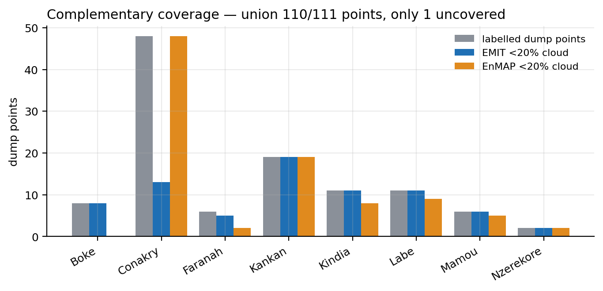
Figure 27. Complementary EMIT and EnMAP coverage by region, scenes below 20% cloud.

C.2 Sentinel-2 does not sample either diagnostic feature
Before the index results, the band arithmetic, because it determines how any index result must be read. 1215 nm lies between B9 at 945 nm and the B10 cirrus band at 1375 nm, which is not carried in the Level-2A product used here; the next band in that product is B11 at 1614 nm. 1730 nm lies between B11 and B12 at 2202 nm, a 589 nm gap. Neither is inside any Sentinel-2 band.
It follows that whatever the plastic-mulch index family measures on Sentinel-2, it is not C-H absorption. It is the shape of the shortwave infrared continuum, which bare soil, concrete and metal roofing also possess. The index results below should be read in that light.
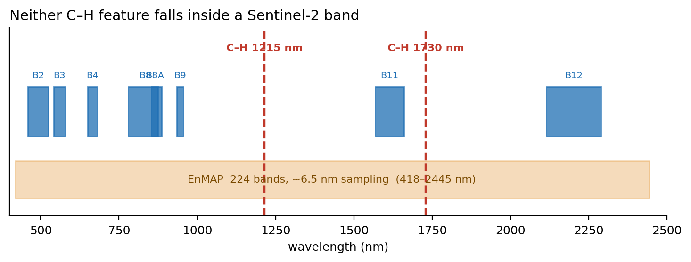
Figure 28. Sentinel-2 band positions against the two C-H absorption features. Both fall in gaps between bands.

C.3 Gate 2 falsified: the indices detect bare ground
Table 64. Index performance at the native 20 m pixel, 646 of the 651 labelled points (§3.3), baseline (prevalence) 0.172. A plain vegetation index outranks every purpose-built plastic index. PMLI_SWIR, PMLI_NIR and PMLI_ND are monotonic transforms of the same band ratio and therefore impose identical rankings; average precision depends only on ranking, so their values are identical by construction rather than by coincidence.
Index | Average precision | 95% CI | Lift over baseline
NDVI (control) | 0.440 | [0.313, 0.581] | 2.56
PMLI | 0.436 | [0.313, 0.571] | 2.54
PMLI_SWIR | 0.335 | [0.201, 0.515] | 1.95
PMLI_NIR | 0.335 | [0.201, 0.515] | 1.95
PMLI_ND | 0.335 | [0.201, 0.515] | 1.95
PGI_altdenom | 0.330 | [0.226, 0.451] | 1.92
RPGI | 0.315 | [0.205, 0.450] | 1.83
NDBI (control) | 0.282 | [0.176, 0.429] | 1.64
PGI | 0.208 | [0.150, 0.269] | 1.21
Vi | 0.169 | [0.124, 0.225] | 0.98

PGI, the index designed to detect plastic sheeting, reaches a lift of 1.21; Vi is indistinguishable from chance. NDVI, which has no plastic sensitivity whatsoever, leads the table. That ordering is not consistent with the indices responding to plastic, and it is entirely consistent with all of them responding to the absence of vegetation.
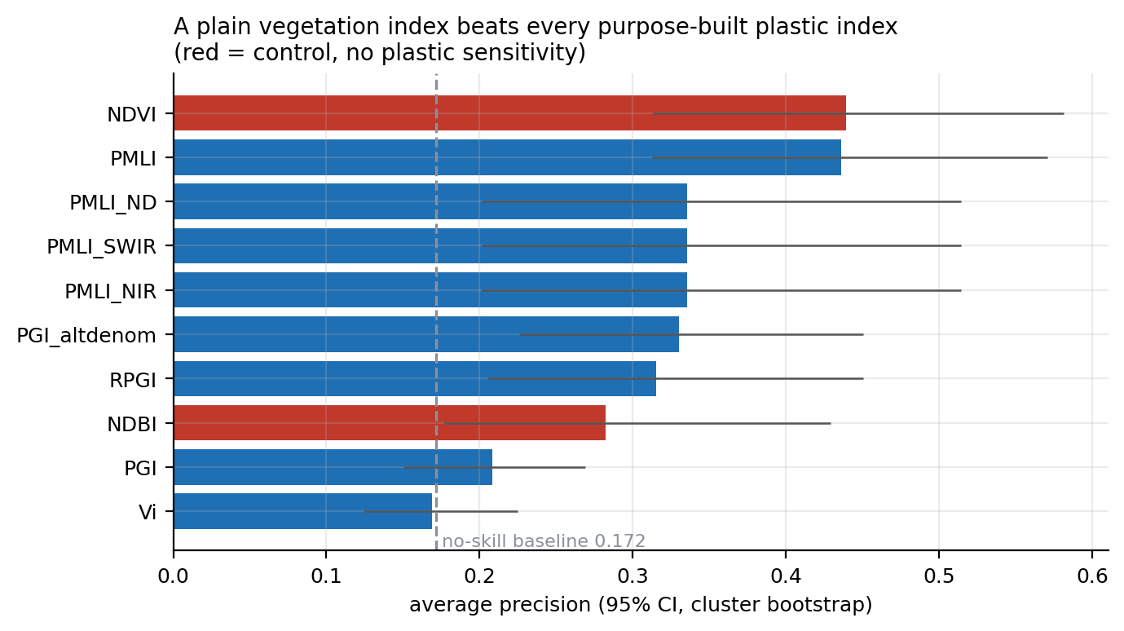
Figure 29. Average precision by index at the native 20 m pixel. Red bars are controls with no plastic sensitivity.
The decisive sub-test asks whether the plastic indices add anything over NDVI, using two spatially blocked models on identical folds.
Table 65. Incremental value of the plastic indices over NDVI alone, at three footprints. At the dumpsite's own scale, they add nothing.
Footprint | NDVI only | NDVI + plastic | ΔAP | 95% CI | Verdict
250 m box | 0.446 | 0.529 | +0.083 | [+0.010, +0.160] | significant
80 m box | 0.445 | 0.503 | +0.060 | [-0.037, +0.161] | not significant
Native pixel | 0.466 | 0.457 | -0.003 | [-0.090, +0.082] | not significant

The only footprint at which they help is the 250 m box, which is precisely the footprint §7.2.2 established measures the neighborhood instead of the dump. The most parsimonious reading of that result is built-up surroundings, and it should not be presented as evidence of plastic sensitivity.

C.4 Gate 3 falsified: FDI reproduces the same non-specific signal
FDI is not flat on land. Dumpsites read a median −0.141 against −0.098 for non-dumps at the native pixel: lower, because with the index as Biermann et al. define it the rise from the red-edge band to the near-infrared is a vegetation signal, and dumpsites are less vegetated than their surroundings. The separation exceeds baseline at every footprint, but FDI never beats NDVI: at the native pixel it reaches 0.301 against NDVI's 0.440 (ΔAP −0.147, 95% CI [−0.274, −0.009]).
On land the index therefore measures the absence of vegetation, the same non-specific signal NDVI measures, and measures it less well. This is also why the marine pipeline requires a positive water constraint (§5.1.3): over land the index responds to surface cover, not to floating material.
The operational pipeline, with its real masks, produces no land output at all: 0 of 646 points survive the water constraint. The pipeline is correctly scoped to water and must not be repurposed, because removing that constraint reintroduces the exact failure it was added to fix.

C.5 Gate 4 falsified: no C-H signature in EnMAP
Six 0%-cloud acquisitions, four regions, three years, 1,256 spectra (140 of them dump spectra) over 30 distinct dumpsites, against matched ring controls.
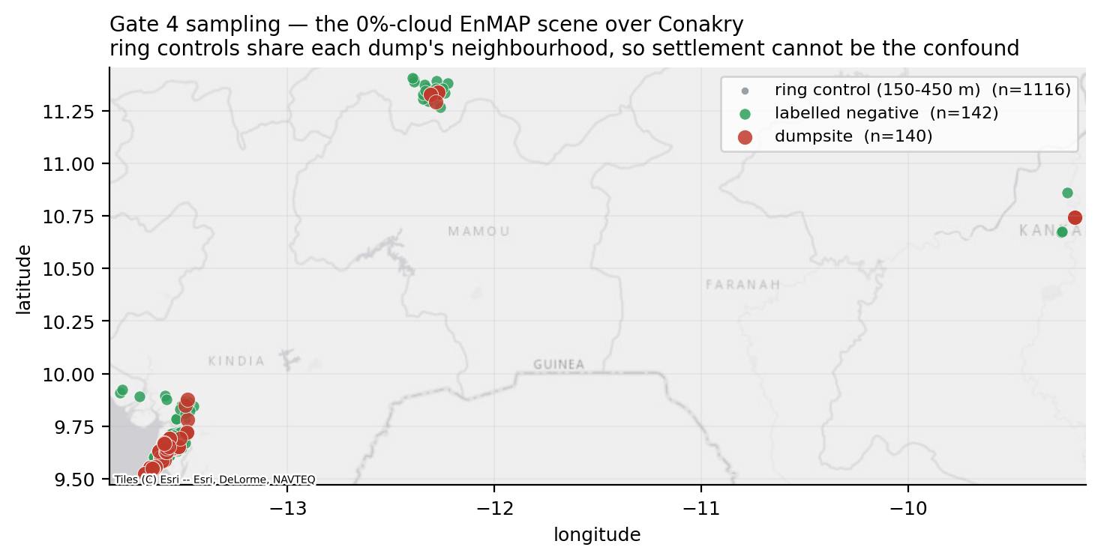
Figure 30. Gate 4 sampling design on one scene. Ring controls share each dumpsite's immediate neighbourhood, so settlement cannot be the confound.
Weak separability exists. The site-blocked out-of-fold classifier reaches average precision 0.218 against a 0.111 baseline, a lift of 1.95. Dumpsites are bare and disturbed, so some difference from their surroundings is expected. The question the gate asks is where that difference lies.
Table 66. The two C-H diagnostic features among the 218 EnMAP bands retained of the nominal 224; the excluded bands fall in the atmospheric water-vapour absorption windows at 1340-1460 nm and 1800-1960 nm, where surface reflectance cannot be retrieved. If plastic were driving the signal they would rank at the top.
Feature | Raw AP | Raw rank | AP, brightness removed | Rank, brightness removed
1215nm | 0.115 | 140 of 218 | 0.113 | 163 of 218
1730nm | 0.116 | 128 of 218 | 0.123 | 46 of 218

Both diagnostic features rank mid-pack. Removing brightness reduces the multivariate lift from 1.95 to 1.41, so most of what separability exists is albedo.
The single-scene result was stronger and is worth recording, because the direction of change is itself evidence. On one scene the features ranked 19 and 25 of 218; with six scenes they fall to 140 and 128. A real signal rises as noise averages out. These sank, which is what a null does when more data arrives.
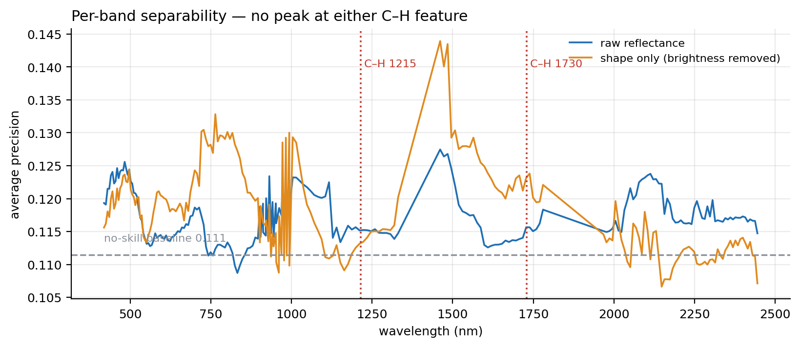
Figure 31. Per-band separability across the EnMAP range, with and without brightness. There is no peak at either C-H feature.

C.6 Convergence of four independent lines of evidence
Four lines of evidence converge on the same result, and they are independent in the sense that each rests on a different sensor or a different physical argument and none inherits the others' assumptions. The three spectral tests (the Sentinel-2 plastic indices, the Floating Debris Index on land and a 218-band EnMAP classifier) each separate dumpsites from their surroundings to some degree, none through a plastic-specific mechanism, and with a magnitude consistent with bare ground in every case. The fourth, the measured dumpsite extent, explains why.
Table 67. The four lines of evidence behind the negative result. The fourth supplies the mechanism that explains the first three.
Line of evidence | What it found | Section
Sentinel-2 plastic indices | NDVI matches or beats every plastic index; zero incremental value at dumpsite scale | §C.3
Floating Debris Index on land | Responds, but below NDVI: on land it tracks vegetation cover | §C.4
EnMAP 218-band classifier | Weak separability, mostly albedo; C-H features rank mid-pack | §C.5
Measured dumpsite extent | Median site is sub-pixel at every capable sensor | §7.3

The explanation is geometric. The target is approximately 14 m. The finest openly available shortwave-infrared pixel is 20 m, and it does not sample the diagnostic wavelengths. The sensors that do sample them have 30 to 60 m pixels. The plastic fraction within that sub-pixel target is precisely the quantity the concept note requested, and it lies below the detection floor of every openly available instrument in orbit capable of observing the relevant physics.

